EWM FAQ
Category | EWM | Date | 2021/04/22
Keyword | AIW-344FQ(EWM-C148FL02E),windows 10 OS (Version1809),UTX-3117

- Question:
How to establish LTE cellular network with AIW-344FQ(EWM-C148FL02E) on windows 10 OS x86 platform?

- Instructions :
Step 1
Insert AIW-344FQ(EWM-C148FL02E) module into mini PCI-E slot and both of Main and Aux has connected antenna cables already

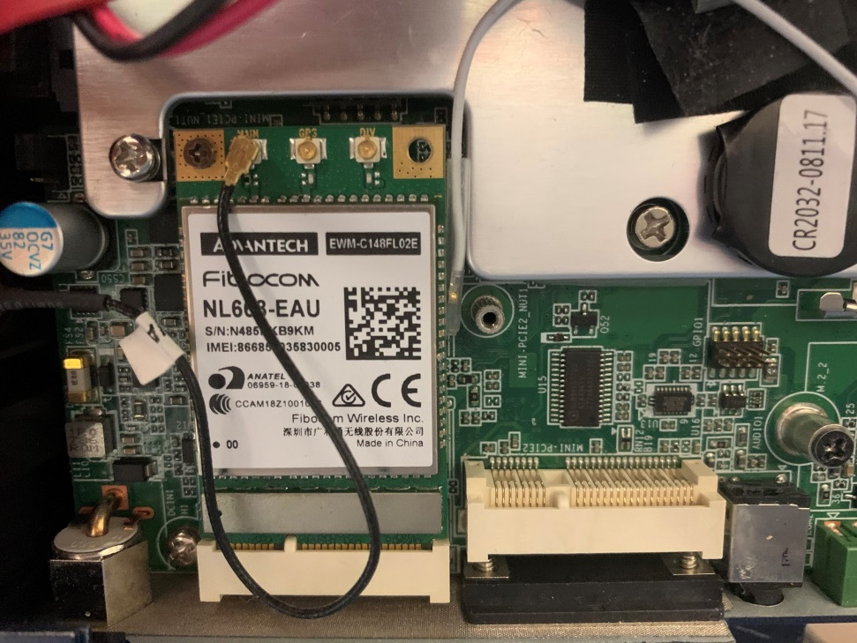
Step 2
Download windows driver package by following URL and install on your OS
https://1drv.ms/u/s!AvzLe5sr2qg2g8kKnlENkfCyqiOLRg?e=szaQdI
Step 3
Enter to Setting section and enable cellular mode for establishing cellular connection
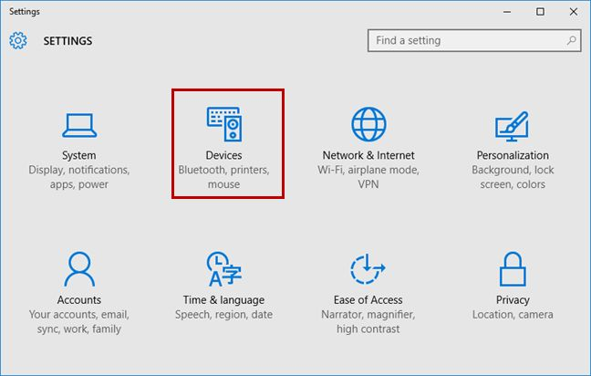

Step 4
With specific sim card, it must enter APN setting, username and password in advance
- Click advance option to add APN profile
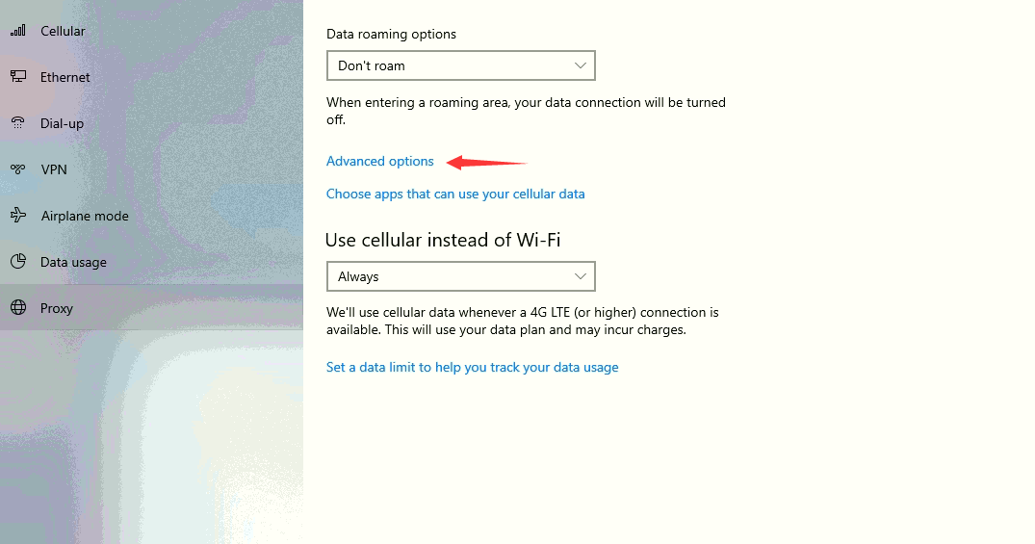
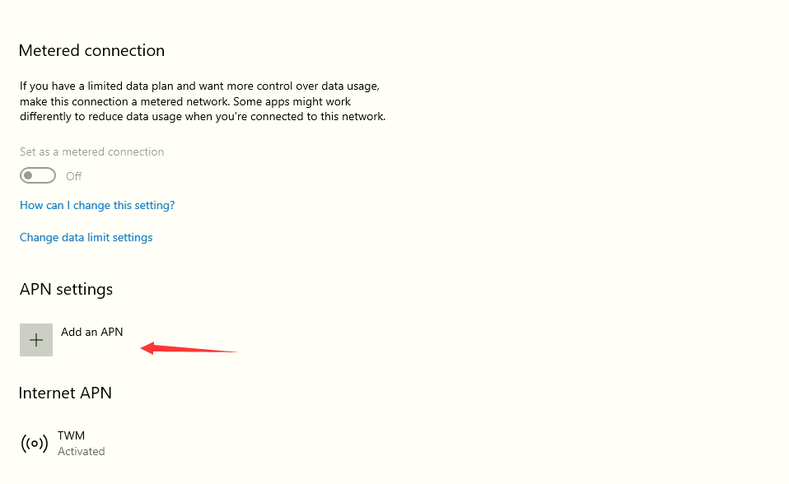
- Add related configuration and apply it
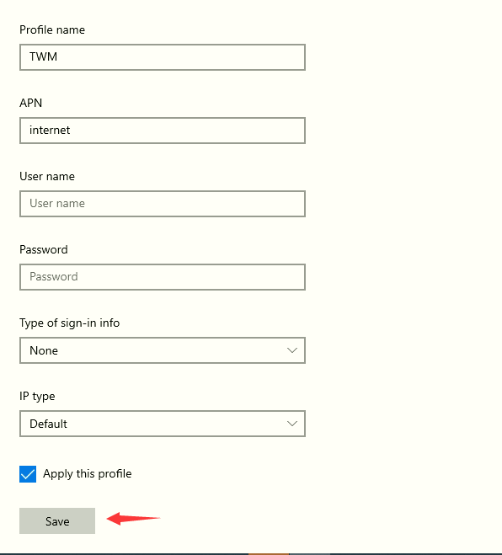
Step 5
After enabling, the cellular function will auto-search 3G/4G signal around your place to establish connection

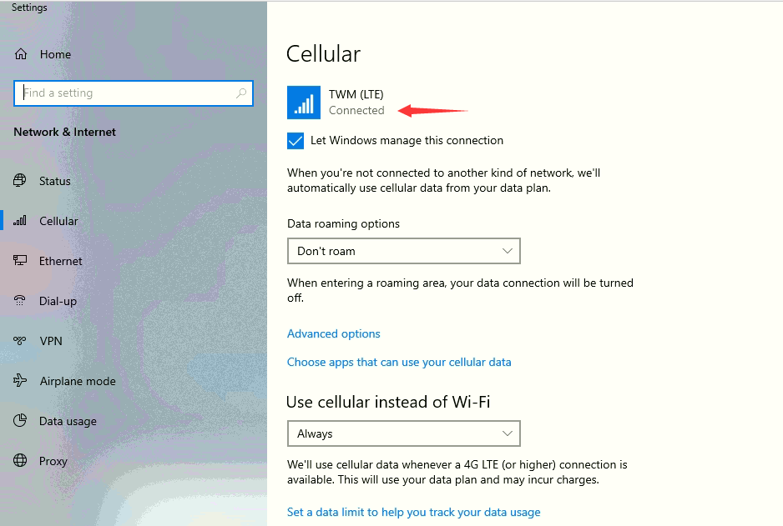
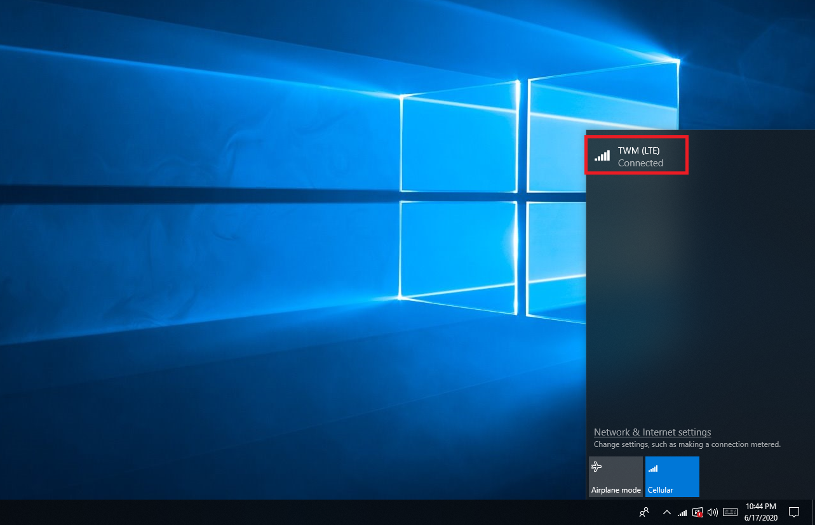
Step 6
Access the internet by browser and ensure if the webpage can show normal or not

