How to Setup Wi-Fi/Bluetooth with EWM-W180
Prerequisite
MIO-5272 and built-in Windows 10 on it.

Install Driver
- Wi-Fi
Please select install driver directory to “RTLWlanU_WindowsDriver_1030.42.0910.2020\” after extract the file “Windows\Wi-Fi\RTLWlanU_WindowsDriver_1030.42.0910.2020.zip” and follow the prompt to install driver.
- Bluetooth
Windows Device Manager will shows “Generic Bluetooth Adapter” under Bluetooth enumeration, so, you have to right click on the “Generic Bluetooth Adapter” and select “Update Driver” to install driver directory with “RTBlueR_Windows10_FilterDriver_1037.3003_0511.2021\RTBlueR_Windows10_FilterDriver_1037.3003_0511.2021_new_L” after extract the file “Windows\BT\RTBlueR_Windows10_FilterDriver_1037.3003_0511.2021.zip” and follow the prompt to install driver.

Check Device
- Before driver being installed, the unknown device is displayed on “Device Manager”.
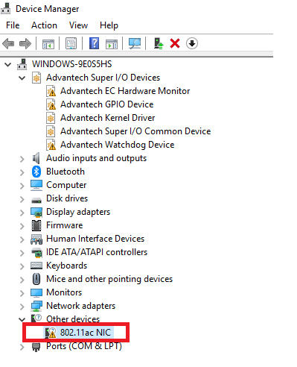

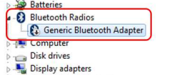

- After driver being installed, you will see the snapshot as below.

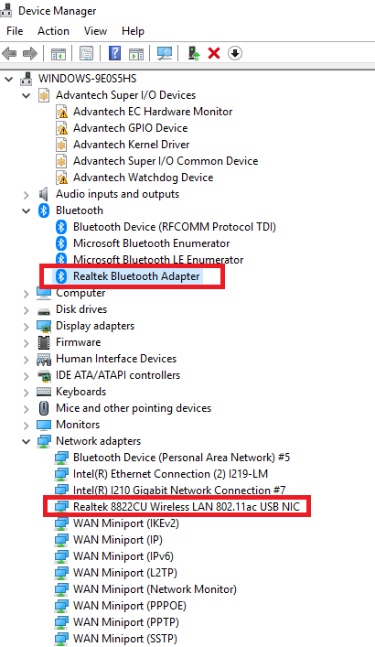
Function Test
- Wi-Fi
Setup Wi-Fi on Windows 10 and run the Wi-Fi connection test with internet by Google Fiber Speed Test.
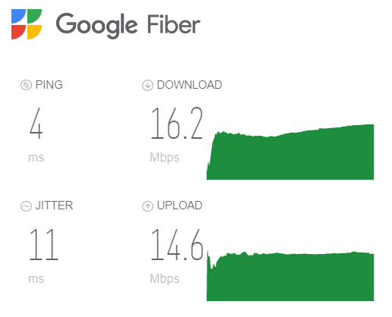

- Bluetooth
Scan devices by settings on Windows10.
Start menu button and select Settings -> Devices -> Bluetooth & other devices