How to Setup Network with AIW-343
on Ubuntu
Prerequisite
- PC and setup Ubuntu 20.04 on it
- Tarball file “aiw-343-peer-config.tar.bz2”

Test

- Stop modem manager
# sudo service ModemManager stop

- Copy configuration file
decompress the tarball “aiw-343-peer-config.tar.bz2”
# tar jxvf “aiw-343-peer-config.tar.bz2”
Copy all files to /etc/ppp/peers
# sudo cp aiw-343-peer-config/* /etc/ppp/peers/

- Open the file “aiw-343-chat” and modify the APN
# sudo vi /etc/ppp/peers/aiw-343-chat
To fill the string of your APN in the below red rectangle.
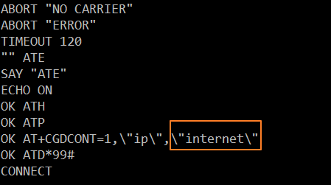

- Dial out
# sudo pppd call aiw-343 &
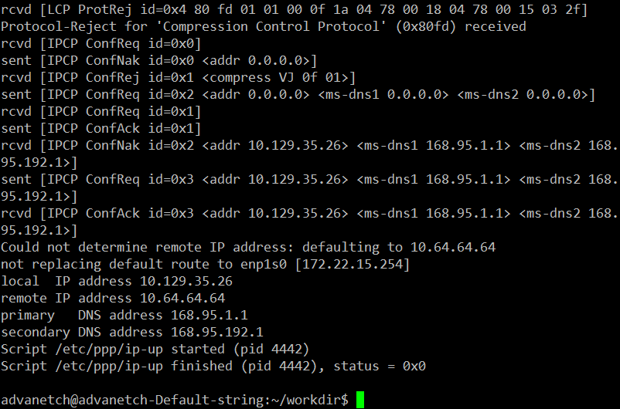

- Check network connection
# ping -c 3 -I ppp0 8.8.8.8
