**EWM FAQ**

|  |  |  |  |
| --- | --- | --- | --- |
| **Category** | EWM | **Date** | 2019/09/12 |
| **Keyword** | EWM-C148FL01E,4G Connection,Ubuntu 16.04 LTS,18.04.4 LTS and above version,GobiNet Driver integration | | |

* **Question:**

How to establish 4G connection with EWM-C148FL01E automatically when system boots up on Ubuntu Linux OS?

* **Instructions :**

Step 1

Preinstall related software component on your Ubuntu system OS in advance

**sudo apt-get install build-essential /* Avoid GCC package not found during compiling**

**sudo apt-get install minicom /*Enter AT commands if needs**

Step 2

Download Fibocom GobiNet Linux driver package and copy it to your Ubuntu OS Desktop



Step 3

Edit “**makefile”** file under “Fibocom_GobiNet_Linux_Driver” packageand confirm the GCC version is consistent as your Ubuntu OS (if it’s inconsistent,please modify and save it)

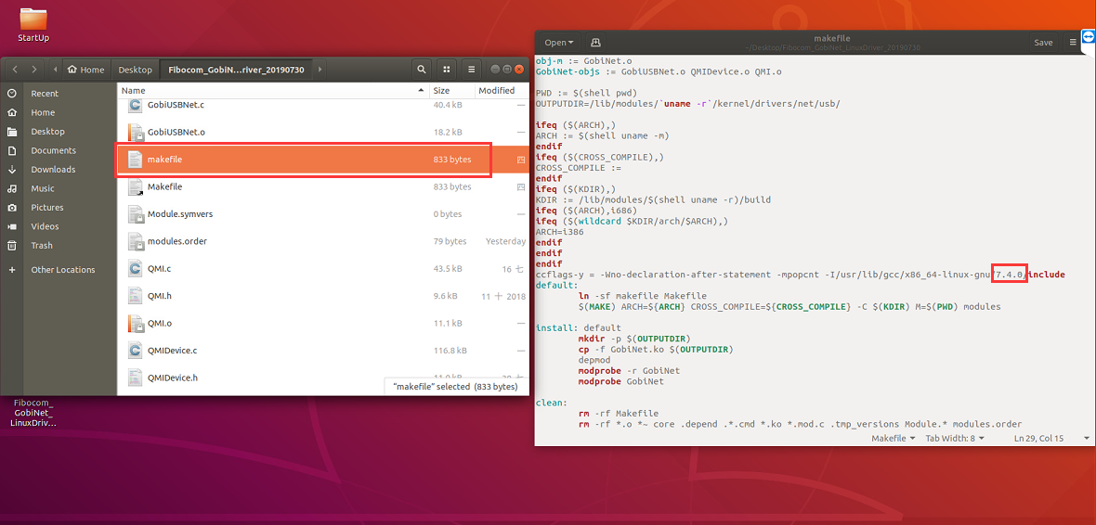

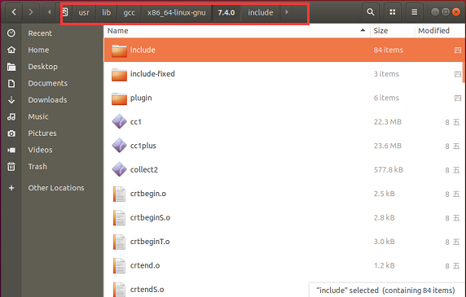

Step 4

Enter to specific file folder (Fibocom_GobiNet_LinuxDriver_20190730) on terminal and execute “sudo make install “ command to insert GobiNet driver into your system

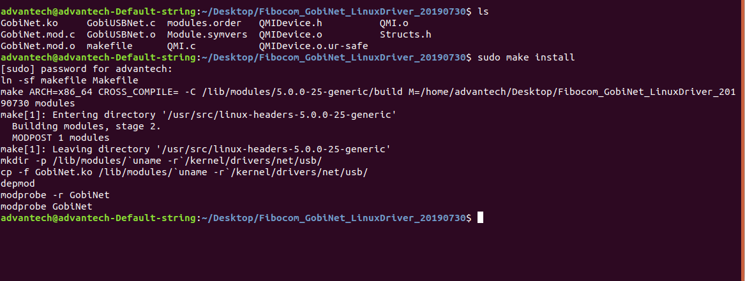

Step 5

Cross check if your system already build in “qmi_wwan.ko” driver under specific folder. (lib/modules/5.0.0-25-generic(own kernel version)/kernel/drivers/net/usb/)  
In order to avoid resource confliction,please remove “qmi_wwan.ko” driver to ensure the GobiNet driver performs well.

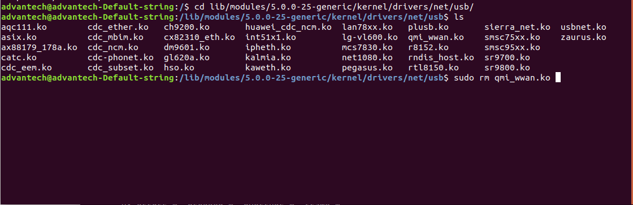

Step 6

Create a shell script under specific folder(/home/Desktop/Startup),then input APN setting & Dial action by AT commands to establish 4G network automatically  
<refer to attached script file below>

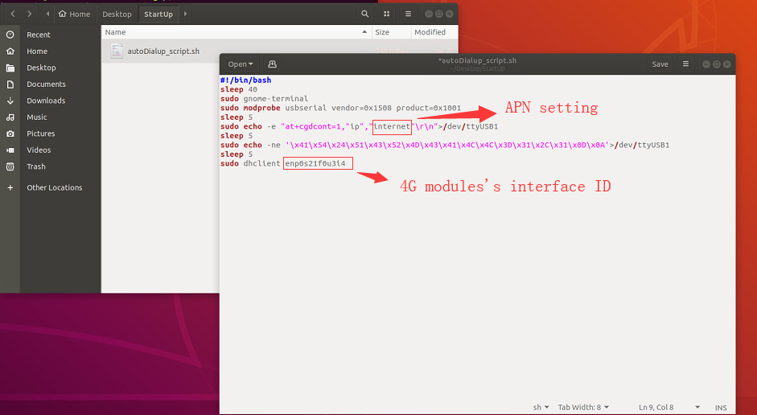



Note: The system may need different delay time during executing network process, please determine the sleep time “40” value by yourself.

Step 7

Create a startup service under specific folder(/etc/systemd/system/)which can execute “autoDialup_script.sh” script when boots up system automatically <please refer to attached service file below>

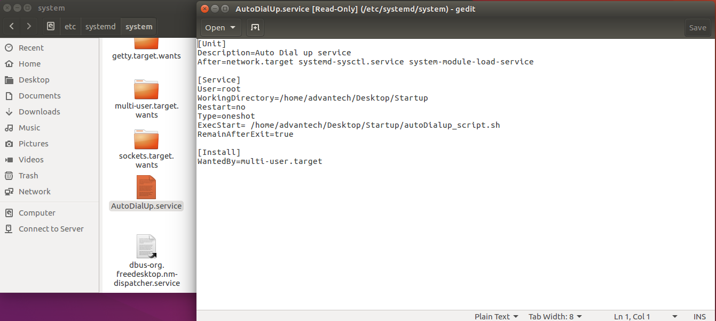



<Directory modification>

/etc/systemd/system/AutoDialUp.service

|  |
| --- |
| [Unit]  Description=Auto Dial up service  After=network.target systemd-sysctl.service systemd-modules-load.service  [Service]  User=root  WorkingDirectory=/home/advantech/Desktop/Startup  Restart=no  Type=oneshot  ExecStart=/home/advantech/Desktop/Startup/autoDialup_script.sh  RemainAfterExit=true  [Install]  WantedBy=multi-user.target |

Step 8

Double check if the service has created under specific folder and modify the access permission of service by “sudo chmod 777 AutoDialUp.service” command.

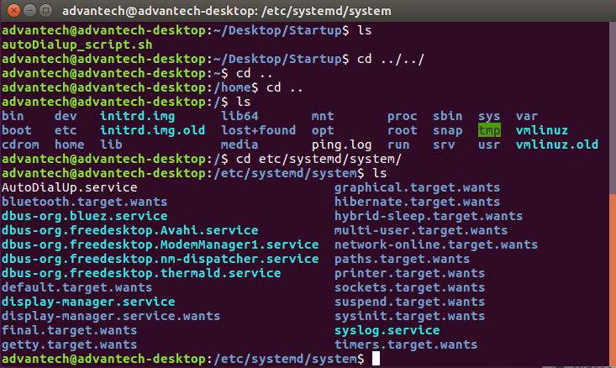

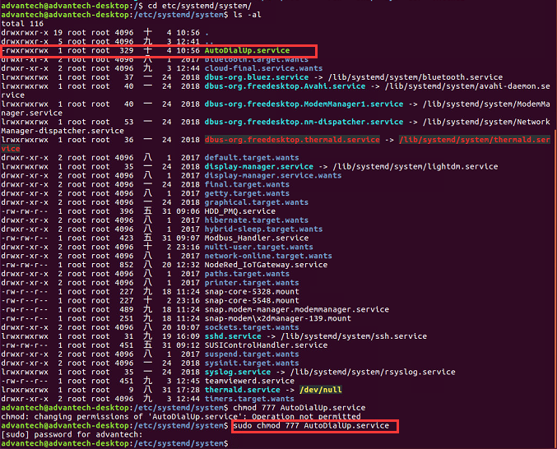

Step 9

Enable “AutoDialUp.service” service and activate it by following commands in red mark in order to execute process when system boots up

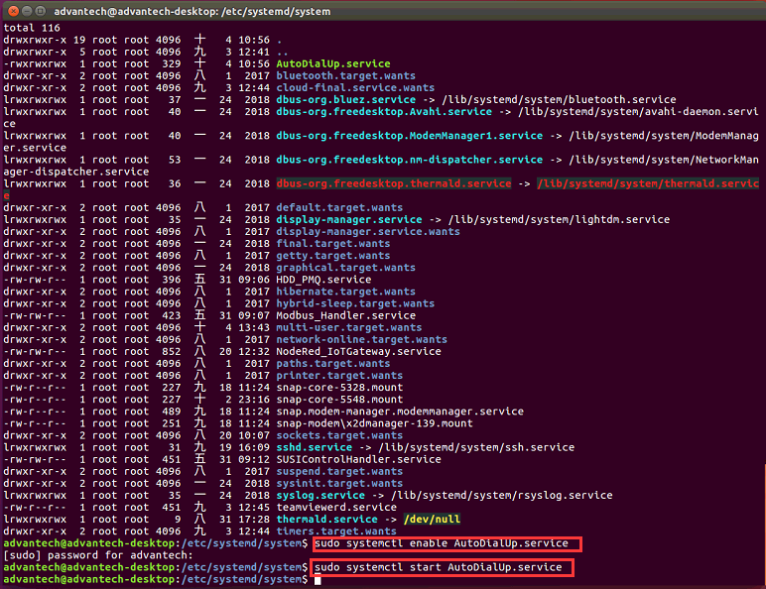

Step 10

Shut down system and confirm if 4G connection can be established after booting up

