EWM FAQ
Category | EWM | Date | 2020/06/18
Keyword | EWM-C148FL02E,windows 10 OS (Version1809),UTX-3117

- Question:
How to establish LTE cellular network with EWM-C148FL02E on windows 10 OS x86 platform?

- Instructions :
Step 1
Insert EWM-C148FL02E module into mini PCI-E slot and both of Main and Aux has connected antenna cables already.

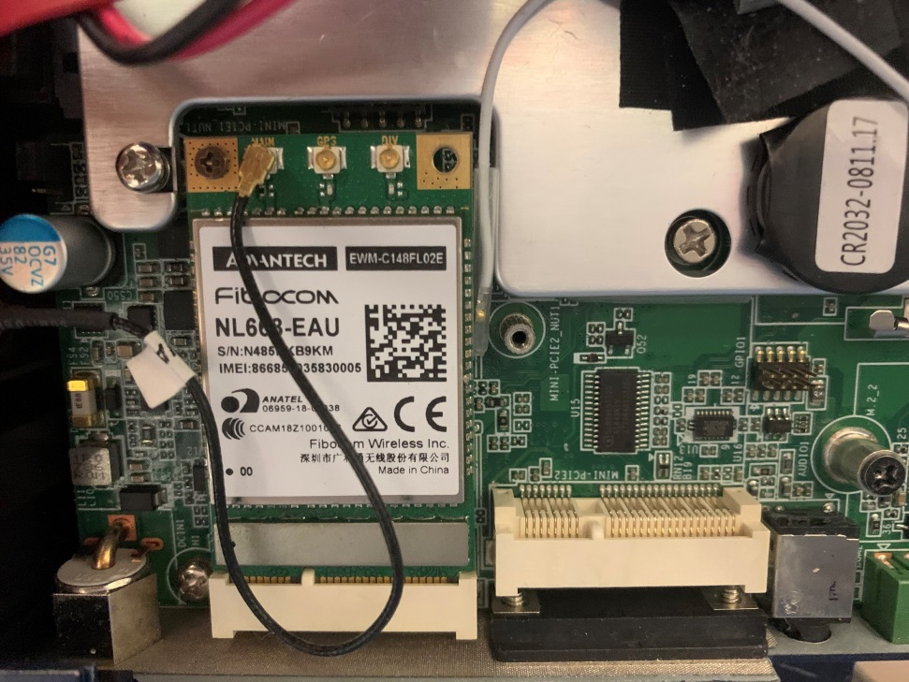
Step 2
Download windows driver package by following URL and install on your OS
https://www.dropbox.com/sh/cdgxv4401otjk7l/AAAzo73R-bU-lgz7nIJyWazQa/4G/CAT4/C148/Driver/Windows?dl=0
Step 3
Enter to Setting section and enable cellular mode for establishing cellular connection
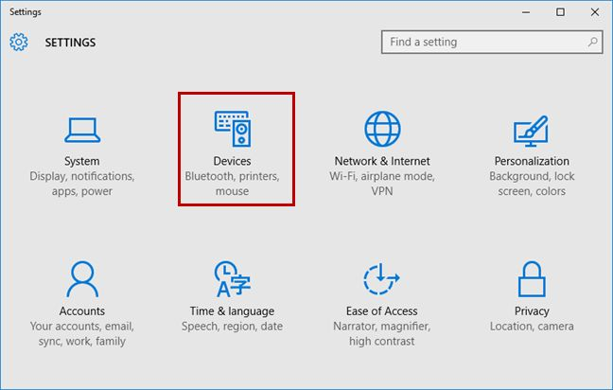
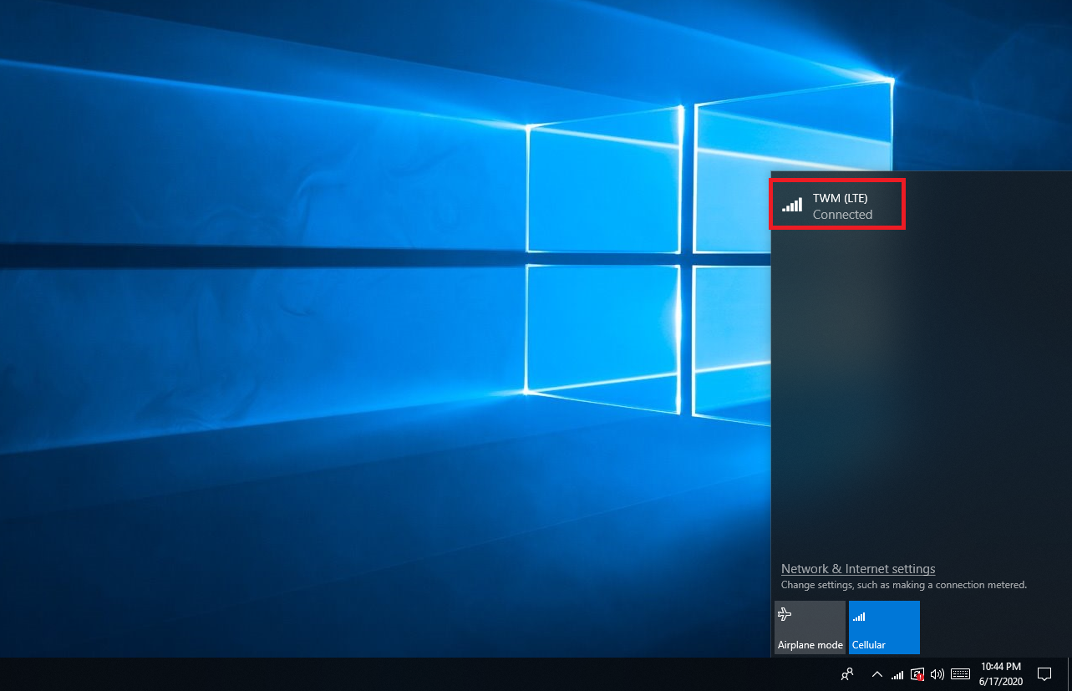
Step 4
After enabling, the cellular function will auto-search 3G/4G signal around your place to establish connection.

