EWM FAQ
Category | EWM | Date | 2019/11/19
Keyword | EWM-C117FL02E ,4G/LTE Connection

- Question:
How to connect 4G/LTE with EWM-C117FL02E in RNDIS mode?

- Instructions :

Step 1
Download related utilities and driver from following link and decompress the file at local device
https://1drv.ms/u/s!AmPTlw75mrwLgzICSmT1IaNxFiEI

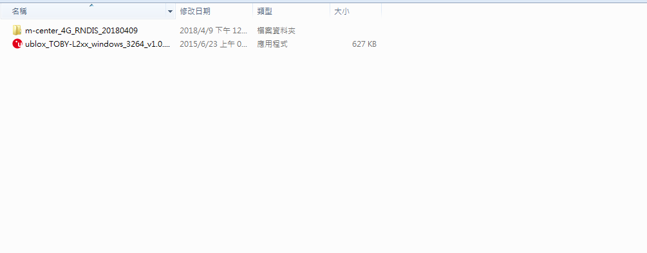

Step 2
Install cellular module on your device and make sure RNDIS driver has installed successfully

Step 3
Enter to device manager and ensure the u-blox USB modem interface has generated
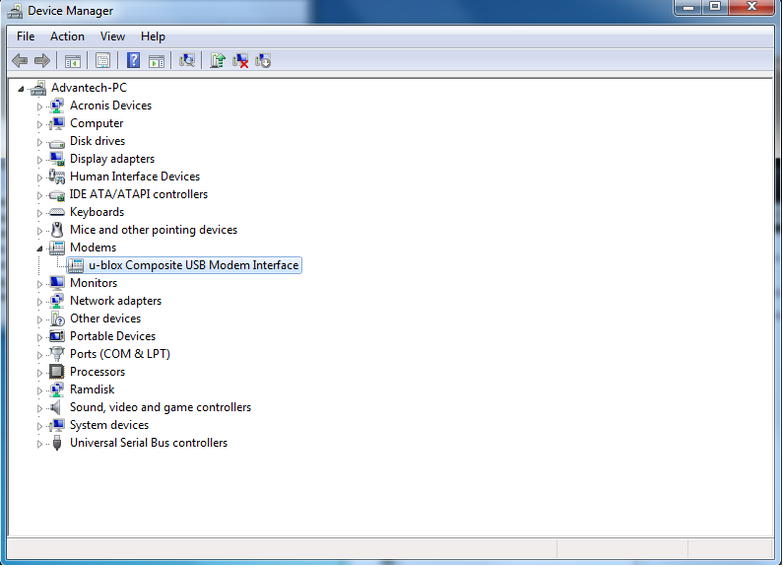

Step 4
Execute m-center utility to configure related setting
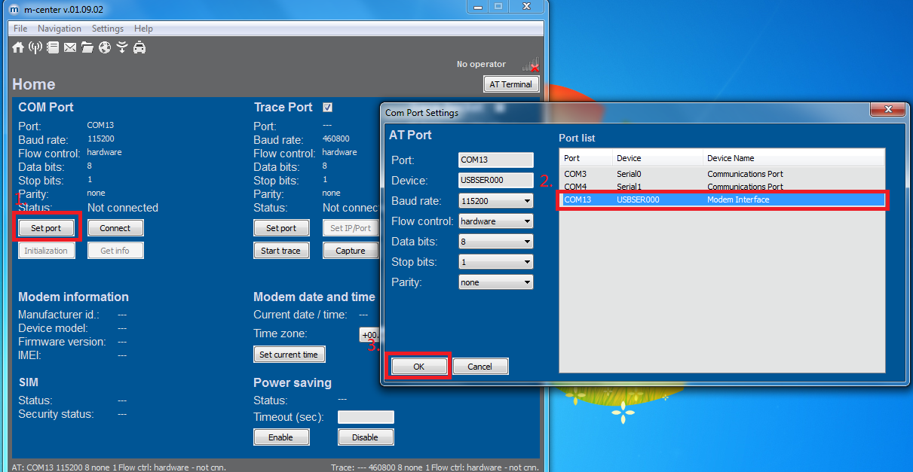

Step 5
After selecting Com port, press connect button for connecting, then press “Get info” button to acquire modem information

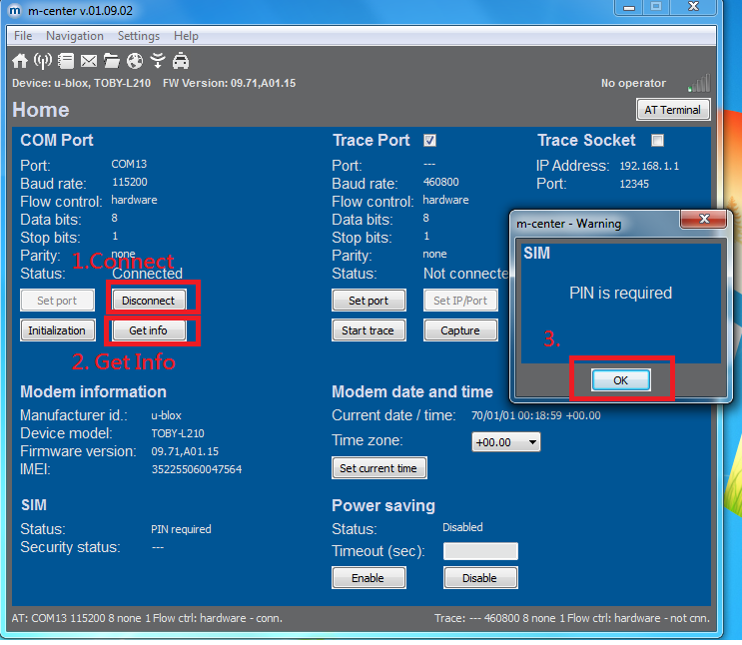
Step 6
Input SIM card’s PIN Code

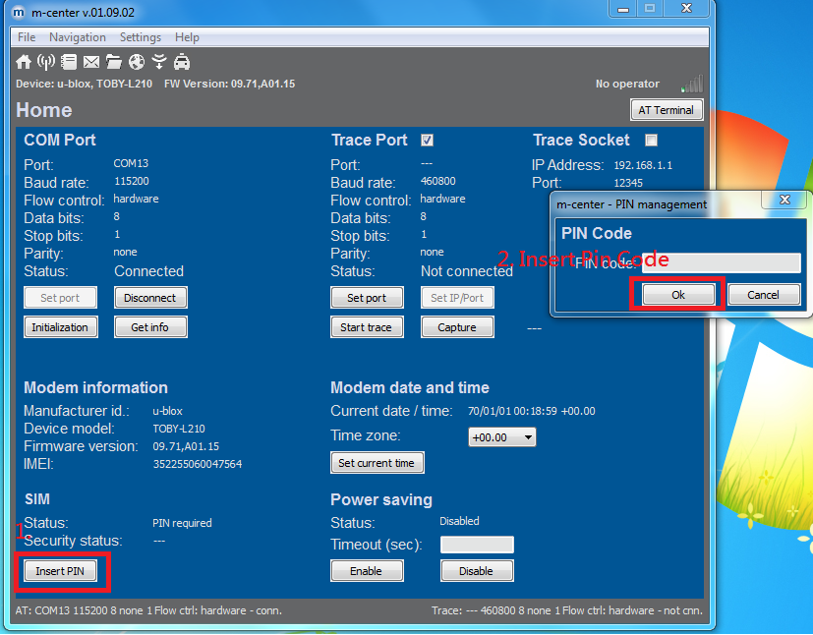

<Note>
Disable your sim card’s pin code to avoid inputting every time when you logon system
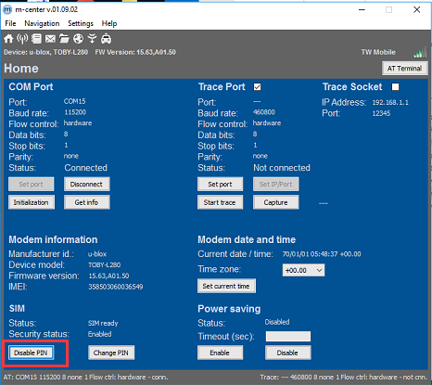
Step 7
Switch to AT terminal mode and select specific AT group (Set_APN) and input Commands orderly.
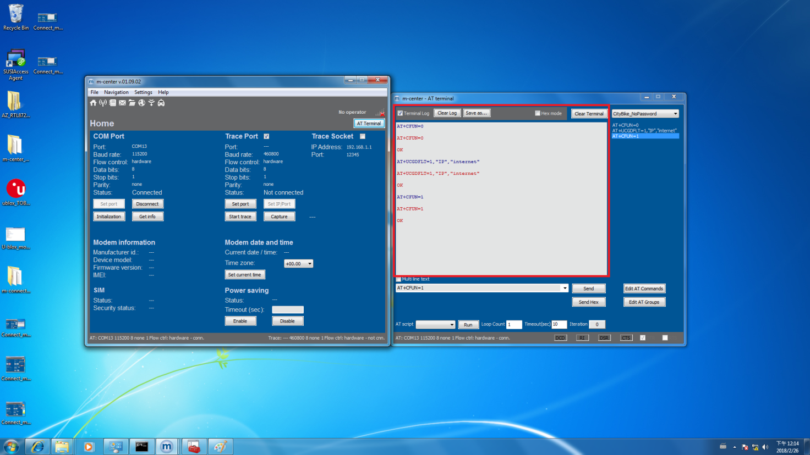

Step 8
If your SIM card already include username and password, please select “Set_APN_user/pwd” AT group and change APN/USERNAME/PASSWORD before sending commands.
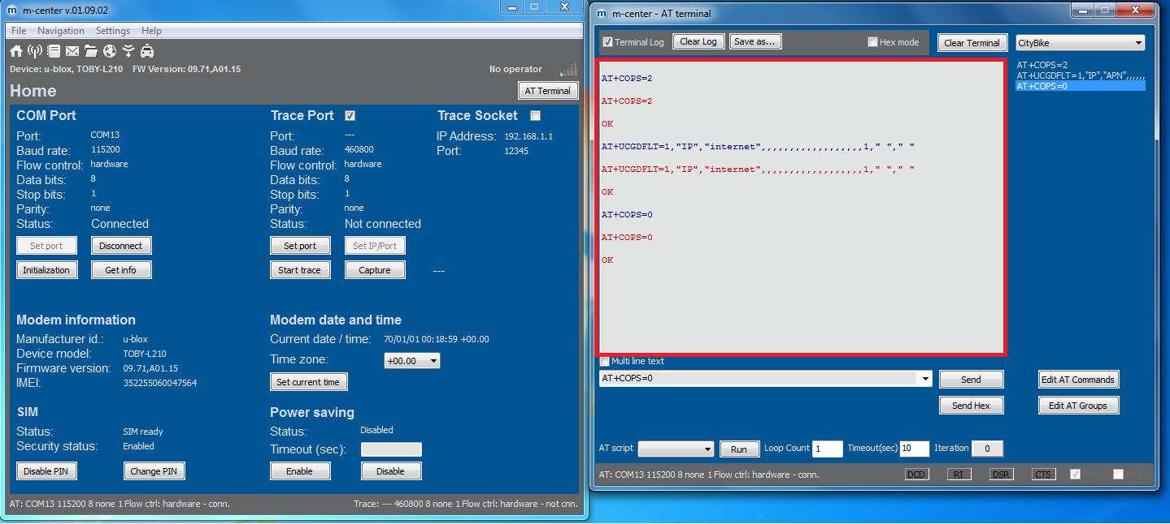
Step 9
Close AT terminal session and exit m-center utility, then reboot system for establishing RNDIS connection automatically.
Step 10
After above configurations, you will see the connection is established to browse internet as usual.
