How to Setup Network with AIW-342
on Ubuntu
Prerequisite
- EPC-R7200 and setup Ubuntu 18.04 from nVidia BSP on it
- AIW-342 hardware revision “LE910C4-EU-H” M.2 Card
- GNSS active anttena
- Tarball file aiw-342-xxx-peer-config.tar.bz2 and gpsd-3.23.1.tar.gz

Network Test

- Stop modem manager
# sudo service ModemManager stop

- Copy configuration file
decompress the tarball “aiw-342-xxx-peer-config.tar.bz2”
# tar jxvf “aiw-342-xxx-peer-config.tar.bz2”
Copy all files to /etc/ppp/peers
# sudo cp aiw-342-xxx-peer-config/* /etc/ppp/peers/

- Open the file “aiw-342-chat” and modify the APN
# sudo vi /etc/ppp/peers/aiw-342-chat
To fill the string of your APN in the below orange rectangle.
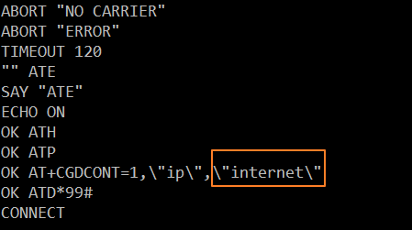

- Load option driver to enable serial port
Change to root permission by command “su -“
# sudo su -
# modprobe option
# echo "0x1bc7 0x1252" > /sys/bus/usb-serial/drivers/option1/new_id
# exit

- Dial out
# sudo pppd call aiw-342 &
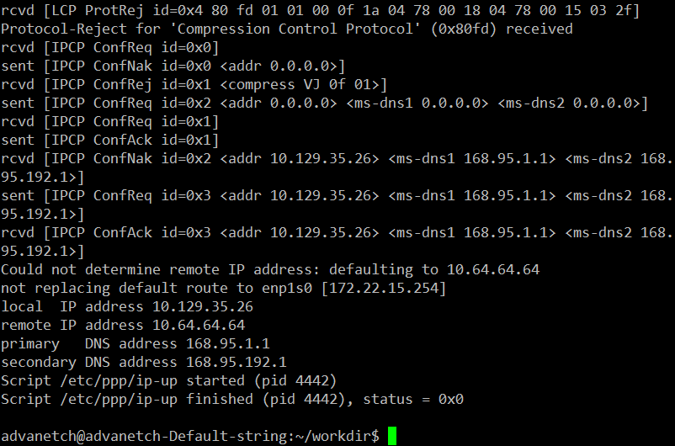

- Check network connection
# ping -c 3 -I ppp0 8.8.8.8
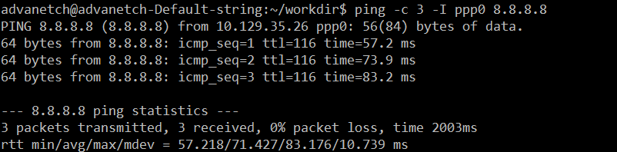

GNSS Test
- Remove gpsd on system
To stop/disable gpsd as default by below commands
# sudo systemctl stop gpsd
# sudo systemctl disable gpsd
# sudo systemctl stop gpsd.socket

Remove gpsd
# sudo apt-get update
# sudo apt-get remove gpsd
# sudo apt-get remove gpsd-clients

- Install gpsd with version 3.23.1
Prepare some library and gpsd package.
# sudo apt install -y scons libncurses-dev python-dev pps-tools git-core asciidoctor python3-matplotlib build-essential manpages-dev pkg-config python3-distutils
# tar -xzf gpsd-3.23.1.tar.gz

To build gpsd
# cd gpsd-3.23.1
# sudo scons
# sudo scons install

- Load option driver to enable serial port
Change to root permission by command “su -“
# sudo su -
# modprobe option
# echo "0x1bc7 0x1252" > /sys/bus/usb-serial/drivers/option1/new_id
# exit

- Steps to test with GNSS
- Start to run minicom and select the “Serial port setup”
# sudo minicom -s
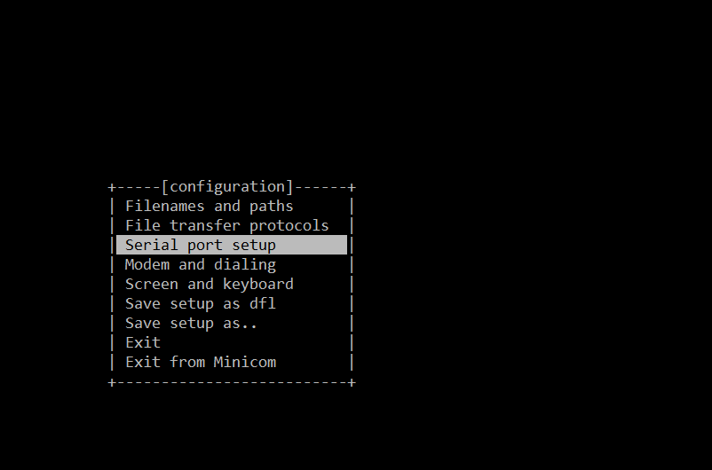

- Please set serial port to /dev/ttyUSB3 and setting as below screenshot.
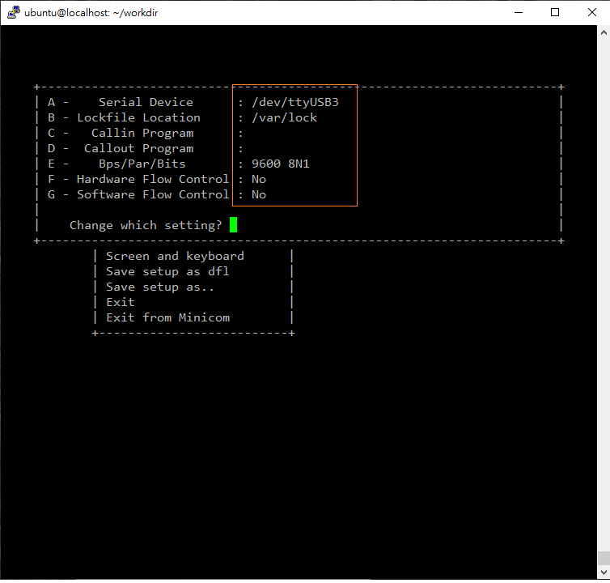

- Exit the setting and get into minicom console.
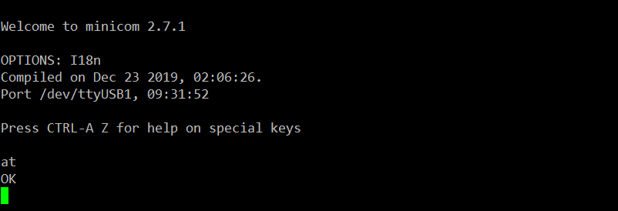

- Setting with GNSS in minicom
  - Set to support active antenna

  - Set to GNSS_ALL (gps+glonass+galileo+beidou)

  - Set unsolicited NMEA Data Configuration
For GPS、Galileo and Beidou
AT$GPSNMUN=1,0,0,1,1,1,0
AT$GPSNMUNEX=1,1,0,1,1,1

For GLONASS
AT$GPSNMUN=1,0,0,1,1,1,0
AT$GPSNMUNEX=1,1,1,0,0,0

  - Start GNSS positioning session

- Begin to run gpsd
# sudo gpsd -n /dev/ttyUSB2
gpsd is running in debug mode if needed.
# sudo gpsd -D 5 -N -n /dev/ttyUSB2

- Get longitude and latitude
# cgps
