How to Setup Network with AIW-344
Prerequisite
- ARK-1551 and setup Windows 10 on it
- AIW-344 with AIW-344FQ-E02 (30) version.

Install Driver
- Device driver
Please run the installer “USBDeviceSetup.exe” and follow the prompt to install driver.

Check Device
After driver installed, you will see the snapshot as below.
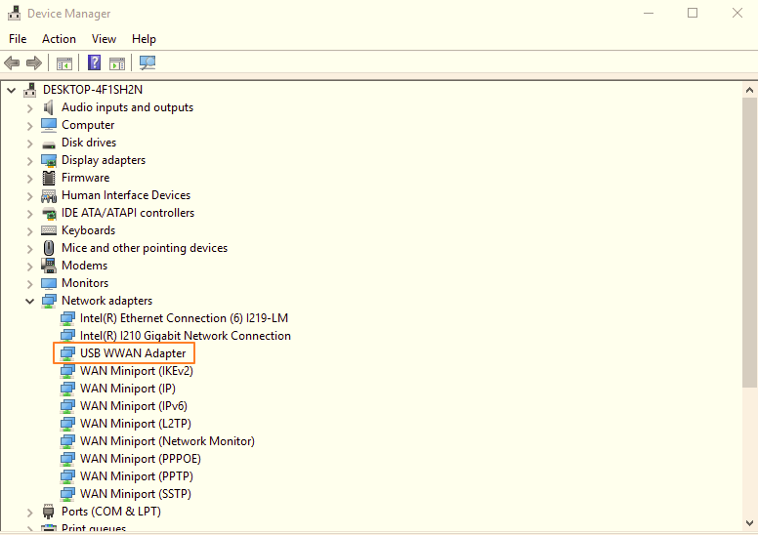

Function Test
- Speed test
This is only for reference.
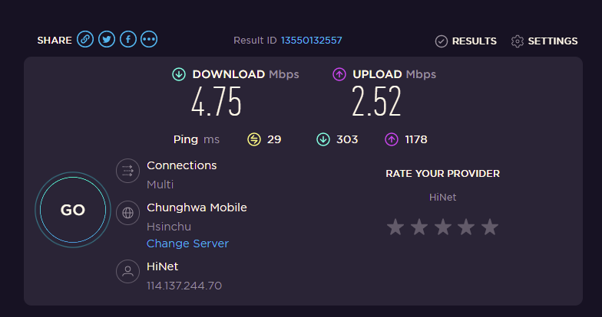

- Reliability
Observe the ping test at least 6 hours.

- AT command
- Check the number of COM port with AIW-344 in device manager.
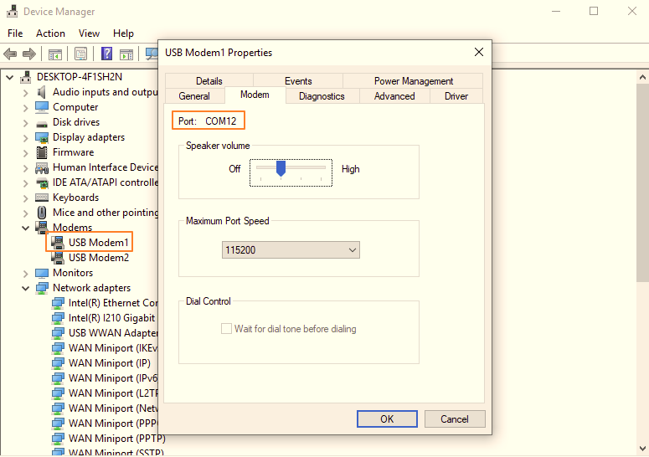

- Access to AT command through terminal like putty.
Please make setting as below:
  - Baud Rate “9600”
  - Data bits "8"
  - Stop bits "1"
  - Parity "None"
  - Flow Control "None"
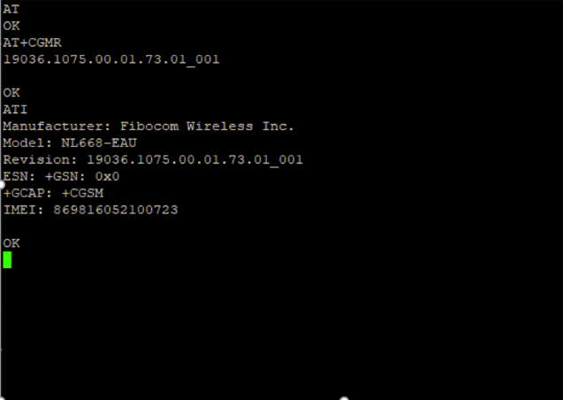

- GPS test
Please follow the below commands to input by AT command on the terminal.
Noted that please use passive antenna on AIW-344.
- Set supl server and port
at+gtagpsserv="supl.qxwz.com",7276
- Set supl version
at+gtgpscfg=0,1
- Check APN setting, there should be a correct APN
at+cgdcont?
- Check the device attach to network
at+cops?
- Enable AGPS.
at+gtgpsepo=1
- Start GPS.
at+gtgpspower=1

- at+gtgps?
Get longitude and latitude by checking NMEA data.
Noted that please waiting for 3 minutes for sync.
