AIW(EWM) FAQ
Category | AIW | Date | 2022/02/08
Keyword | AIW-166, Windows 10 Enterprise LTSC(version 1809)

- Question:
How to fix yellow bang(error code 10) issue on AIW-166(Intel WiFi-6E AX210 160MHz)?
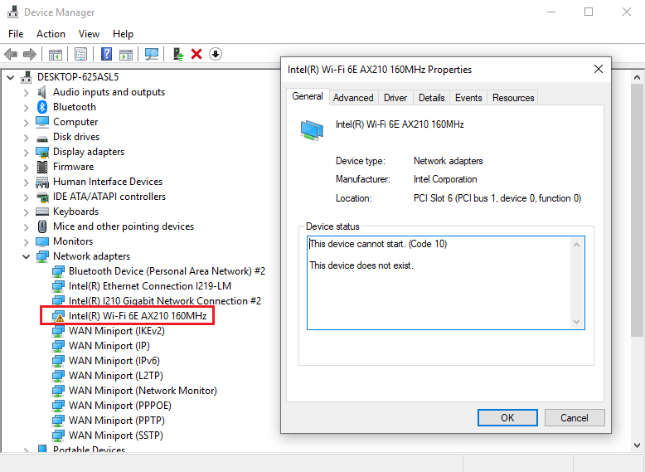
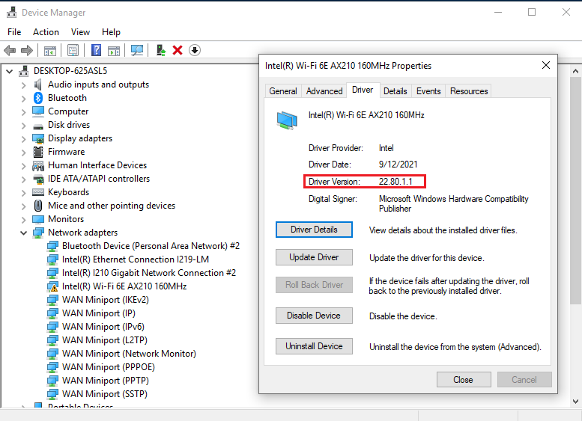

- Instructions :

Step 1
Download the newer wireless adapter driver version 22.110.1 or above from Windows official website. https://www.intel.com.tw/content/www/tw/zh/download/19351/windows-10-and-windows-11-wi-fi-drivers-for-intel-wireless-adapters.html?wapkw=19351

Step 2
Run the .exe file to install the driver 22.110.1, then reboot the PC.

Step 3
After PC reboot, yellow bang(error code 10) issue has disappeared and AIW-166 works well.
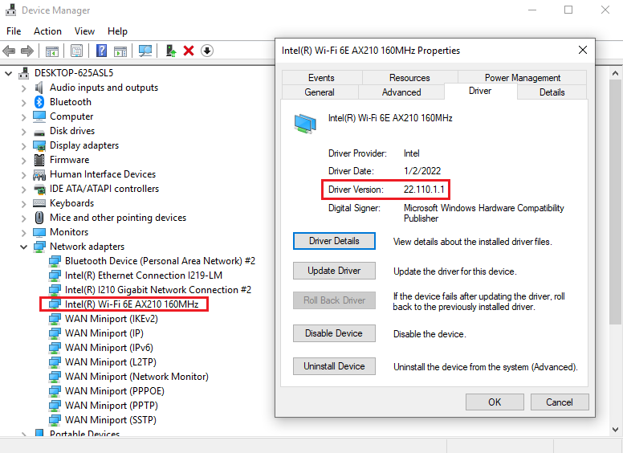

2.4GHz SSID:
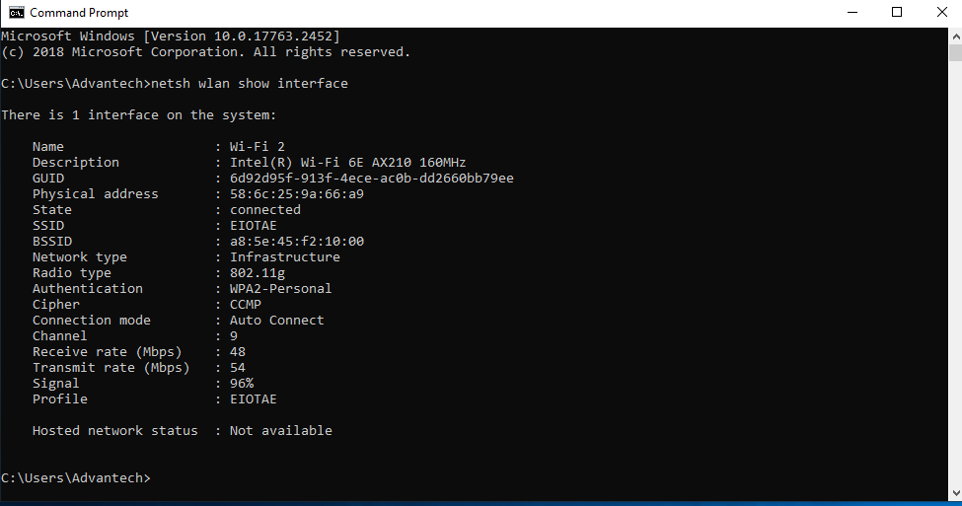

5GHz SSID:
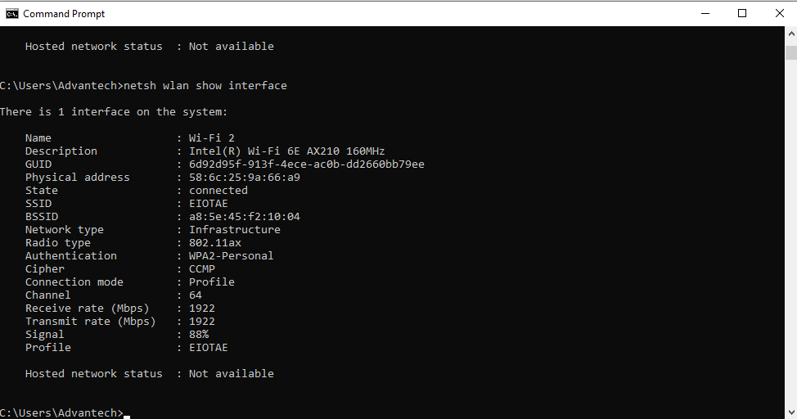

*Note: If the issue still existed after upgraded the newer driver, please try to disable and enable the Wi-Fi adapter then reboot the PC once again.

Platform information:
