EWM FAQ
Category | EWM | Date | 2018/09/27
Keyword | 3G/4G Cellular module troubleshooting, AT Commands,EWM-C109F601E,EWM-C117FL0XE

- Question:
How to do troubleshooting by AT commands when 3G/4G connection is not workable with EWM-C109F601E/EWM-C117FL0XE on Linux OS?

- Instructions :

Step 1
There are two ways to input AT commands on terminal console.
- Input specific format with AT commands on terminal
Format:
echo -e "ate0\r\n"> /dev/ttyACM0
cat /dev/ttyACM0 //receive module’s response after assigning correct port number
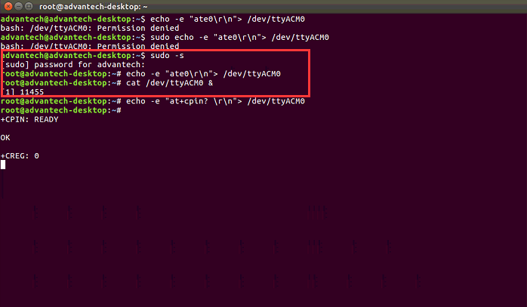
- Install “minicom” application on OS and execute it on terminal (please refer to following instructions)
https://www.poftut.com/install-use-linux-minicom-command-tutorial-examples/
With minicom application, please input AT+XXXX commands directly without other parameters.

Step 2
Make sure the antenna already connect on your module to avoid bad signal quality
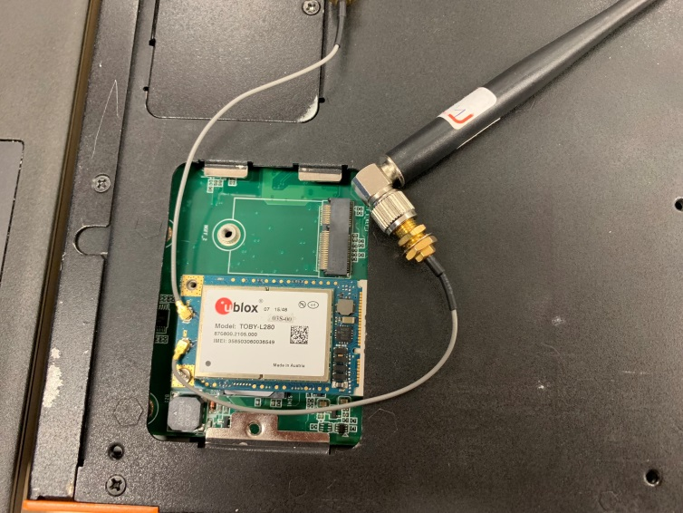
Step 3
Receive module’s response with assigning port number (Notice:there is no need to input following AT commands when using minicom application)
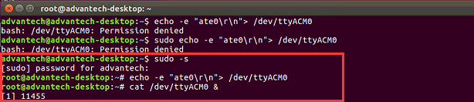
Step 4
Confirm the sim card’s pin code has inputted or not
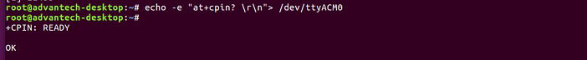
If the the CPIN status is “SIM PIN”, please refer to following command to insert your pin code(modify “0000” section)
The response sim card error may cause by following reasons.
Possible Reason:
- SIM or SIM holder not properly inserted
- Lock of SIM connector is not locked (see SIM card lock feature)
- SIM failure
- defective SIM card reader, lSIM not recognized (5V SIM with a modem/module compatible with 3V SIMs only).

Step 5
Check Network status by “at+cops?” AT command and ensure if get Carrier provider and status
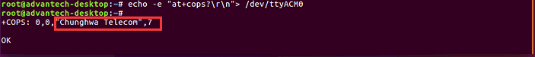
Step 6
Check the carrier provider around your operating platform
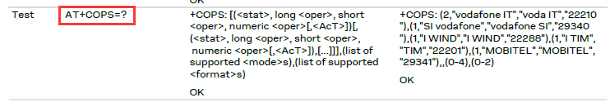
Step 7
Check detail network registration status
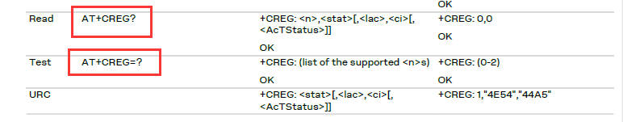
<Defined Value>
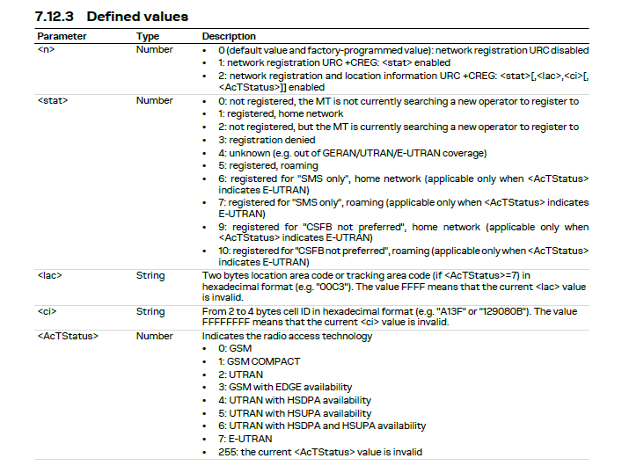
Step 8
Check Cellular signal Quality (the first digit should be higher than 9,otherwise the module may not get ip address from cellular base)
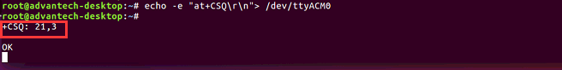
Step 9
Check your APN setting and IP address which already get correct data or not
Step 10
Check current registration if it is already done or not (the registration will be done when the four-last digit is changed to “2”)
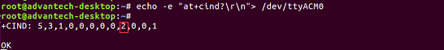
Step 11
If the module response is weird or abnormal, please refer to following commands to reset module for sure
-Firmware reset
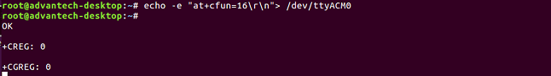
-Factory reset (do software reset to restore factory default setting)

