AIW FAQ
Category | DeviceOn/ePaper | Date | 2021/8/9
Keyword | DeviceOn/ePaper, WISE-3240, EPD-230, EPD-332

- Question:
How to check and export DeviceOn/ePaper log?

- Steps:
Step 1: Login ePaper Manager. The account is root and the password is P@ssw0rd.
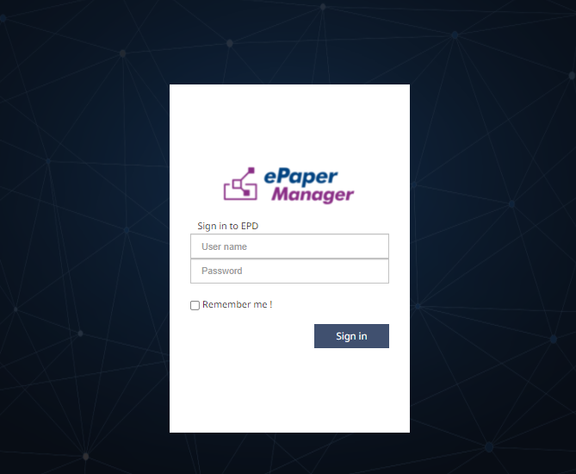
Step 2: After login the ePaper Manager, click “Event”
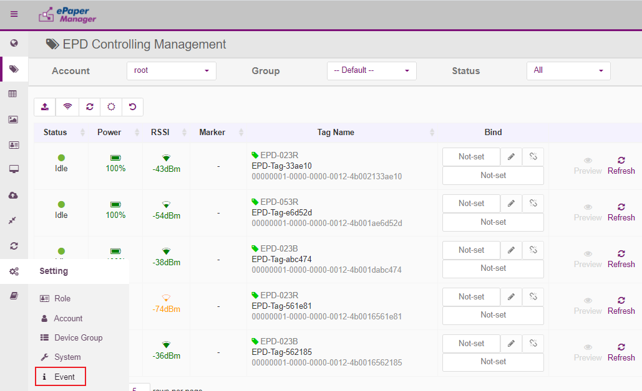
Step 3: Follow the below step to open Extended Message
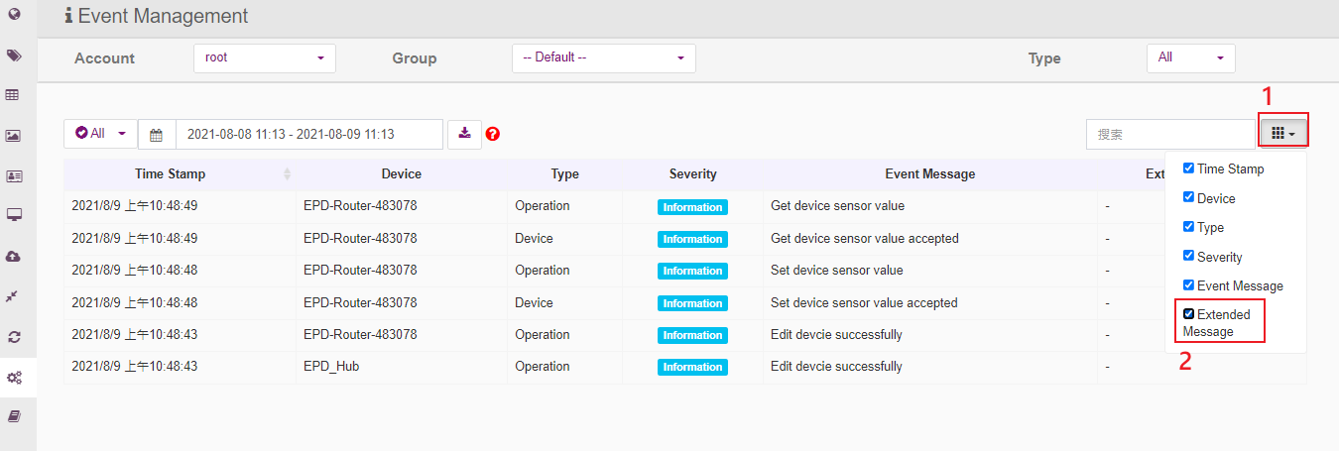
Step 4: Select the period and export the Event log
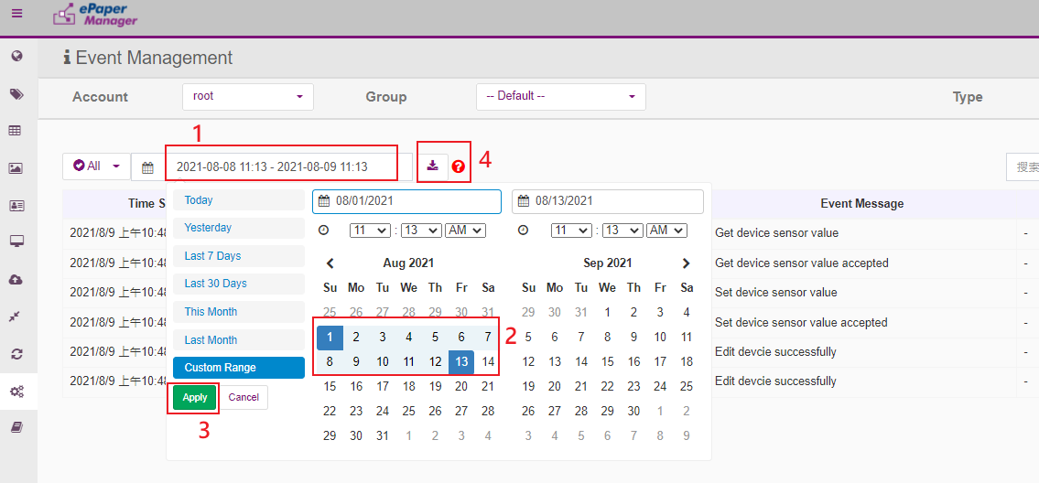
Step 5: Press the below buttons to export server logs
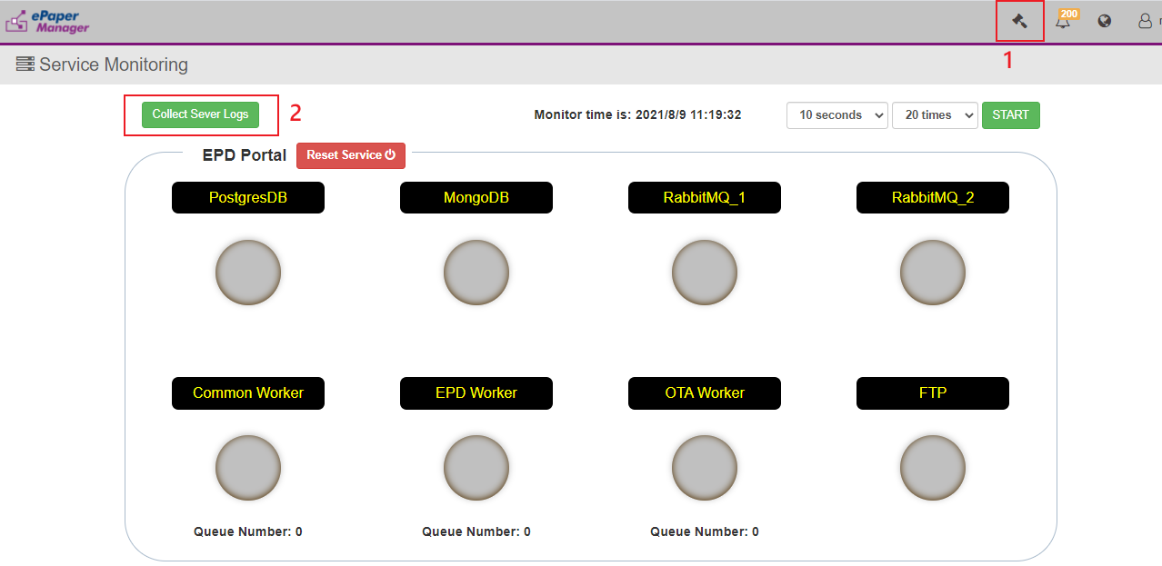
Step 6: Click Yes
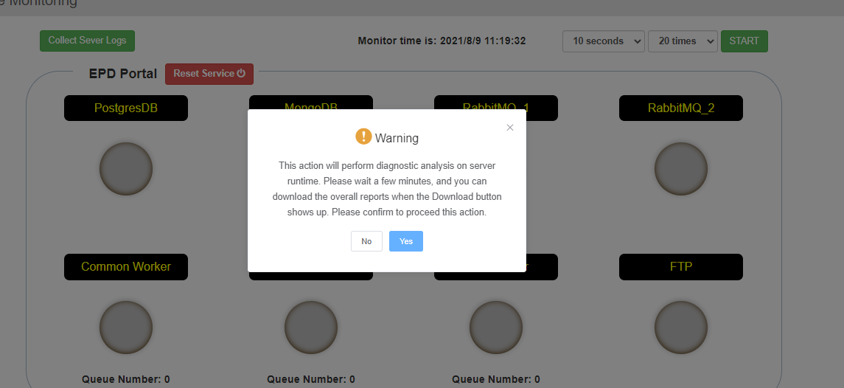
Step 7: Issue the the account and password. The account is advantech and the password is P@ssw0rd.
