How to enable WiFi/Bluetooth with AIW-169

Prerequisite
- RSB-4810 with Debian 10.12 (Linux kernel v4.19.232) on it
- Stop system background daemons by following commands with console utility.
# systemctl stop NetworkManager
# killall wpa_supplicant
- Extract “AIW-169_RSB4810_FW.zip” and copy files to one USB stick and plugged into any one USB port of RSB-4810 platform and follows WiFi/ Bluetooth test steps next.
“AIW-169_RSB4810_FW.zip” includes following files:
- WiFi driver files:
- rtkm.ko
- 8852ce.ko

- Bluetooth driver and firmware files:
- rtk_btusb.ko
- rtl8852cu_config
- rtl8852cu_fw
[* Notes ] WiFi 6GHz is only supported if RSB-4810 kernel 5.4 or above

Test WiFi
- Bring up WiFi driver :
- Bring up WiFi driver with 8852ce.ko if mount USB stick underlying /run/media/sda1 on RSB-4810
# cp /run/media/sda1/*.ko /tmp
# insmod rtkm.ko
# insmod 8852ce.ko
Note: you will see the interface wlan0 by “ifconfig –a” command
# ifconfig wlan0 up

- Test with WiFi AP
- Using editor (such as Vim) to create WiFi client configuration in /etc/wpa_supplicant.conf
(Following is one example as one AP named as “TEST” with pre-shared key
“123456789” for your reference)

# cat /etc/wpa_supplicant.conf
ctrl_interface=/var/run/wpa_supplicant
ctrl_interface_group=0
update_config=1
network={
ssid="TEST"
psk="123456789"
}

# wpa_supplicant -i wlan0 -c /etc/wpa_supplicant.conf -B
# dhclient wlan0

- If AP is configured with internet connection, user can use ping to check the internet availability as follows.
  - Check network connection after obtained IP address
# ping 8.8.8.8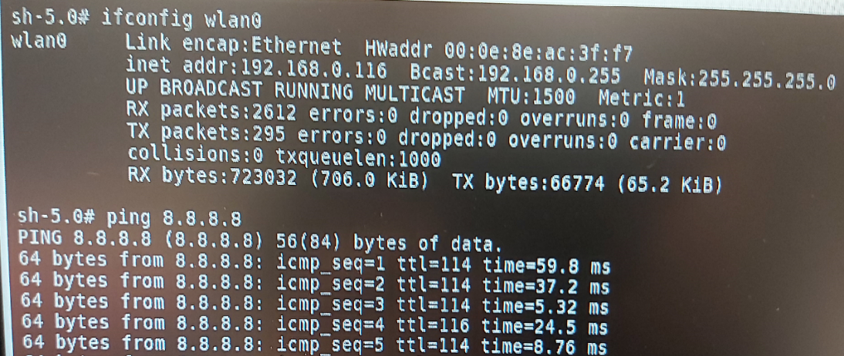

Test Bluetooth
- Bring up Bluetooth Interface
- Bring up Bluetooth driver with follows if have mount USB stick underlying /run/media/sda1 on RSB-4810

# cp /run/media/sda1/rtl8852cu_* /lib/firmware/
# cp /run/media/sda1/rtk_btusb.ko /tmp/
# sudo insmod /tmp/rtk_btusb.ko

Note: you will see the interface hci0 by “hciconfig –a” command

- Test Bluetooth Interface
- Using Bluetooth with following commands
# hciconfig hci0 up
# bluetoothctl
[bluetooth]# scan on
[bluetooth]# scan off
If there are any Bluetooth devices nearby you will see some devices listed by “devices” command as follows.
[bluetooth]# devices

How To Build Driver with RSB-4810 BSP
- Download RSB-4810 BSP with following URL:
http://ess-wiki.advantech.com.tw/view/Linux_BSP_User_Guide_for_rk3568_series_Debian10

- Checkout RK3568_RISC_DIV130035 source code
# cd kernel
# git checkout rk3568_RISC_DIV130035
# make ARCH=arm64 rk3568_adv_defconfig
# make ARCH=arm64 rk3568-rsb4810-a2.img

- Copy driver zipped source file (RTL8852CE_WiFi_linux_v1.19.4.5-0-g285f1de55.20231027_RSB4810.zip) to your BSP build host with USB stick (assumed USB stick is mounted on /run/media/sda1/)
# cp /run/media/sda1/RTL8852CE_WiFi_linux_v1.19.4.5-0-g285f1de55.20231027(131786)_RSB4810.zip /tmp/

- To build Wi-Fi driver (rtkm.ko, 8852ce.ko) as following steps:
# cd RTL8852CE_WiFi_linux_v1.19.4.5-0-g285f1de55.20230127
# sudo make ARCH=arm64 –C /home/adv/BSP/rk3568_linux_risc/kernel M=`pwd` modules

- To build Bluetooth driver (rtk_btusb.ko) as following steps:
# cd 20230413_LINUX_BT_DRIVER_RTL8852C_COEX_v0707/
# sudo make INTERFACE=usb
Notes: Bluetooth firmware (rtl8852cu_fw&rtl8852_config) is available at “rtkbt-firmware/lib/firmware/”

