AIW(EWM) FAQ
Category | AIW | Date | 2023/11/23
Keyword | EWM-W179M201E, driver, EPC-R7200, Ubuntu 18.04.5, kernel 4.9.201-tegra

- Question:
How to insert driver .ko file for EWM-W179M201E on EPC-R7200, Ubuntu 18.04.4 with kernel 4.9.201-tegra?

- Instructions :
Driver .ko package:
EWM-W179_module_for_EPC-R7200.zip

Wi-Fi:
# sudo modprobe cfg80211
# sudo insmod 8852be.ko

Bluetooth:
# sudo cp rt8852bu_config /lib/firmware/
# sudo cp rt8852bu_fw /lib/firmware/
# sudo insmod rtk_btusb.ko

*To make sure that there’re 8852be.ko & rtk_btusb.ko under current path, then we’re able to execute “insmod” command successfully. So first we need to copy both Wi-Fi and BT .ko files to the system and use “cd” command in terminal to move to the corresponding path.

After both Wi-Fi & BT driver are inserted successfully, we can use following commands to double confirm, if there’re something output value returned, then which means that above part is finished.
# lsmod | grep 8852be
# lsmod | grep rtk_btusb

Then using following commands to check separately whether Wi-Fi and BT interface are appearing as expected or not.
-Wi-Fi:
# ifconfig
If there’s something like wlp1s0 or wlan related interface, it means wireless interface is ready and the next step is to test connecting with AP or router directly.
Take following screenshot for example:
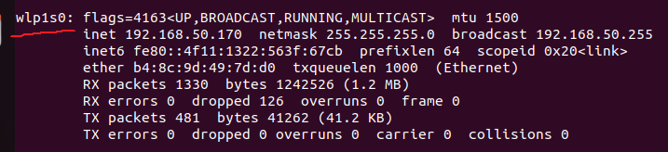
-BT:
# hciconfig -a
If there’s something value returned, it means BT interface is ready and the next step is to test connecting with other BT devices.
Take following screenshot for example:
