SOP of submit issue on Intel Customer Support web site

Web site:
https://customercare.intel.com/?lang=en-US

- Enter your E-Mail Address ( System would send mail info by E-Mail)
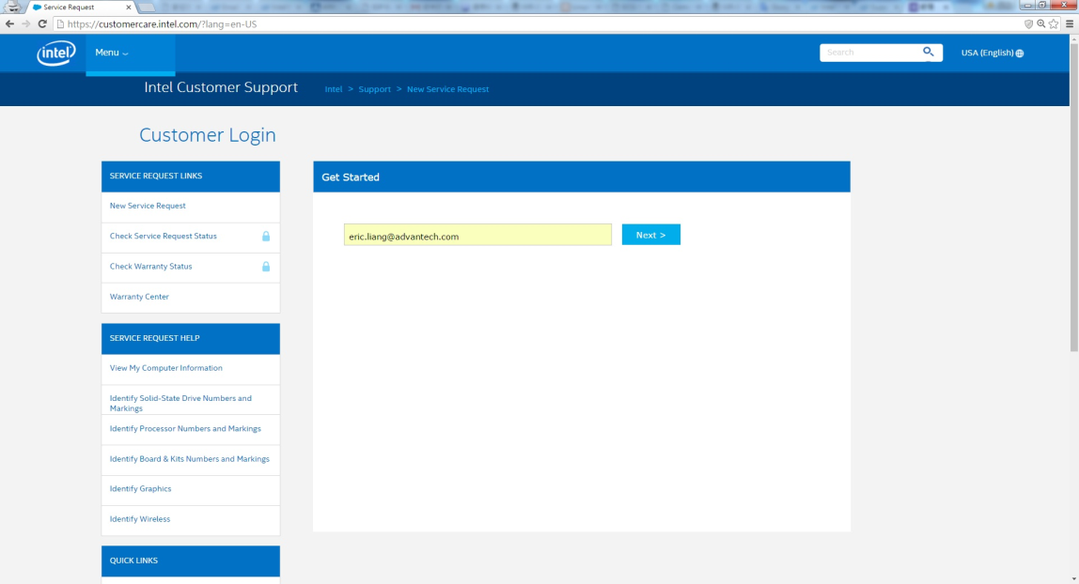

- Skip Sign in to submit your service requests
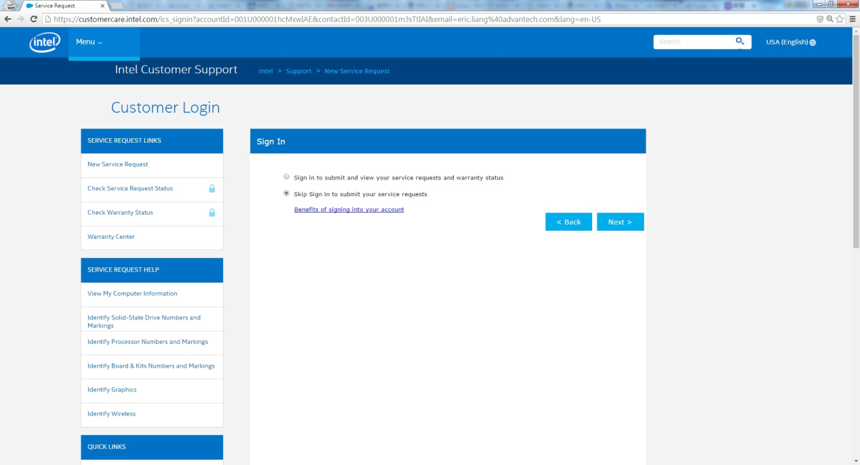
- Choice your product & write your request
Intel IoT Gatweway Pro Pilot Software Suite
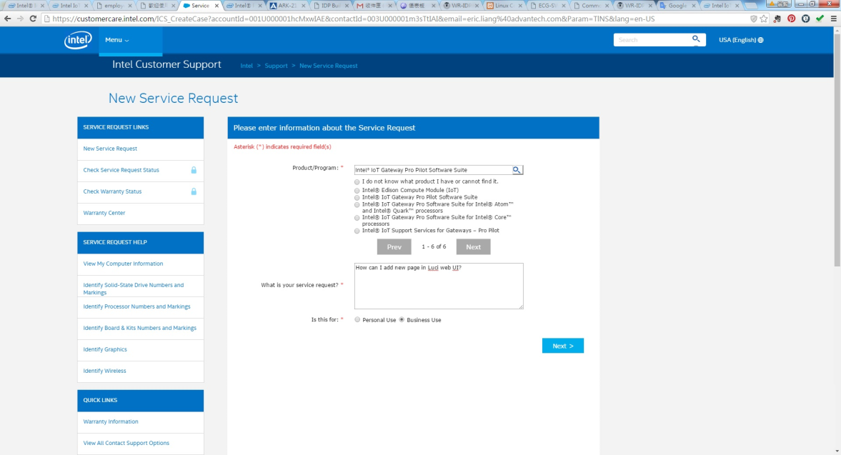

- Enter entitlement# : 799975
Detail Information & Attachment
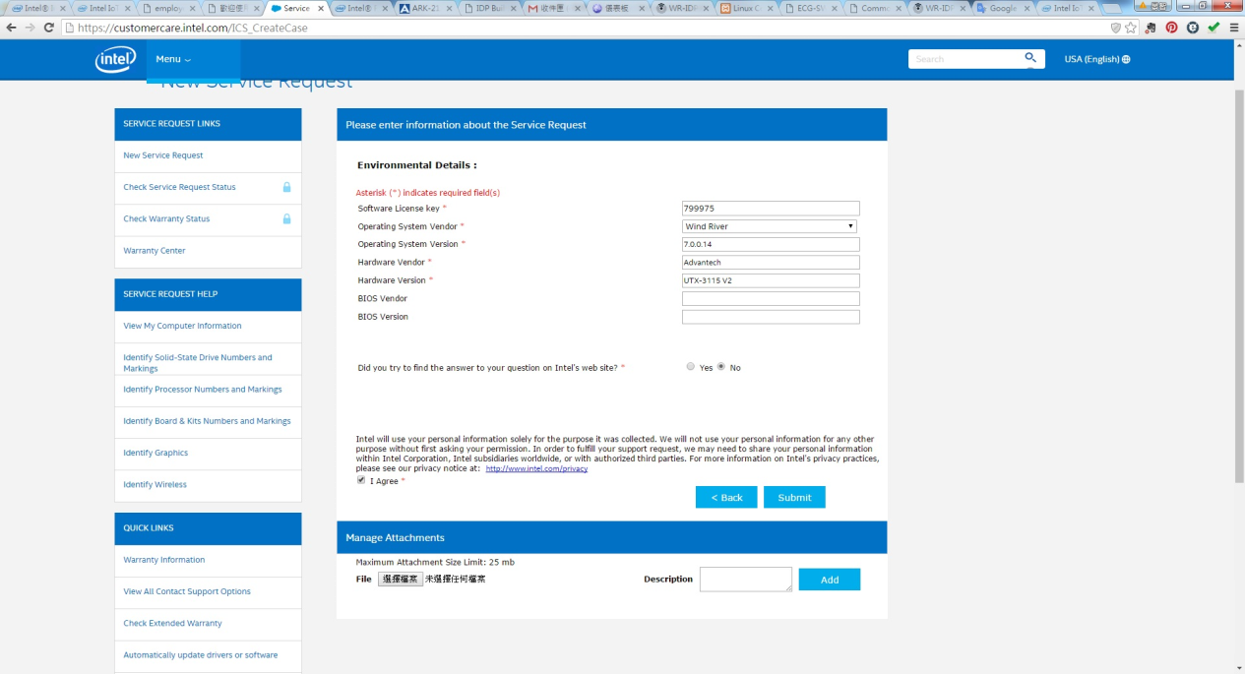

- Complete & Wait Intel’s reply
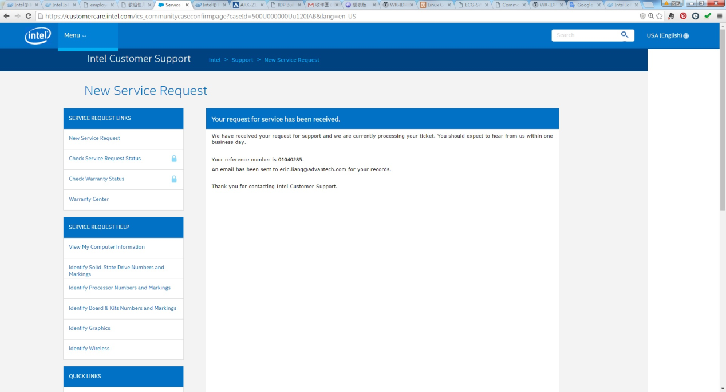

Note: If you want to check your request status. You need login the web site by your account. System will auto create a new account for your e-mail. Default account is the string before “@” of e-mail. (ex: eric.liang@advantech.com -> account is “eric.liang” ). To click forget password to reset then system will send a mail for resetting your password.

