**AIW EPD Deploy Guide**

|  |  |  |  |
| --- | --- | --- | --- |
| **Category** | EPD | **Date** | 20220106 |
| **Keyword** | WISE-3610Z、WISE-1810、EPD-023、EPD-053 | | |

* **Introduction**

Because of the wireless signal is invisible, we have to do site survey before deploy the EPD system. There are many factors that affect wireless signals. The major effect is in the different field the occupy frequency is different. All objects made of metal in the field will affect the direction of radio wave reflection. This document will tell you what do you need to do in the site survey.

* **Hardware Requirement:**

1. WISE-3240
2. ARK-2250 or ARK-1123
3. More than 6 EPD-230
4. Spectrum Analysis tool

* **Instructurment**

**WISE-3240 field estimate.**

When you want to deploy WISE-3240 in the field, you have to know below information.

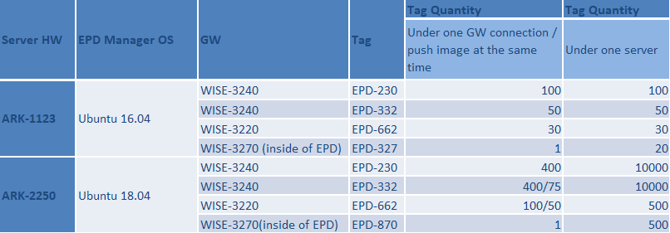

Three dimensional radiation pattern of the antenna

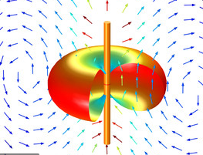

No signal

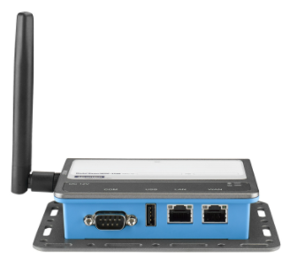

Strong

Strong

No signal

Following I will demo how to estimate the WISE-3240 and EPD-230 deployment position.

Step1. Check 2.4GHz RF environment



Open “Channel Select User” and follow the step to do configuration.

By using RF Explorer tool, you will know which channel is suitable for deployment.

Example:

After you finish the configuration, you will see the analysis result as below.

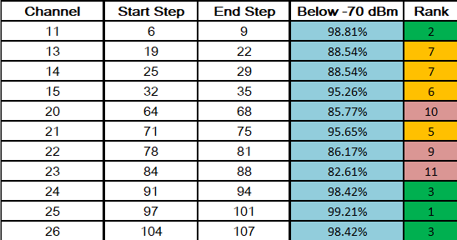Please select the channel which the “Rank” is green. You can select channel 11,24,25 or 26. Normally a clean channel can deploy two GWs.

You can change GW transmit frequency by using ePaper Manager. Please follow below steps.

Step 1.1:

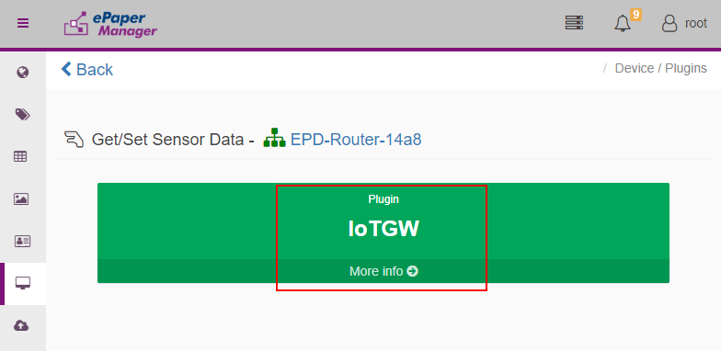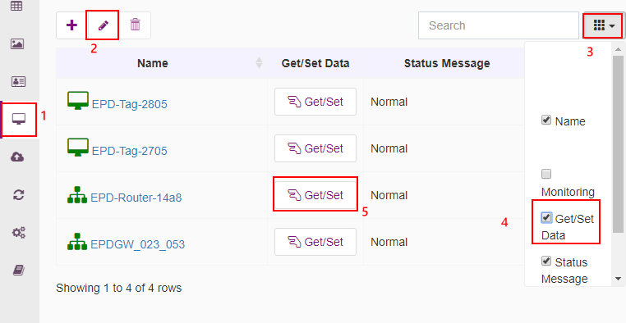Step 1.2:

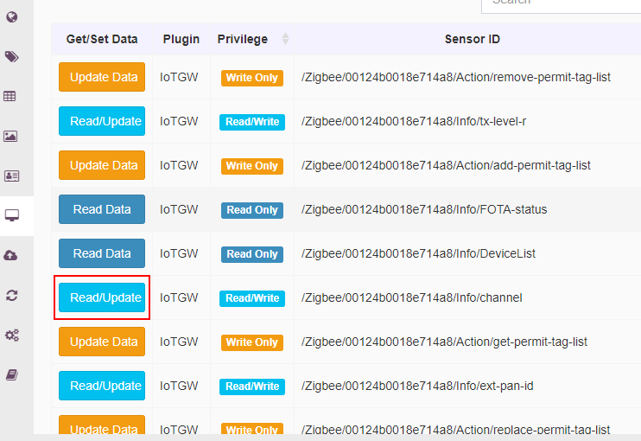Step 1.3:

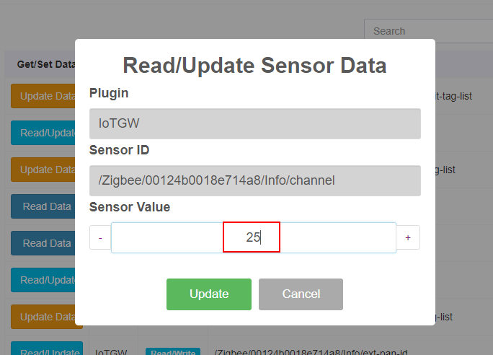Step 1.4: Change the channel value

Step2. Deploy EPD-230 in the Field.

Normally, you can place the EPD device anywhere. But how to make all EPD devices online stably? Is our main consideration. Some people think that the stronger the signal, the better, but we have to evaluate that all EPD devices in the field are online. Therefore, the RSSI of all EPD devices need to be greater than -70 dBm. If the RSSI of an electronic paper is lower than -70 dBm, then that device will easily offline.

Before you deploy the EPD device in the field, you should have a floor plan. It will help you to know how many WISE-3240 should be in the deployment field.

Step3. Choose WISE-3240 deploy position.

After tags location are decide, you have to choose the WISE-3240 deploy position.

In the different fields, the WISE-3240 position will affect the tag receive the wireless signal. This document will show some samples as below.

Case 1:

Application field:

In the small warehouse, all tags will in the small region (Ex. More than 400 tags within a radius of 20 meters). The Shelf material is metal and it will cause serious interference. In the field, we recommend all tags are deployed around GW. Please reference below picture. In this example, a GW connects around 400 tags.

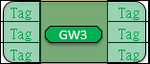

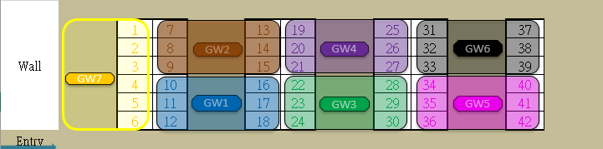The following picture is in the real field deployment (Floor plan).

Case 2:

If the warehouse is wide, we have to estimate the number of connection tags and avoid across metal or cement shelters. In the following picture, I will show how to deploy in the wide warehouse.

First, we must determine the area that includes the least shadow deployment and calculate how many tags will be in that area.

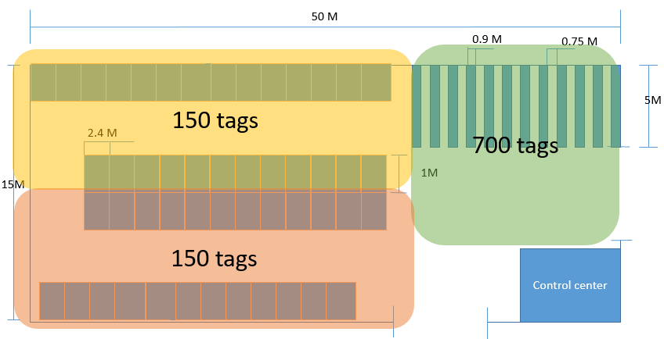In the following picture, I separate three regions and I will estimate how many GWs will deploy in each area.

A WISE-3240 support 400 tags. If there are less than 400 tags in a field, please deploy WISE-3240 near the center of the field. You can reference yellow and orange region. In the green region, there are 700 tags in the field so we have to deploy two WISE-3240. Because of there are many metal shelters, the GW in the field will be slightly away from the metal shield. If you deploy GW between shelves, the wireless signal will have interference. Please reference below picture.

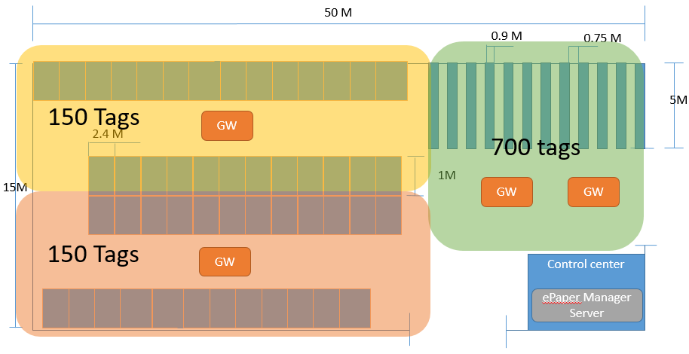Case 3.

In meeting room applications, since the number of tags is mostly less than 400, only the communication distance of the router needs to be considered. The evaluation method is the maximum number of tags that can be included in the transmission distance. In addition, there will be steel beams indoors, which should be avoided when deployment WISE-3240.

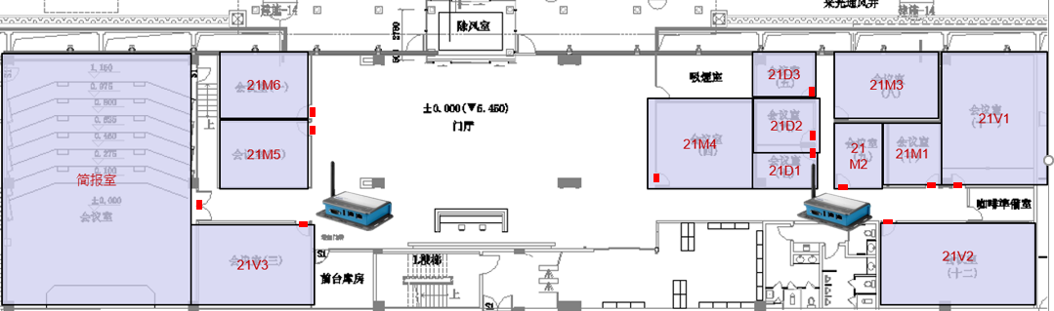

Step4. Check the tags RSSI and test flash image. If the transition image is successful, we can know the interference is weak. If the transition image is fail, we have to change WISE-3240 deployment position or modify the direction of WISE-3240 antenna.

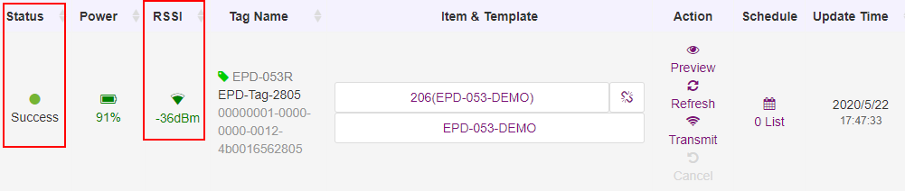

Step5. Check WISE-3240 antenna direction.

Position 1. WISE-3240 is on the ceiling.

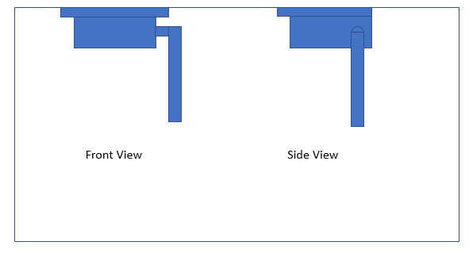

If the signal RSSI is still not good, please modify the antenna as below.

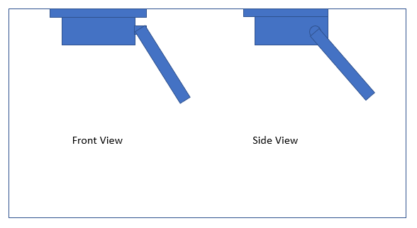

Position 2. WISE-3240 is on the high platform

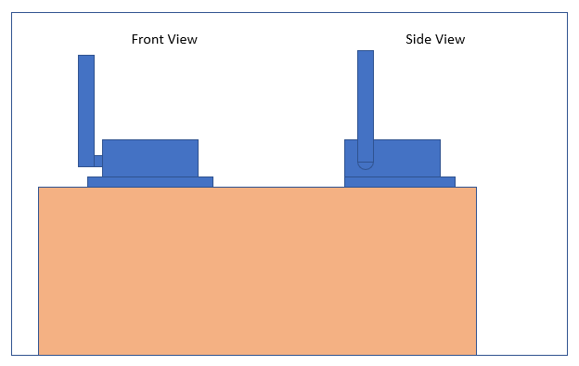

If the signal RSSI is still not good, please modify the antenna as below.

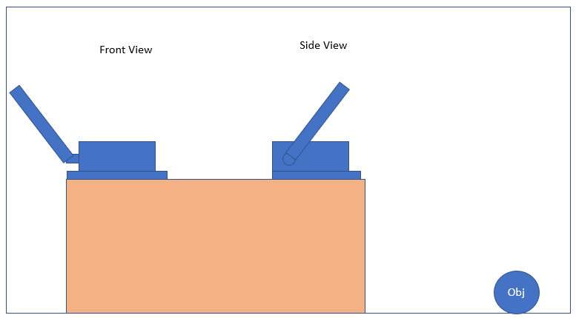

Appendix:

**Item Data design**

In the DeviceOn/ePaper, item data has some rule. When you design the item data, the first column has to be unique in every table.

Normally, the customer only put the data which show on the EPD device. We recommend the customer can add more information in the table. For example, the customer can add the tag mac and location in the table. It will easier to find the tag location.

