How to enable WiFi/Bluetooth with AP6275P
Prerequisite
- Host PC and setup Windows10 on it
- If the user need to porting driver and rebuild kernel, please prepare another host PC that has SSD with a storage capacity of at least 512 GB and setup Ubuntu 20.04 on it
- Programming tool and driver
- RSB-3710
- For setup terminal, need an USB to RS232 cable between the debug port and Host Windows PC.
- For programming tool, need an USB cable between the Micro USB connector and Host Windows PC.
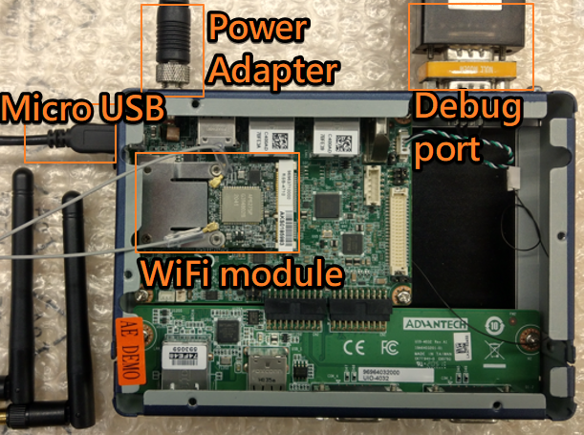

Setup terminal
- UART connection will appear in device manager on the PC
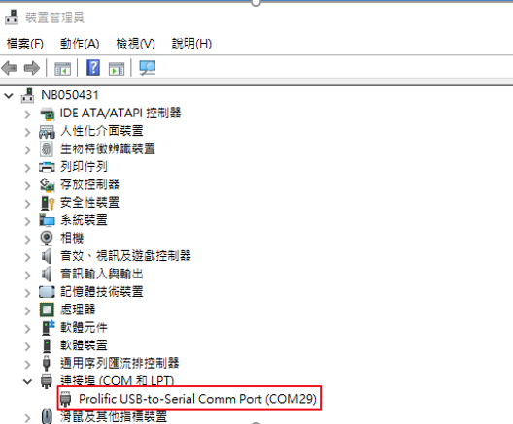

- Open the terminal window (e.g., Tera Term), choose the COM port number and apply the following configuration
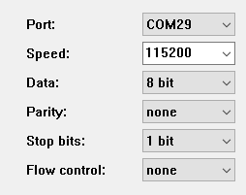

- The user will see the snapshot as below after booting.
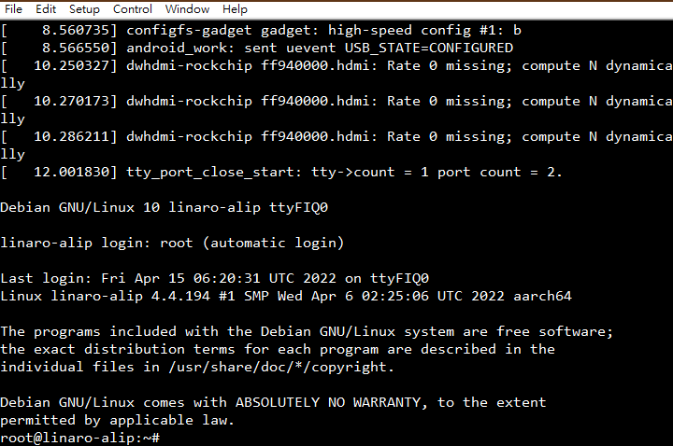

Programming for Kernel Image
- Install driver for programming tool
Please run the installer “DriverInstall.exe” after extract the file “DriverAssitant_v5.0.zip” and follow the prompt to install driver.
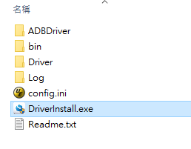

- Programming for kernel
- Power on RSB-3710 and get into u-boot
Press “Ctrl + C” while u-boot booting
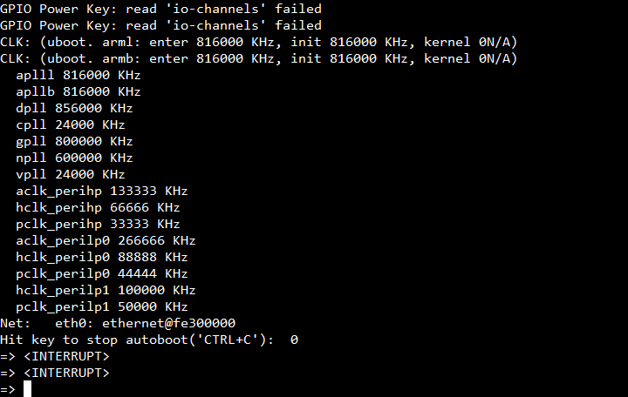

Input the string “rbrom”, then press the enter
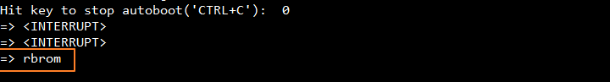

- Extract the file “RSB3710A2AIM20DIV251013_2021-04-15.zip” and run the programming tool
Select the folder “RKDevTool_Release”, then double click on “RKDevTool.exe”.

- Programming for kernel
  - Check the device is detected or not
  - Select loader and boot (kernel image)
  - Start to run the tool
  - Check the result
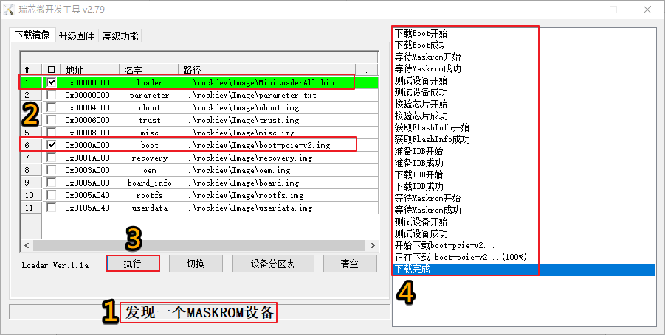

Copy Driver and Firmware to System

- Copy the tarball file “ap6275p_rs3710_eXX.tar.bz2” to USB storage on Windows host PC.

- Rename with the original driver
# cd /system/lib/modules
# mv bcmdhd.ko bcmdhd.ko.orig
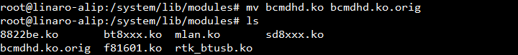

- Create the specified directory for firmware
# mkdir /lib/firmware/bcmdhd

- Plug the USB storage into RSB-3710
After plug the USB storage in, you will see the snapshot

Use fdisk command to double confirm the information related to USB storage
# fdisk -l
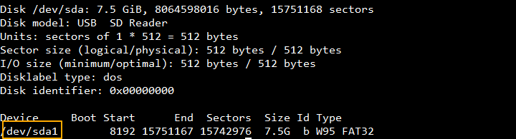

Use mount command to load USB storage into system
# mount /dev/sda1 /mnt

# ls /mnt
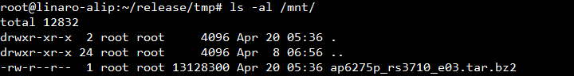

- Decompress the tarball “ap6275p_rs3710_eXX.tar.bz2” to system
# mkdir ~/ap6275p
# cd ~/ap6275p
# tar jxvf /mnt/ap6275p_rs3710_eXX.tar.bz2
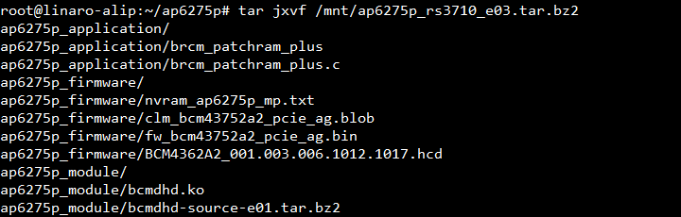

- Copy the file “bcmdhd.ko” to “modules” directory
# cp ~/ap6275p/ap6275p_module/bcmdhd.ko /system/lib/modules
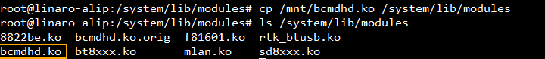

- Copy the firmware files to “bcmdhd” directory
# cp ~/ap6275p/ap6275p_firmware/BCMxxx.hcd /lib/firmware/bcmdhd
# cp ~/ap6275p/ap6275p_firmware/fw_bcmxxx_pcie_ag.bin /lib/firmware/bcmdhd
# cp ~/ap6275pap6275p_firmware/clm_bcmxxx_pcie_ag.blob /lib/firmware/bcmdhd
# cp ~/ap6275p/ap6275p_firmware/nvram_ap6275p_mp.txt /lib/firmware/bcmdhd
# ls /lib/firmware/bcmdhd
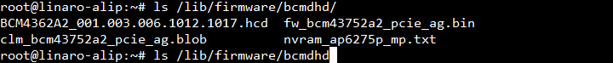

Test

WiFi
- Stop wpa_supplicant service
# systemctl stop wpa_supplicant.service

- Create configuration
# echo "ctrl_interface=/run/wpa_supplicant"> /tmp/wpa.conf
# echo "update_config=1" >> /tmp/wpa.conf
# wpa_passphrase "XX" YY >> /tmp/wpa.conf
Note: XX: SSID, YY: Password

- Enable WiFi and check interface
# sudo rfkill unblock wifi
# sudo iwconfig
Note: you will see the interface like wlan0

- Running wpa_supplicant
# wpa_supplicant -d -B -i wlan0 -c /tmp/wpa.conf

- Get IP address by DHCP and check network connection
# dhclient wlan0
# ping -c 3 8.8.8.8

Bluetooth
- Enable Bluetooth
# ~/ap6275p/brcm_patchram_plus -d --enable_hci --no2bytes --tosleep 200000 --baudrate 2000000 --patchram /lib/firmware/bcmdhd/BCM4362A2_001.003.006.1012.1017.hcd /dev/ttyUSB0 &
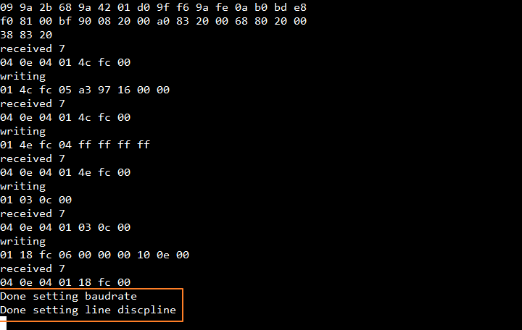

- Check interface of bluetooth
# hciconfig
Note: you will see the interface like hciX
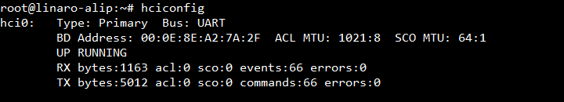

- Turn on/off scan
# bluetoothctl scan on
# bluetoothctl scan off
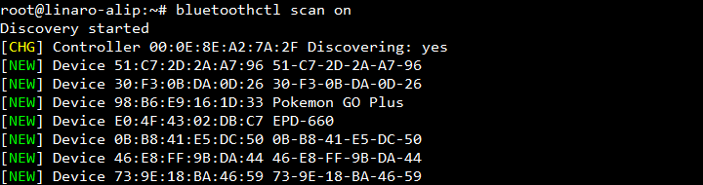

How to Porting Driver to Kernel for RK3399 BSP
- Create RK3399 BSP development environment
Please refer to the below link to create development environment
http://ess-wiki.advantech.com.tw/view/Debian_BSP_User_Guide_for_rk3399_risc_series

- Copy driver source to kernel source tree
Decompress the bcmdhd driver tarball and put it to kernel source tree
- Change to directory as below
# cd /the_path_to_kernel/drivers/net/wireless/rockchip_wlan/rkwifi
- Rename the original driver
# mv bcmdhd bcmdhd.orig
- Decompress the driver tarball
# tar jxvf /the_path_to_driver_tarball/bcmdhd_eXX.tar.bz2

- Modify Kconfig to add bcmdhd driver
Add string
[source "drivers/net/wireless/rockchip_wlan/rkwifi/bcmdhd/Kconfig"] to Kconfig file “/the_path_to_kernel/drivers/net/wireless/rockchip_wlan/rkwifi/Kconfig”
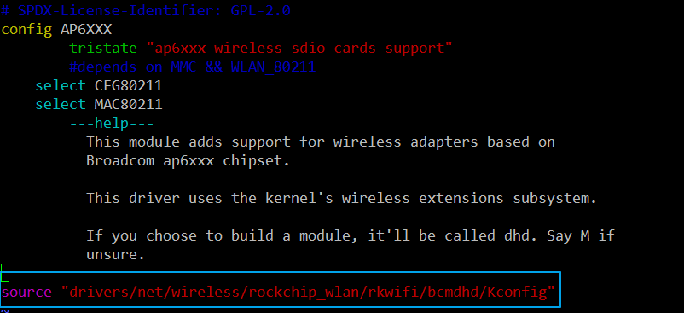

- Make kernel configuration
Get into menuconfig menu
# make ARCH=arm64 menuconfig

- Select [ Device Drivers ---> Network device support ---> Wireless LAN ---> Rockchip Wireless LAN support]
- Enable [Broadcom FullMAC wireless cards support] as module
- Input the path of firmware as below
    - /lib/firmware/bcmdhd/fw_bcm43752a2_pcie_ag.bin
    - /lib/firmware/bcmdhd/nvram_ap6275p_mp.txt
- Save configuration and exit the menu
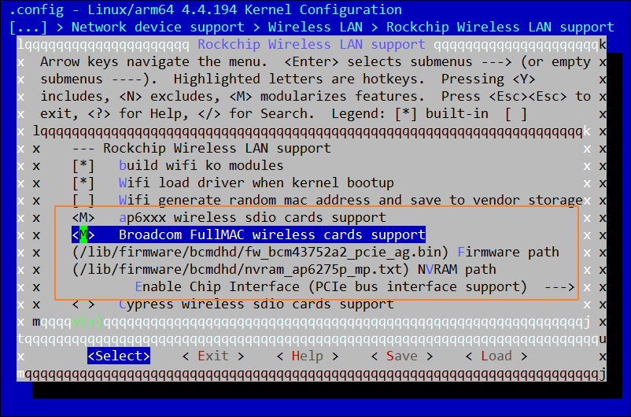

- Rebuild kernel
# make ARCH=arm64 rk3399-rsb3710-a2.img

After that, the boot.img will be outputted in current directory.

