**How to Setup Network with AIW-343**

**on Ubuntu**

**Prerequisite**

* PC and setup Ubuntu 20.04 on it
* Tarball file “aiw-343-peer-config.tar.bz2”

**Network Test**

* Stop modem manager

# sudo service ModemManager stop

* Copy configuration file

decompress the tarball “aiw-343-peer-config.tar.bz2”

# tar jxvf “aiw-343-peer-config.tar.bz2”

Copy all files to /etc/ppp/peers

# sudo cp aiw-343-peer-config/* /etc/ppp/peers/

* Open the file “aiw-343-chat” and modify the APN

# sudo vi /etc/ppp/peers/aiw-343-chat

To fill the string of your APN in the below red rectangle.

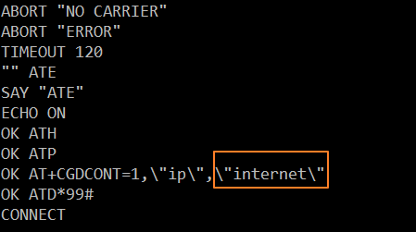

* Dial out

# sudo pppd call aiw-343 &



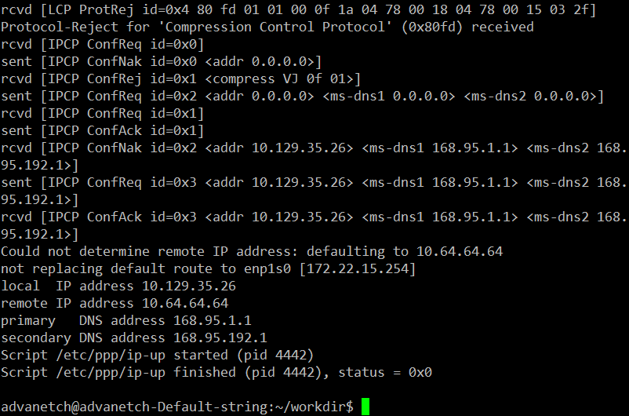

* Check network connection

# ping -c 3 -I ppp0 8.8.8.8

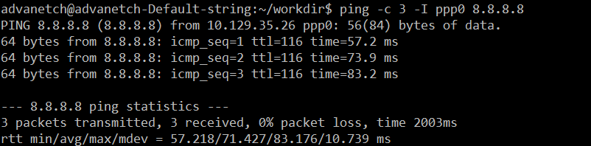

**GNSS Test**

1. First, please follow the below commands to install gpsd package before GNSS test.

# sudo apt-get update

# sudo apt-get install gpsd

# sudo apt-get install gpsd-clients

To stop/disable gpsd as default by below commands

# sudo systemctl stop gpsd

# sudo systemctl disable gpsd

# sudo systemctl stop gpsd.socket

1. Steps to test with GNSS

* Start to run minicom and select the “Serial port setup”

# sudo minicom -s

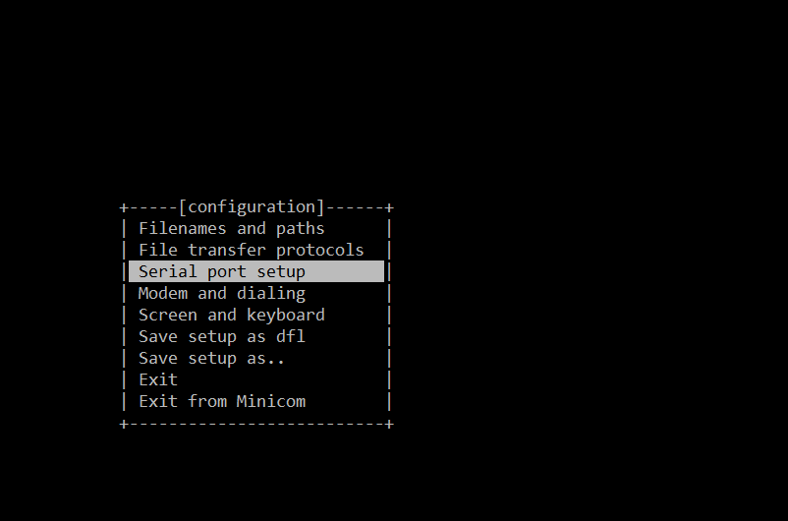

* Please set serial setting as below screenshot.

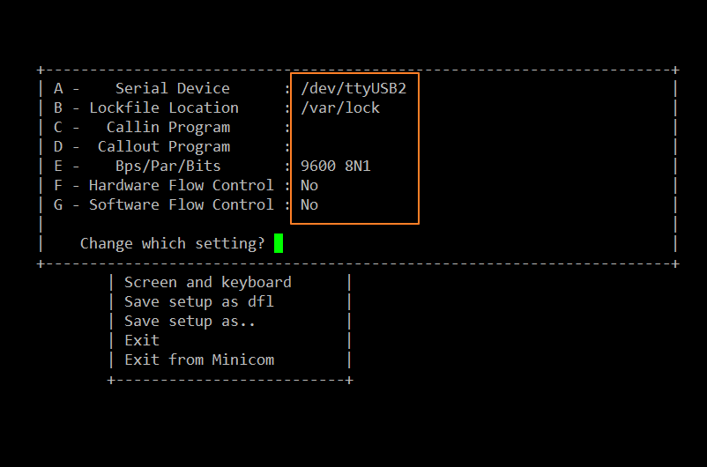

* Exit the setting and get into minicom console.

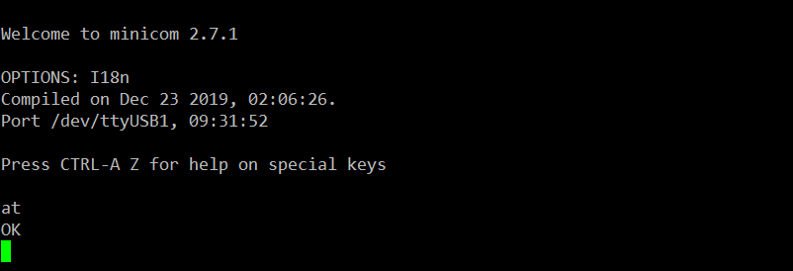

* Setting with GNSS in minicom
  + Set to support active antenna

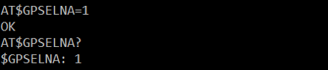

* + Set to GNSS_ALL (gps+glonass+galileo+beidou)

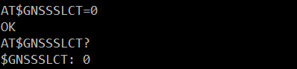

* + Set unsolicited NMEA Data Configuration

For GPS、Galileo and Beidou

AT$GPSNMUN=1,0,0,1,1,1,0

AT$GPSNMUNEX=1,1,0,0,1,1,1,1,0

For GLONASS

AT$GPSNMUN=1,0,0,1,1,1,0

AT$GPSNMUNEX=1,1,1,0,0,0,0,0,0

* + Start GNSS positioning session

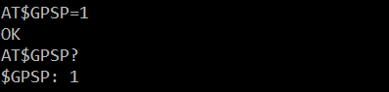

* Begin to run gpsd

# sudo gpsd -n /dev/ttyUSB1

gpsd is running in debug mode if needed.

# sudo gpsd -D 5 -N -n /dev/ttyUSB1

* Get longitude and latitude

# cgps

