How to Setup Network with AIW-342
Prerequisite
- MIO-5373 and setup Windows 10 on it

Install Driver
- Device driver
Please run the installer “TelitWHQLDriversxXX.msi” after extract the file “Telit_Windows_10_WHQL_Drivers_Installer_2.09.0002.zip” and follow the prompt to install driver.

- AT command utility
Please run the installer “Setup_TATC_3.3.1__XFP_3.2.2.msi” after extract the file “Telit_AT_Controller_r3.3.1_XFP_3.2.2.zip” and follow the prompt to install utility.

Check Device
After driver installed, you will see the snapshot as below.
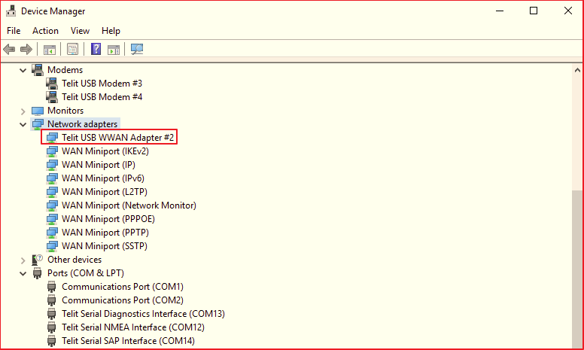

Function Test
- Speed test
This is only for reference.
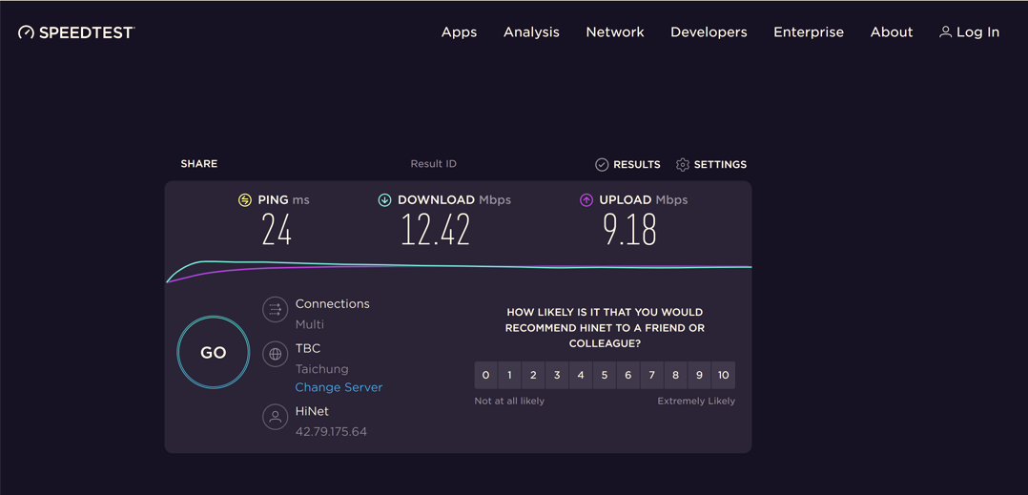

- Reliability
Observe the ping test at least 6 hours.

- AT command
Open the “Telit AT Controller” utility and setting as below, then input the AT command to test.
