|  |
| --- |
| **Press-Release-Template**2010-Logo-with-Slogan  **[AIW-Tool]**  **Driver and Tool**  Released Version:V1.0.02  Released Date: 2021.09.24 |

**Advantech Co., Ltd.**

**Version History**

|  |  |  |  |
| --- | --- | --- | --- |
| Date | Version | Part no | Remark |
| 2021-06-10 | 1.0.00 | Will Chen | Initial Release |
| 2021-07-16 | 1.0.01 | Will Chen | Add Monitor and Log in AIW-tool chapter |
| 2021-09-24 | 1.0.02 | Will Chen | Modification to support multi-module |
|  |  |  |  |
|  |  |  |  |
|  |  |  |  |

**Table of Contents**

1. Introduction 4

2. Prerequisites 5

3. Source Tree 6

4. Setup 7

5. AIW Tool 11

6. GPS test 13

# Introduction

This document is used for AIW 4G/5G module. There are two topics we prepare for user included driver and tool. For the driver, the user can learn how to install it to make AIW module ready to work. For the tool, we can use it to communicate with AIW module, and the user can use it to get information form AIW module or set configuration to AIW module.

# Prerequisites

Please prepare your platform and install OS on it. The below is the information about that.

* OS：Ubuntu 20.04.1 LTS。

We expect the user install Ubuntu 20.04.1 with normal installation.

* Platform：UNO-137

We have verified the tool and it’s workable on UNO-137 this moment.

* Ethernet

Please make sure the platform has capability to connect to internet by Ethernet during setup procedure. After install Ubuntu OS, it will obtain IP address through DHCP as default.

# Source Tree

The user can find out the source tree as below after the file “AiwTool_XXX.tar.bz2” is extracted.

|  |  |
| --- | --- |
| **Directory** | **Description** |
| driver/ | Driver and some scripts for setup |
| tool/ | Some scripts used for module |
| template/ | Some templates of scripts |
| version | The file of version |

# Setup

The user can find out the script “setup.sh” in the driver folder that can executed to setup and install driver. The “setup.sh” will help user to install some packages, build driver automatically and it provides interactive interface to prompt user what information needed to fill in. We have another script “dialout.sh” in the driver folder. It’s used to dial out to establish connection. If setup done and all setting are correct, the module will obtain IP address automatically by “dialout.sh” while system booting. By the way, the user can run “dialout.sh” to dial out manually and check out whether obtain IP address or not by Linux command “ifconfig’ in Ubuntu.

First please open the terminal on Ubuntu or third party tool such as putty or teraterm that can used to connect to the platform by SSH protocol, then we can run both scripts on terminal.

* Setup

You will see the screenshot as below while you run the command：

$ cd /the_path_to_AiwTool_xxx/driver

$ sudo ./setup.sh

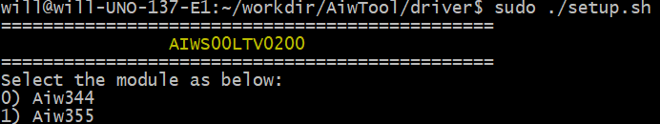

Choose the model name

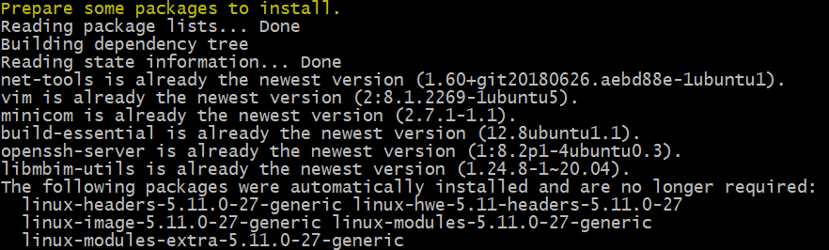

Install some packages

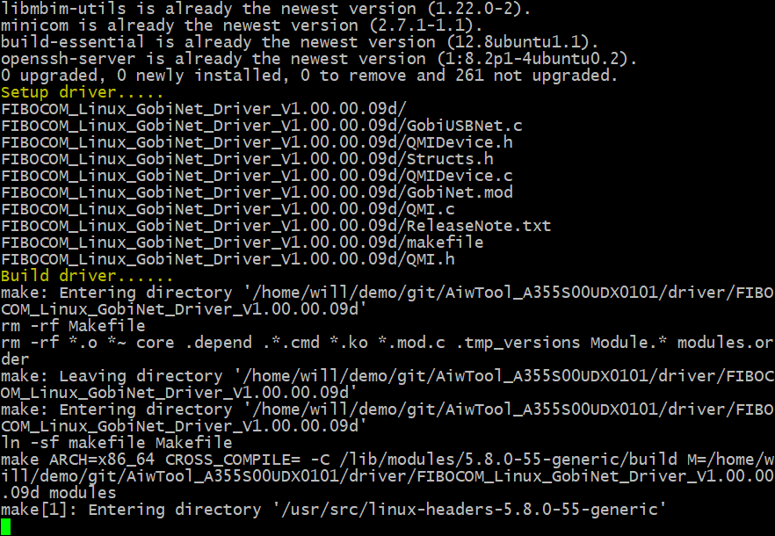

Build driver

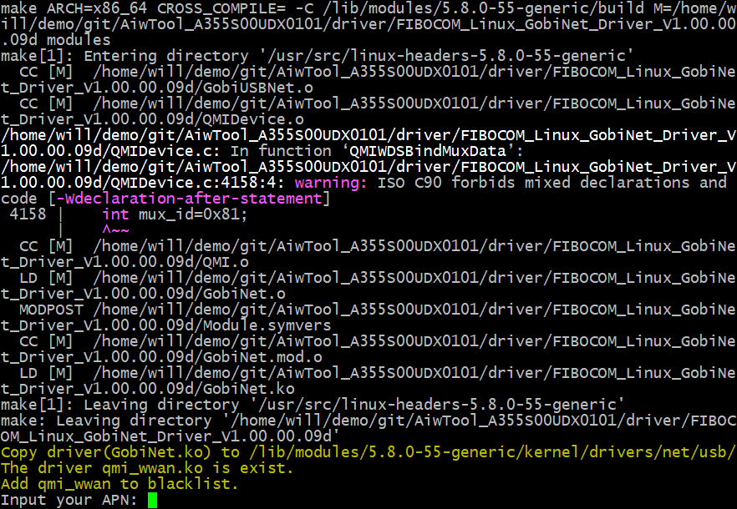

Prompt user to fill in some information

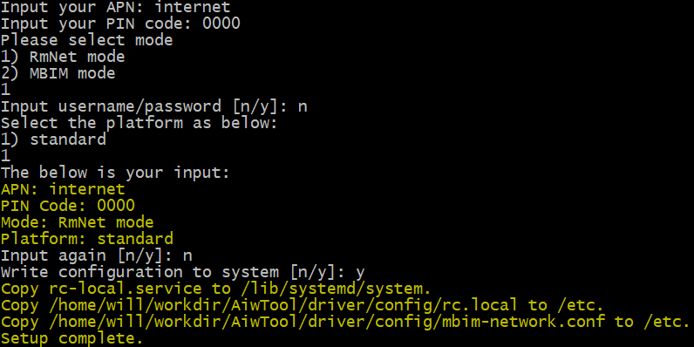

Setup complete

* Dial out to establish connection

You will see the screenshot as below while you run the command：

$ cd /the_path_to_AiwTool_xxx/driver

$ sudo ./dialout.sh

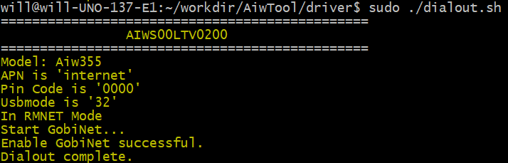

Dial out complete

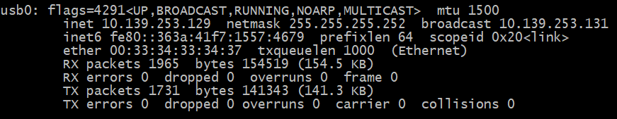

Check IP address by ifconfig

* Disconnection

Please run the command：

$ cd /the_path_to_AiwTool_xxx/driver

$ sudo ./dialout.sh stop

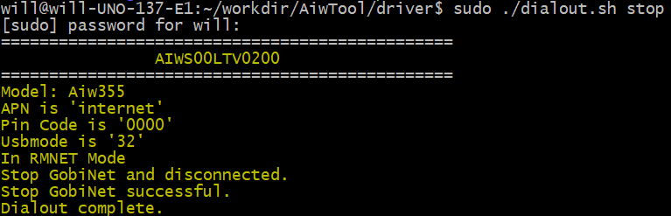

# AIW Tool

The script “tool.sh” provides command set that has the unified interface to communicate with module. The user can use “tool.sh” to set configuration for connection such as APN, PIN, etc. and get information such as reversion, signal strength, etc.

The user can run the command to check out what command are supported：

$ cd /the_path_to_AiwTool_xxx/tool

$ sudo ./tool.sh

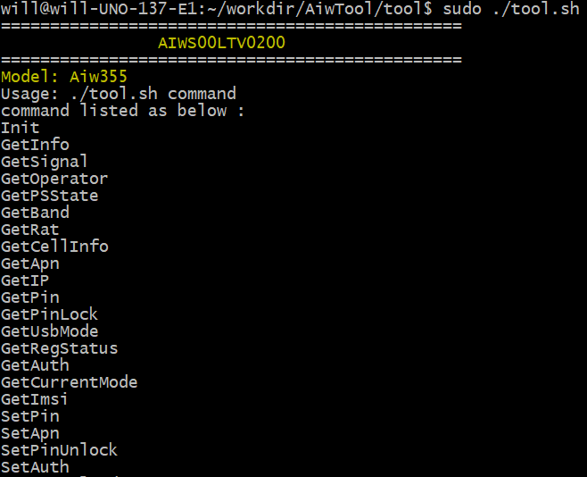

For example, the user can get revision by command “GetInfo”.

$ sudo ./tool.sh GetInfo

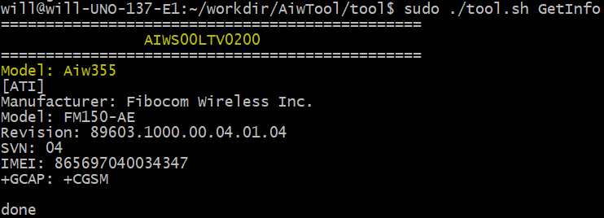

5.1 Monitor

The “monitor.sh” in source tree has been running automatically while booting after setup done by “setup.sh”. It aim to check IP address whether is exist or not. If not obtained IP address, it will try to reconnect to telecom and update IP address. The user can refer to below commands for how to control with “monitor.sh”。

* Enable monitor

$ sudo ./tool.sh EnableMonitor

* Disable monitor

$ sudo ./tool.sh DisableMonitor

5.2 Log

The user can set log level to decide to enable/disable log. The log file “/tmp/monitor.log” will be outputted when log level greater than 0。

* Set log level

$ sudo ./tool.sh SetLogLevel 1

* Disable log

$ sudo ./tool.sh SetLogLevel 0

# GPS test

6.1 Setting with minicom

* Start to run minicom and select the “Serial port setup”

$ sudo minicom -s

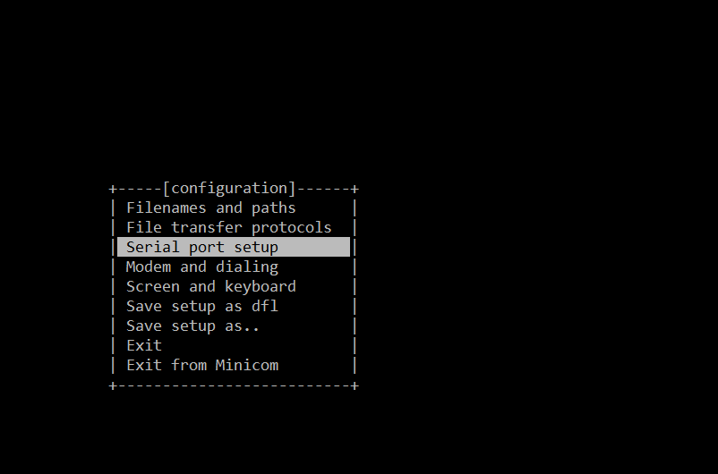

* Please set serial setting as below screenshot.

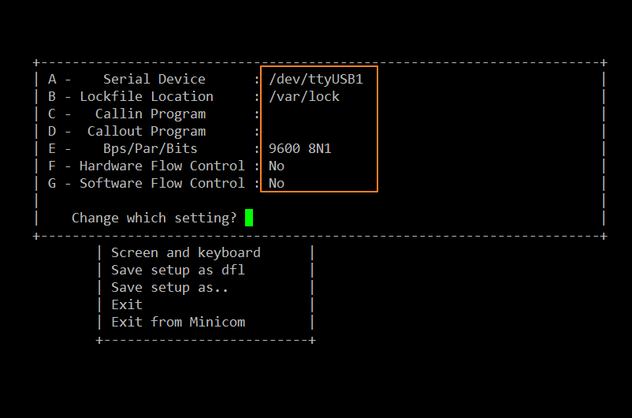

* Exit the setting and get into minicom console.

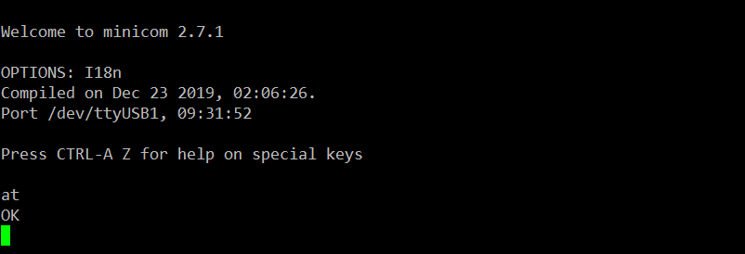

6.2 GPS test

Please follow the below commands to input by AT command on the terminal.

Noted that please use passive antenna on AIW-344.

1. Set supl server and port

at+gtagpsserv="supl.qxwz.com",7276

1. Set supl version

at+gtgpscfg=0,1

1. Check APN setting, there should be a correct APN

at+cgdcont?

1. Check the device attach to network

at+cops?



1. Enable AGPS.

at+gtgpsepo=1

1. Start GPS.

at+gtgpspower=1

1. at+gtgps?

Get longitude and latitude by checking NMEA data.

Noted that please waiting for 3 minutes for sync.

