AIW(EWM) FAQ
Category | AIW | Date | 2022/09/08
Keyword | AIW-163, EWM-W179M201E, driver, Ubuntu 22.04, kernel 5.15

- Question:
How to install AIW-163, EWM-W179M201E driver on Ubuntu 22.04 with kernel 5.15?

- Instructions :
- Download the driver package via below link.
RTL8852BE_WiFi_linux_v1.15.10.0.5-0(71904).7z
- Unzip the .7z file with below command.
# 7z x RTL8852BE_WiFi_linux_v1.15.10.0.5-0(71904).7z
- Access to “WiFi” folder, then decompress .tar.gz file with below command.
# tar zxvf RTL8852BE_WiFi_linux_v1.15.10.0.5-0-gfa2af07cf.20220503.tar.gz
- Access to “RTL8852BE_WiFi_linux_v1.15.10.0.5-0-gfa2af07cf.20220503” folder.
- Access to “driver” folder, then decompress .tar.gz file with below command.
# tar zxvf rtl8852BE_WiFi_linux_v1.15.10.0.5-0-gfa2af07cf.20220503.tar.gz
- Access to “rtl8852BE_WiFi_linux_v1.15.10.0.5-0-gfa2af07cf.20220503” folder.
- Access to “core” folder and try to edit “rtw_br_ext.c”.
Modify KERNEL_VERSION(5, 17, 0) to KERNEL_VERSIONS(5, 15, 0) as below screenshots. There’re two places required to be modified.

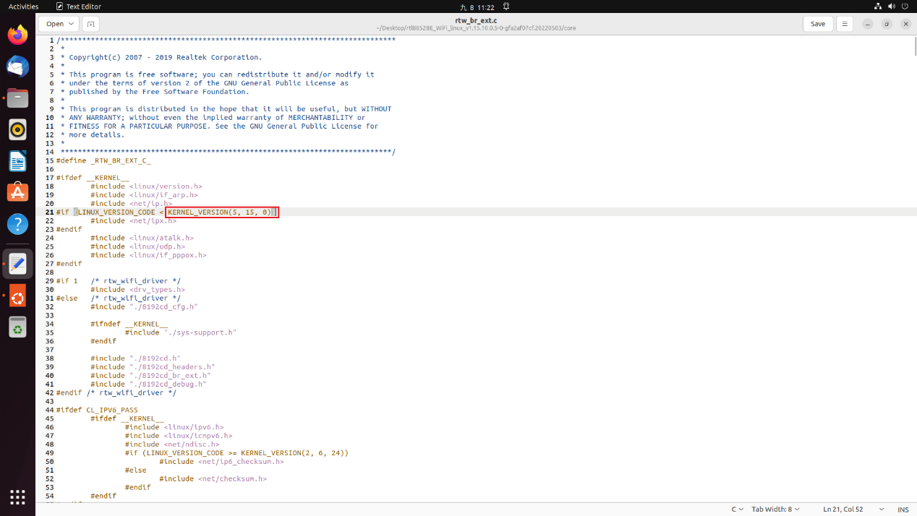
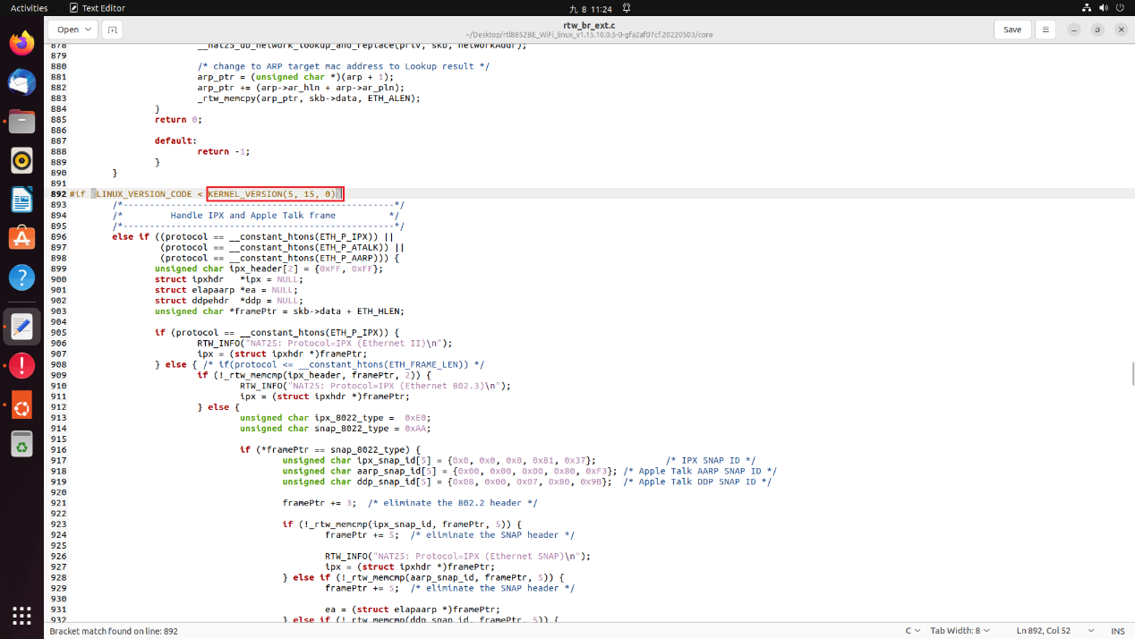

- Leave “core” folder and go back to previous folder.
# cd ..
- Input command “make” to compile driver package to generate ko files.
# make
*If "make" error, try to use below command to fix:
# apt install make
# apt install build-essential
If still can’t make it work, try to copy the whole “rtl8852BE_WiFi_linux_v1.15.10.0.5-0-gfa2af07cf.20220503” folder to the other path, ex. desktop of PC then try to compile again.
After compiling successfully, there’re a few files generated, including “8852be.ko”.
- Try to insert driver with below command.
# insmod 8852be.ko
*If error -2 issue(could not insert module XXX: Unknown symbol in module) happens while trying to insert driver, trying to use below command to fix:
# modprobe cfg80211
# insmod 8852be.ko
Then driver should be able to be inserted successfully.
- Finally, input below command to install the driver so that the driver will be loaded automatically in the future.
# make install
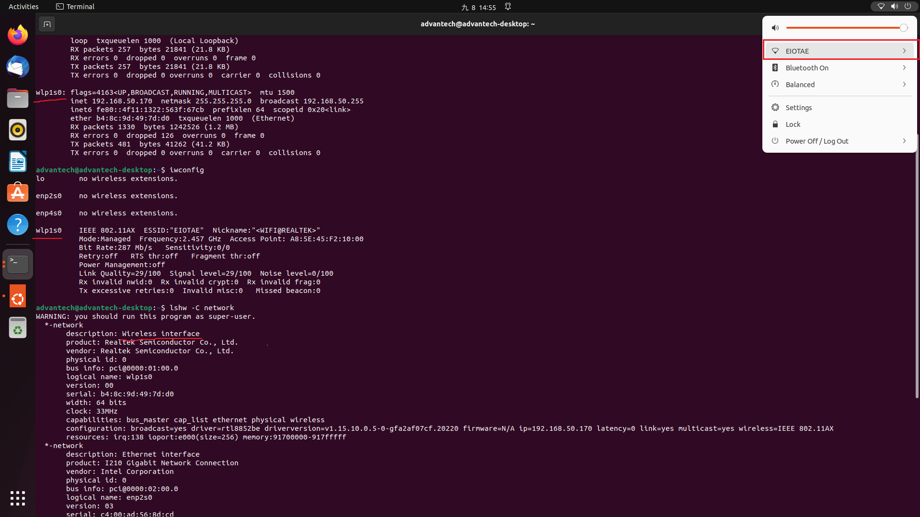

*Test environment:
