**Technical Document**

|  |  |  |  |
| --- | --- | --- | --- |
| **Category** | WISE-PaaS/OTA | **Date** | 2018/01/02 |
| **Topic** | How to change default storage path of downloaded software packages on OTA agent? | | |
| **Keyword** | OTA 3.0.9, OTA Agent, storage path, Windows | | |

* **Suggestion:**

Instructions in this FAQ are intended to walk you through on how to modify default path of storing downloaded or deployed software packages on OTA agent devices

**Step 1: Default path for storing software packages**

Default path for storing software packages is located at:

C:\Program Files (x86)\Advantech\OTA 3.0 Agent\Pkg

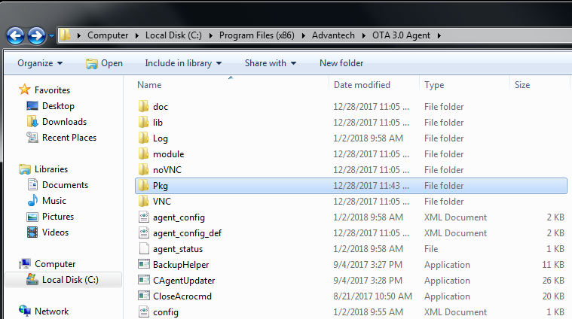

All deployed or downloaded software packages will be stored in this folder

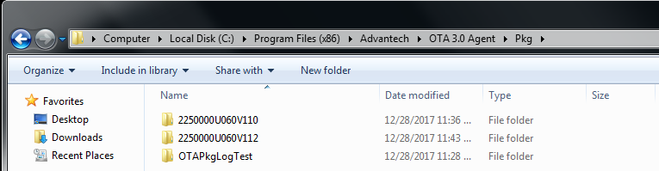

**Step 2: Create/assign custom directory for storing packages instead of default path**

Step 2-1: Create a folder (or use existing one) for package storage (example: OTA_Package_Path)

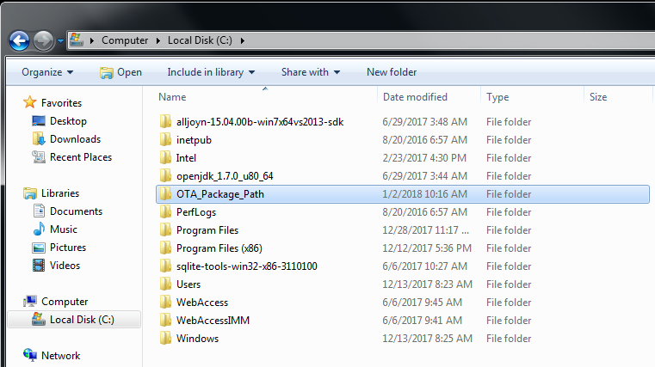

Step 2-2: Put “env_config.ini” file under the path: C:\Program Files (x86)\Advantech\OTA 3.0 Agent

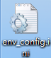

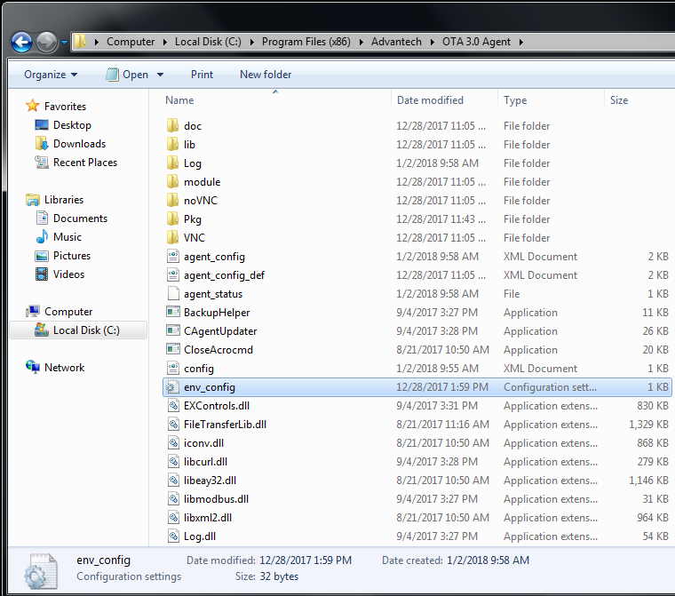

Step 2-3: Right click the file to edit the configuration content

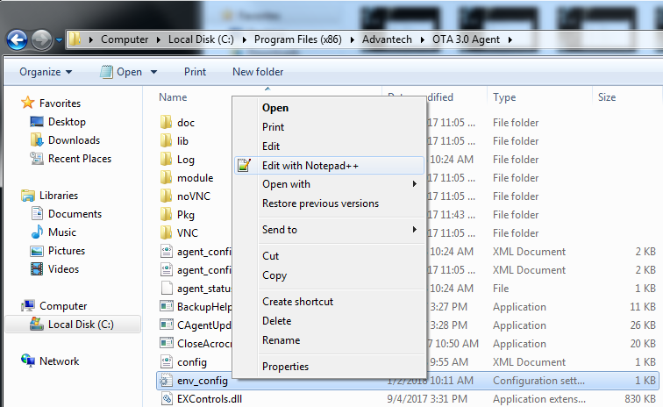

Step 2-4: Modify the path to be the location where you’d like those packages to be stored, here we modify the path to be the folder created in Step 2-1 (c:\OTA_Package_Path)

Important Reminder (for OTA 3.0.9):

1. OTA only recognized “*env_config.ini*” so its file name SHOULD NOT be changed
2. Only assign the storage path to where the folder/directory already exists in .ini file, OTA agent WILL NOT generate new folder if the path doesn’t exist
3. Please make sure the assigned path doesn’t have backslash (“\”) in the end such as “C:\Windows\TEMP\” 🡪 use “C:\Windows\TEMP” instead

(This is actually a small issue for current OTA version; this will be fixed in next version)

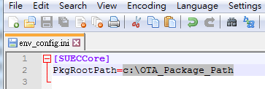

**Step 3: Reconnect OTA agent to server**

Step 3-1: Click “OTAServerSetting” on desktop of agent device

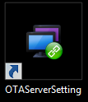

Step 3-2: Click “Save” button to reconnect OTA agent to server for configuration to be updated

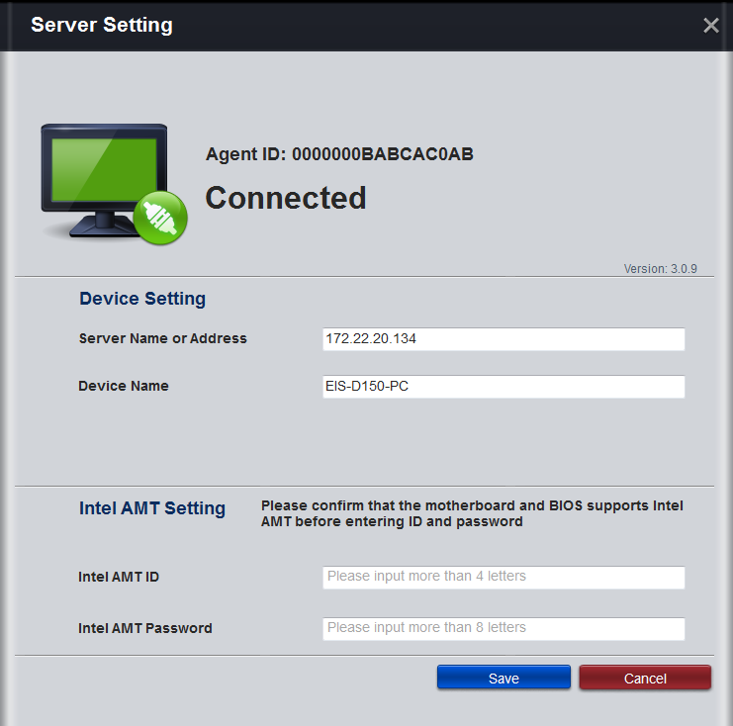

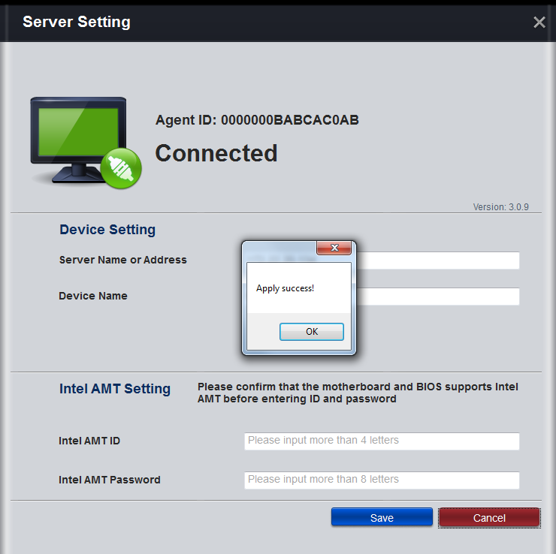

**Step 4: Validation/Testing**

Step 4-1: Login OTA server web console



Step 4-2: Choose agent device and click “Upgrade” button

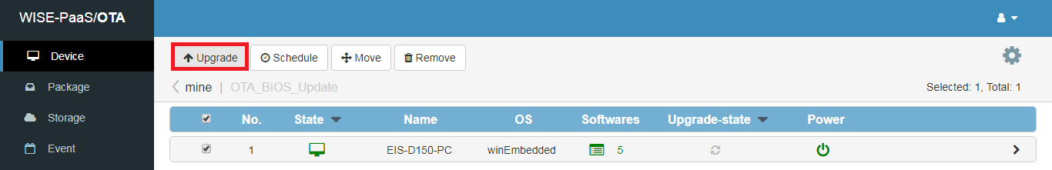

Step 4-3: Select software packages for testing (here we pick two packages generated by OTAPackager, “OTAClient” and “OTAPkgLogTest” for example)

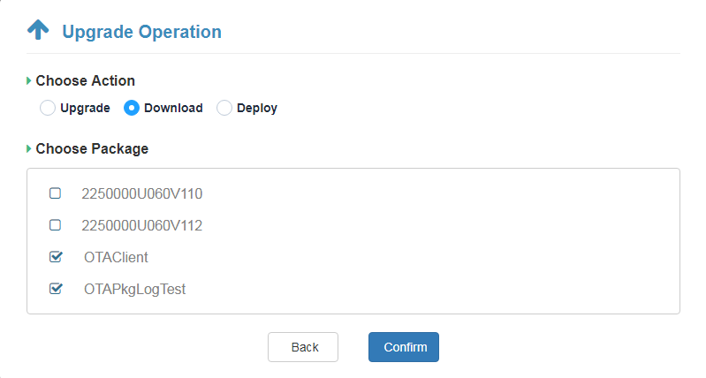

Step 4-4: Confirm packages are downloaded by agent

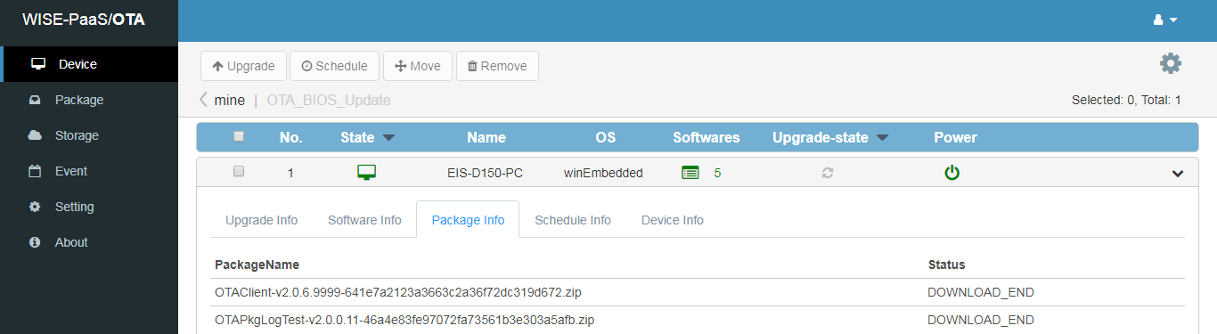

Step 4-5: Open the assigned folder in Step 2-1 to double check “OTAClient” and OTAPkgLogTest” packages are properly stored in desired/assigned folder)

