How to Setup Network with AIW-357
on MIO-5377
Prerequisite
- MIO-5377 with Ubuntu 20.04.6 LTS (kernel version: 5.4.0-42)
- Tarball file “aiw-357-mbim-set-ip.tar.bz2”
- Tarball file “xs5g03_pcie_driver_Advantech.tar.gz”

Build AIW-357 driver and install libmbim-utils

- Build the AIW-357 driver at your home directory “/home/username/”
- Decompress the driver tarball “aiw357_driver/xs5g03_pcie_driver_Advantech.tar.gz”
# tar zxvf xs5g03_pcie_driver_Advantech.tar.gz
- Build the driver
# cd XS5G03_pcie_driver_Advantech
# make
If successful, you will find out the driver “mtk_pcie_wwan_m80.ko”.

- Install libmbim-utils
# sudo apt install libmbim-utils

Network Test
Please follow the below steps to test network.
- Check some files that are build-in at your home directory “/home/username/” on Ubuntu.
- aiw-357-mbim-set-ip.tar.bz2 (application to bring up the network interface)
- aiw357_driver/mtk_pcie_wwan_m80.ko (AIW-357 driver)

- Check AIW-357 module with PCIe
# lspci
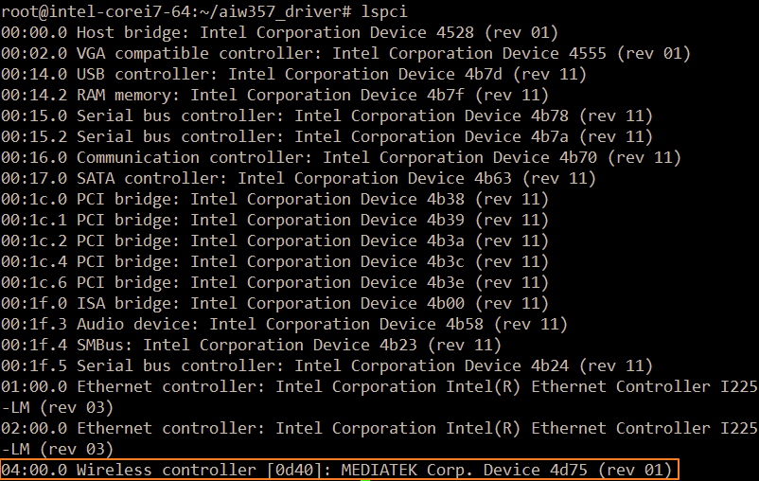

- Load driver
# insmod aiw357_driver/mtk_pcie_wwan_m80.ko

If the driver loaded successful, the user can find out device nodes as below.
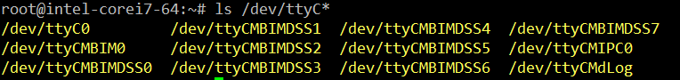

- Prepare some files for MBIM
  - Decompress the tarball aiw-357-mbim-set-ip.tar.bz2” and you will see the script “mbim-set-ip”
# tar jxvf “aiw-357-mbim-set-ip.tar.bz2”
  - Create the mbim configuration and copy it to /etc directory
# vi /etc/mbim-network.conf
Please fill your APN in the below orange rectangle

- Turn radio on
# mbimcli -d /dev/ttyCMBIM0 -p --set-radio-state=on
Note that please wait for 1-2 minutes to let module attaching to base station after running this command.
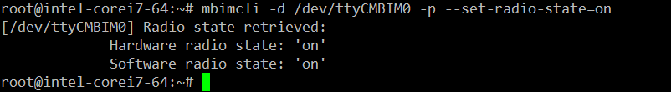

- Start network connection
# mbim-network /dev/ttyCMBIM0 start
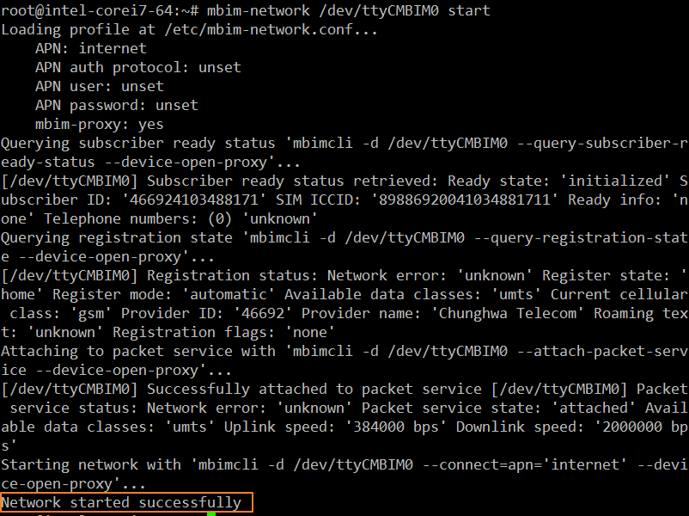

- Set IP and related setting with connection
# ./mbim-set-ip /dev/ttyCMBIM0 ccmni0
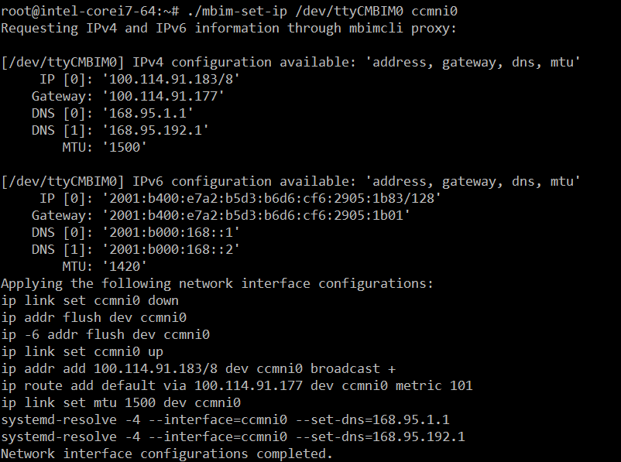

- Ping test
# ping -c 3 -I ccmni0 8.8.8.8
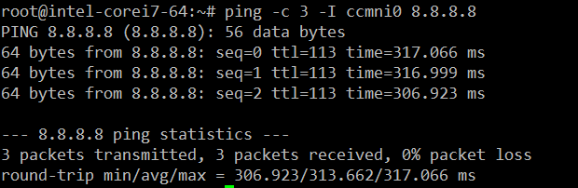

AT command
We can use AT command to communicate with AIW-357 module.

- Check device node ttyC0 whether exist or not
# ls /dev/ttyC*

- Get into AT command console by “Minicom”
  - Start to run minicom and select the “Serial port setup”
# minicom –s
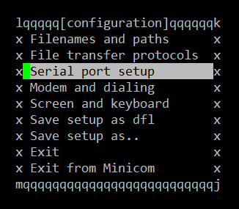

  - Please set serial setting as below screenshot.
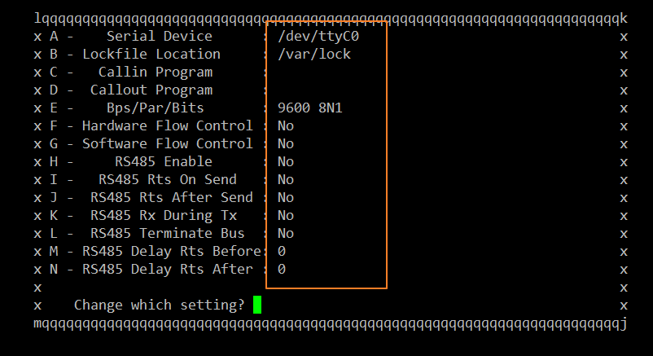

  - Test by AT command “AT” or “ATI”
