How to enable WiFi/Bluetooth with AIW-169

Prerequisite
- RSB-4810 with Android 12 (Linux kernel v4.19.232) on it
- Extract “AIW-169_RSB4810_Android_FW.zip” and copy files to one USB stick and plugged into any one USB port of RSB-4810 platform and follows WiFi/ Bluetooth test steps next.
“AIW-169_RSB4810_Android_FW.zip” includes following files:
- WiFi driver files:
- rtkm.ko
- 8852ce.ko
[* Notes ] WiFi 6GHz is only supported if RSB-4810 kernel 5.4 or above

Test WiFi
- Bring up WiFi driver :
- Bring up WiFi driver with 8852ce.ko if mount USB stick underlying /run/media/sda1 on RSB-4810
# cp /run/media/sda1/*.ko /tmp
# insmod rtkm.ko
# insmod 8852ce.ko
Note: you will see the interface wlan0 by “ifconfig –a” command
# ifconfig wlan0 up

- Test with WiFi AP

- Using GUI with HDMI display for “Internet” as follows to link with your AP
- If AP is configured with internet connection, user can use ping to check the internet availability as follows.

  - Check network connection after obtained IP address
# ping 8.8.8.8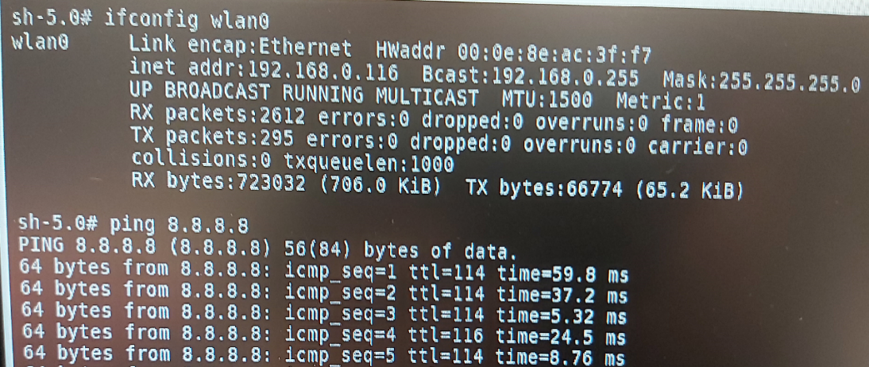

Test Bluetooth
- Test Bluetooth Interface
- Bring up Bluetooth with GUI (with HDMI display) as follows: Click in “Settings-> Connected Devices -> Pair new device (choice your peer device to connect with)” ordering to config your Bluetooth connection.
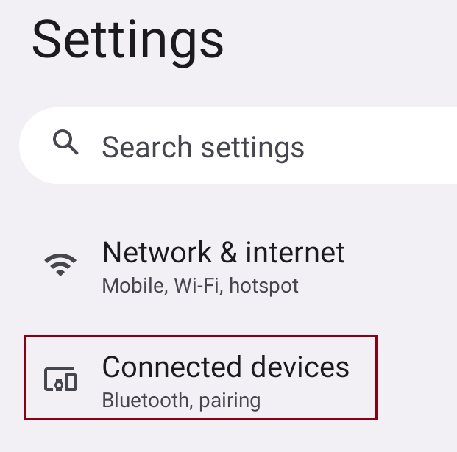
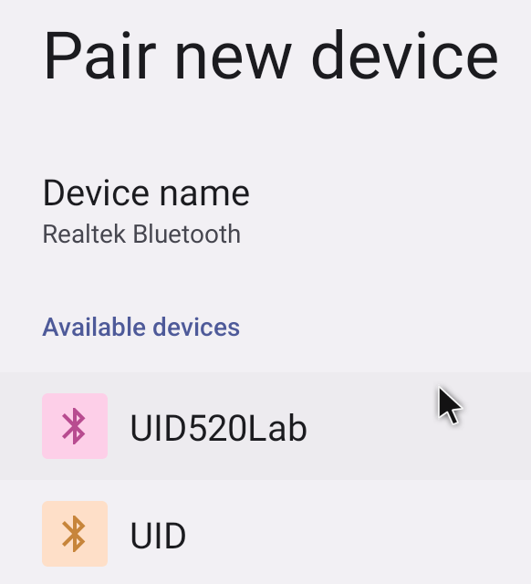

How To Build Driver with RSB-4810 BSP
- Download RSB-4810 BSP ((RK3568_S12_AIV12017.xml) with following URL:
https://ess-wiki.advantech.com.tw/view/Android_BSP_User_Guide_for_rk3568_series_12

# cd kernel-4.19
# make ARCH=arm64 rk3568_adv_defconfig
# make ARCH=arm64 rk3568-rsb4810-a2.img
# cd ../
# ./build.sh -A
# ./build.sh -u
Then use generated update.img to upgrade RSB-4810 platform

- Copy driver zipped source file (RTL8852CE_WiFi_linux_v1.19.4.5-0-g285f1de55.20231027_RSB4810.zip) to your BSP build host with USB stick (assumed USB stick is mounted on /run/media/sda1)
# cp /run/media/sda1/RTL8852CE_WiFi_linux_v1.19.4.5-0-g285f1de55.20231027_RSB4810.tgz /home/adv/BSP

- To build Wi-Fi driver (rtkm.ko, 8852ce.ko) as following steps:
# cd RTL8852CE_WiFi_linux_v1.19.4.5-0-g285f1de55.20230127
# make ARCH=arm64 –C /home/adv/BSP/rk3568_android_S12-rk13/android/kernel-4.19 M=`pwd` modules

- Referring to
- Download “20230424_BT_ANDROID_RTL8852C_COEX_v0707_Adv.tar”
- “Realtek_Bluetooth_Porting_Guide_for_BT_Android12.0_English.pdf”, section 3.2.2 to build Bluetooth driver, and follows the porting instructions to build Bluetooth related settings’ change

