AIW(EWM) FAQ
Category | AIW | Date | 2023/11/14
Keyword | EWM-W173H01E, Linux, Ubuntu 22.04, kernel 5.15, Broadcom AP6275P, BT

- Question:
How to setup and install EWM-W173H01E Bluetooth on Ubuntu 22.04 with kernel 5.15?

- Instructions :
- Download driver & firmware package via below link.
ap6275p_rs3710_e03.tar.bz2

- Create a new folder named “bcmdhd” under /lib/firmware/.
$ sudo mkdir bcmdhd

- Copy Bluetooth FW to /lib/firmware/bcmdhd/.
Bluetooth FW file can be found in folder “ap6275p_firmware”.
$ sudo cp BCM4362A2_001.003.006.1012.1017.hcd /lib/firmware/bcmdhd/

- Input sudo dmesg | grep cp210x to check if cp210x driver is loaded automatically and ttyUSB0 appears.
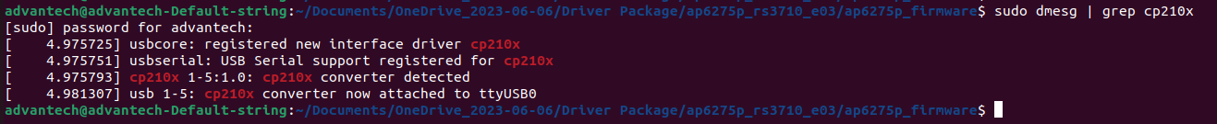

- Move to path /Driver Package/ap6275p_rs3710_e03/ap6275p_application/.
Remove the “brcm_patchram_plus”.
$ sudo rm brcm_patchram_plus

- Then build “brcm_patchram_plus.c” with gcc.
$ sudo gcc brcm_patchram_plus.c -o brcm_patchram_plus
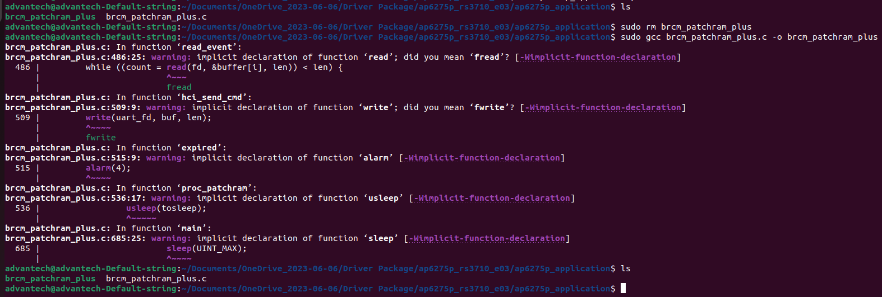

- Input following command to enable HCI interface with brcm_patchram_plus which build in last step. (Please change to root user.)
# ./brcm_patchram_plus -d --enable_hci --no2bytes --tosleep 200000 --baudrate 115200 --patchram /lib/firmware/bcmdhd/BCM4362A2_001.003.006.1012.1017.hcd /dev/ttyUSB0 &
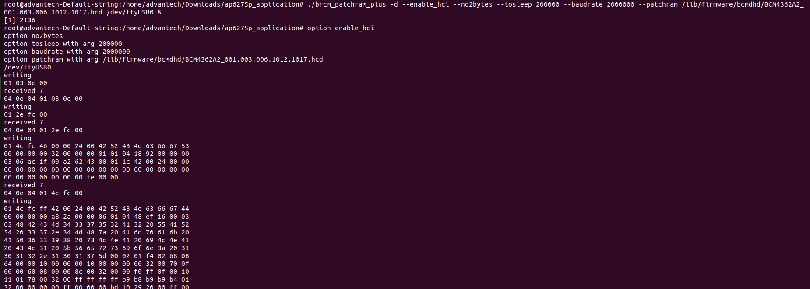

- Check if BT interface appears or not.
If yes, please jump to conclusion part.
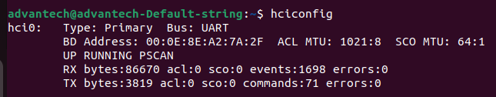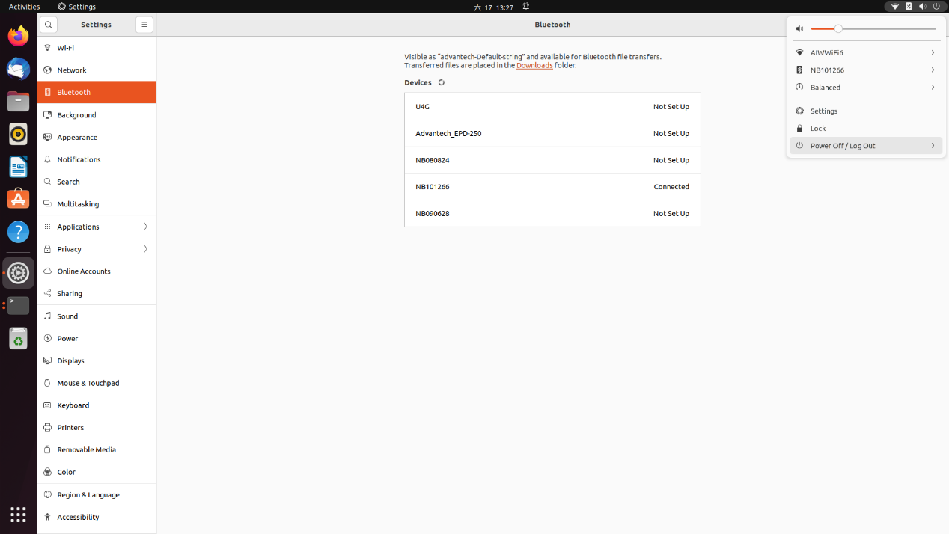
- If not, please check the BT interface status with “hciconfig -a”
If it’s down, please try to make BT interface status up.
$ sudo hciconfig hci0 up
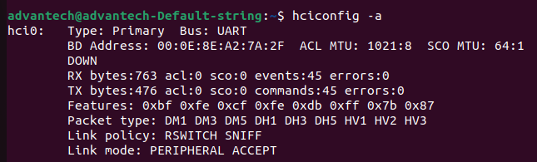

- However, if it can’t be activated, please refer to following screenshot to fix.
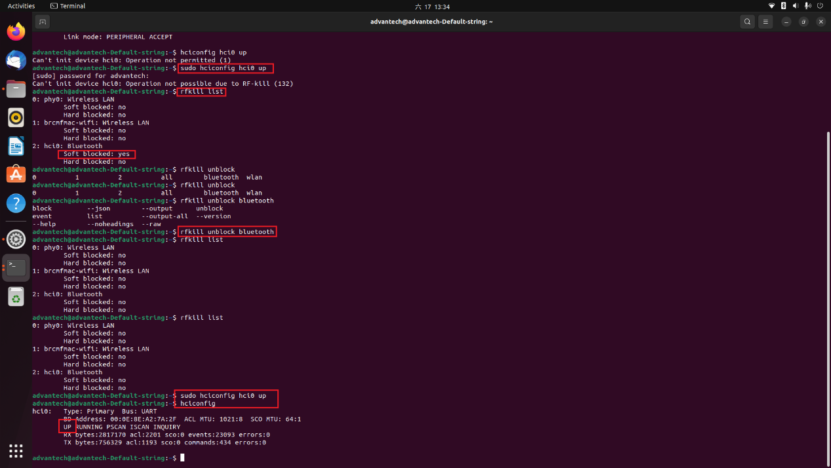

- Conclusion :
After connect to other BT devices, try to send & receive files to verify BT function works.
Send :
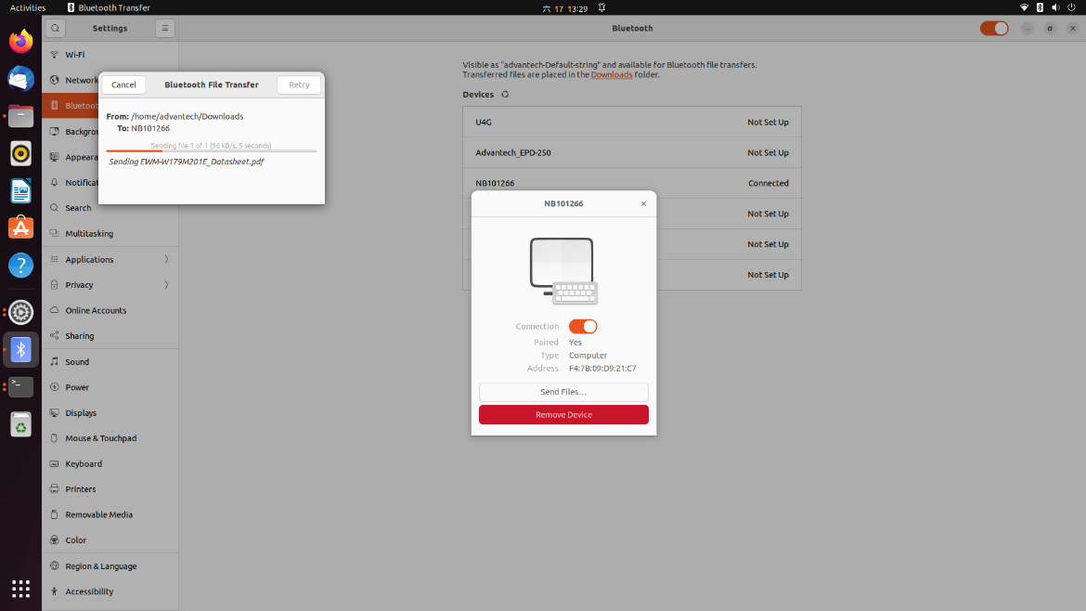

Receive :
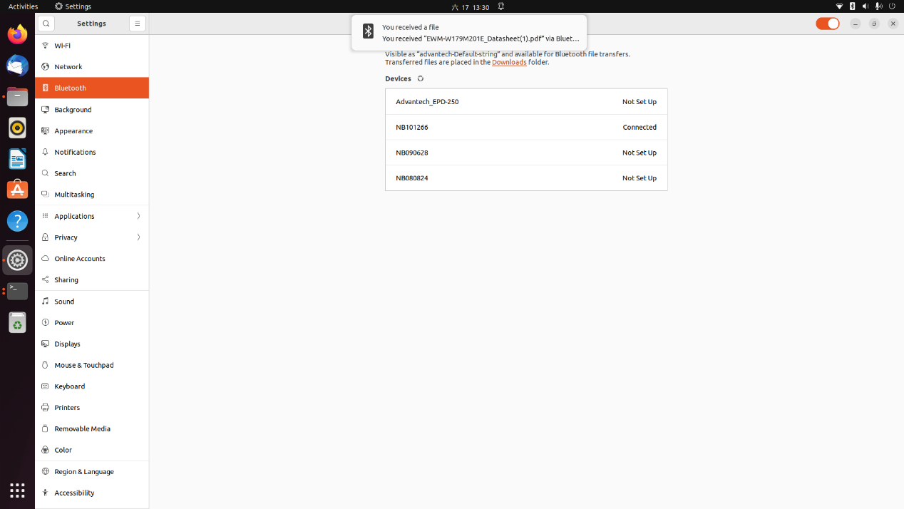

Test with Linux Ubuntu 22.04.1 with kernel 5.15. (ARK-1250L)
