PLM GlobalImageCenter Object Storage Download SOP
Revision: v20251112
Author: ACL IT DBA Tomato.Fan
VOIP:511 EXT:7827
- Download the EXE installer  - Visit website and click the "Download EXE Installer" button to get the installation file. | URL: Download S3 Browser. Amazon S3 Client. Windows Client for Amazon S3.  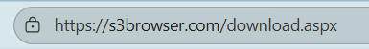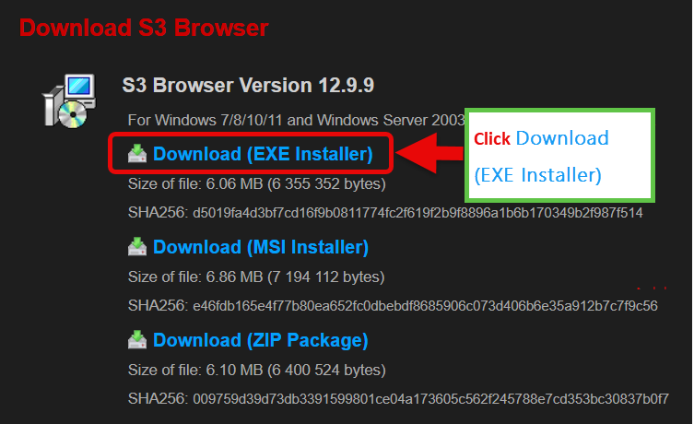
- Run the installer as administrator  - After the download is complete, right-click the installer file and select "Run as administrator" from the context menu.  This ensures the installation has the necessary permissions to complete successfully. | 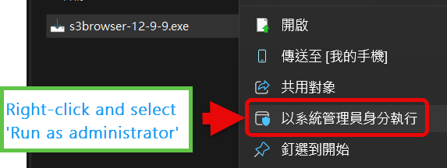
- Follow the on-screen instructions  Proceed with the setup by following the prompts in the installation wizard. | 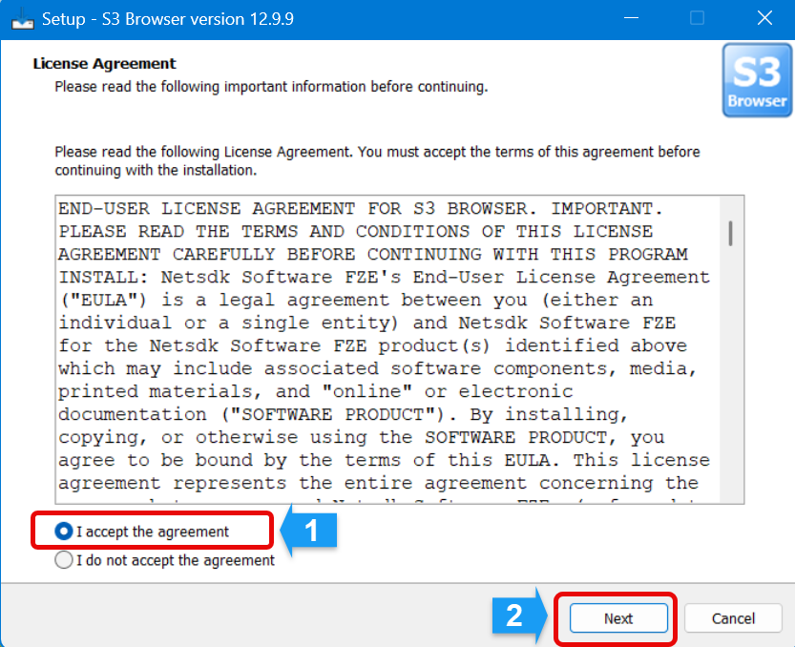  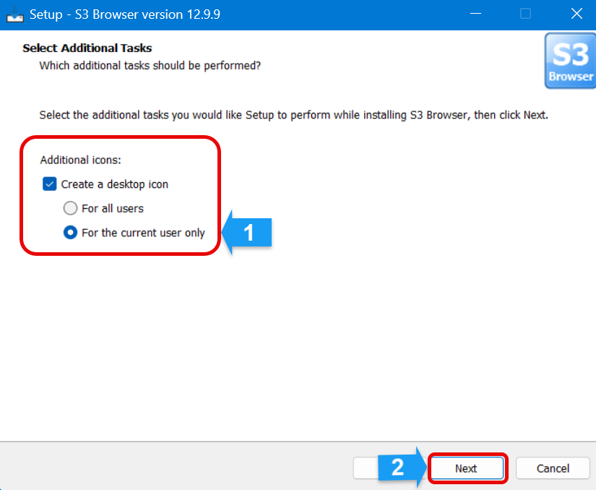  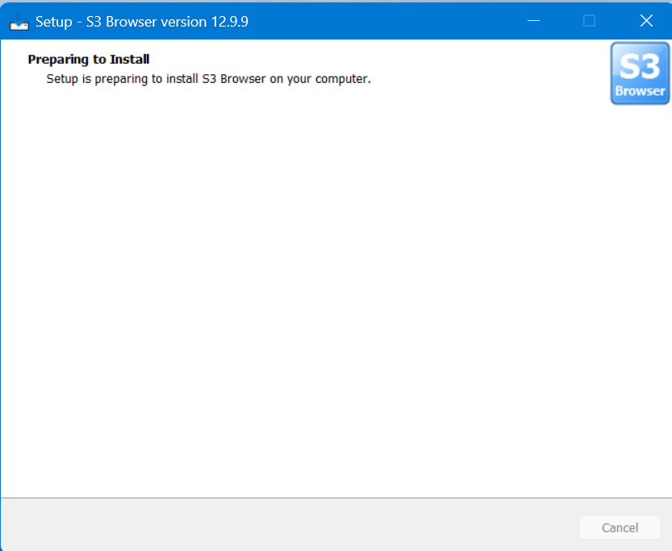  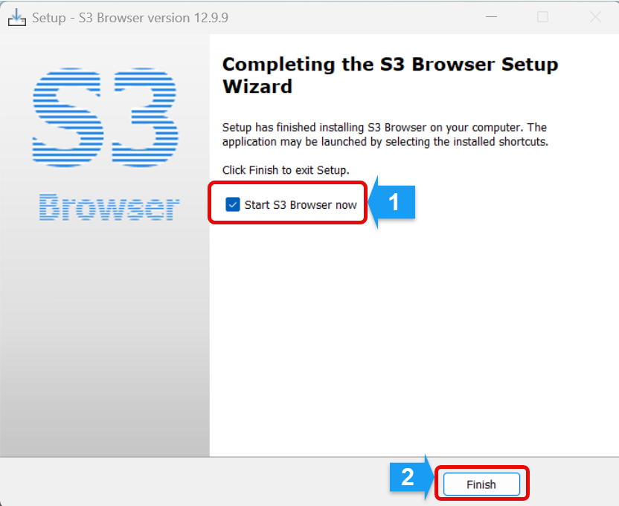

- Enter values according to the configuration settings  When prompted during installation, please enter the required values based on your system's configuration.  Make sure all fields are filled in accurately to ensure proper setup.  - Display name: GICDL  - Select  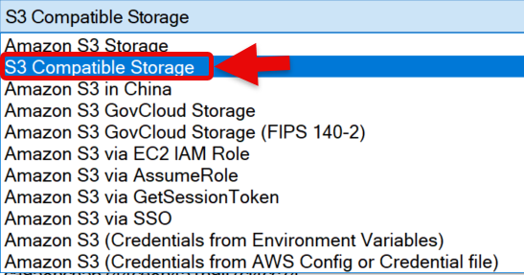  - API endpoint: 165.192.148.201:8443  - Access Key ID: f360aa95d89c41e5b357445940d62879  - Secure Access Key: ea2fbe1804fc8188cd477e8f037878cce9cceacfec6bd7d5  - EAK: Please check the box, enter the required values: REQUEST_PLANT  - UST: Please check the box  - Click the 'Add new account' button"  - Very important:  Close S3 Browser and restart | 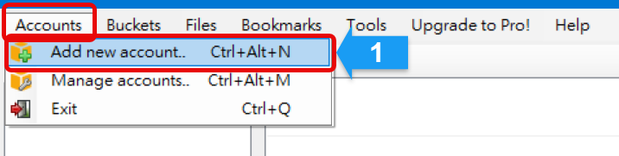  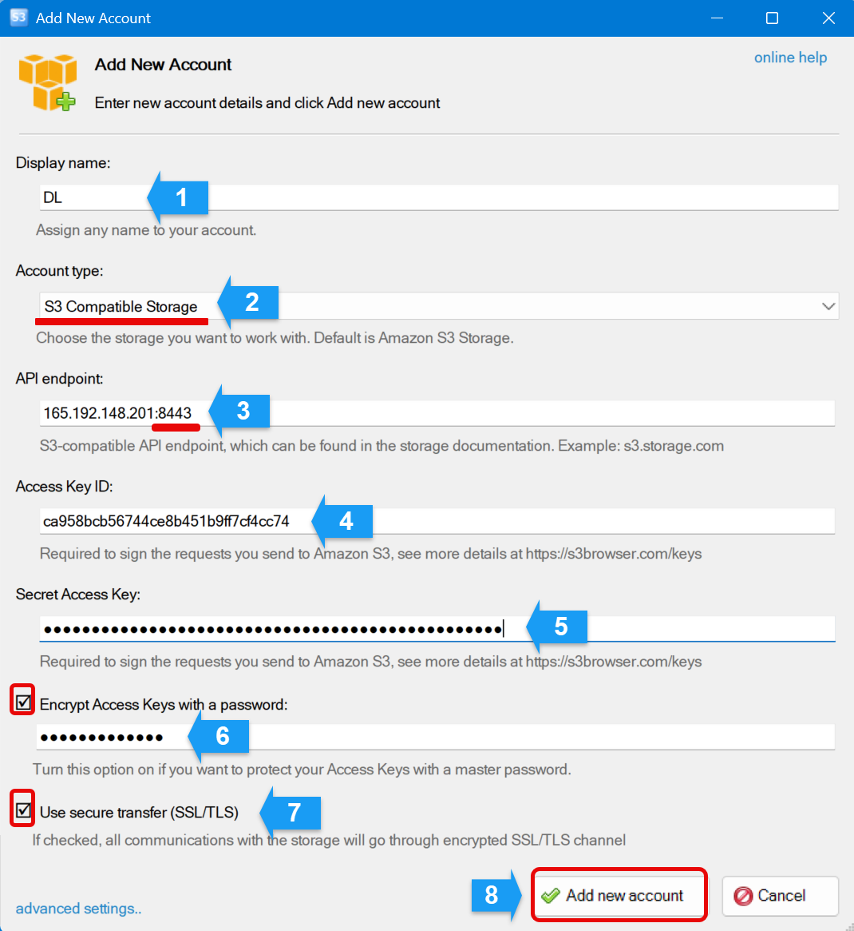

- Search for S3  In the application's interface, type 'S3' in the search bar and press Enter to locate the relevant settings or options.  - Open the application  After the installation is complete, open the application by double-clicking its icon on the desktop or selecting it from the Start menu. | 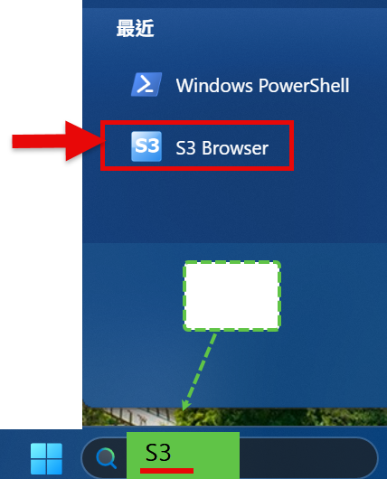  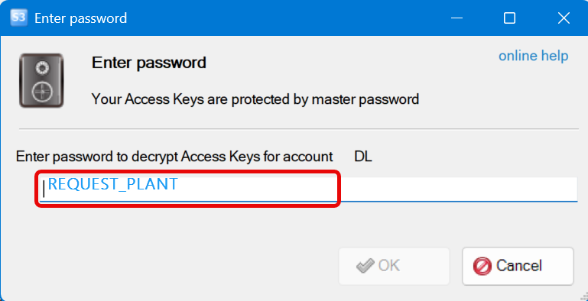
- Configure the options as shown in the screenshot.  After completing the configuration, restart the S3 Browser to apply the changes. | 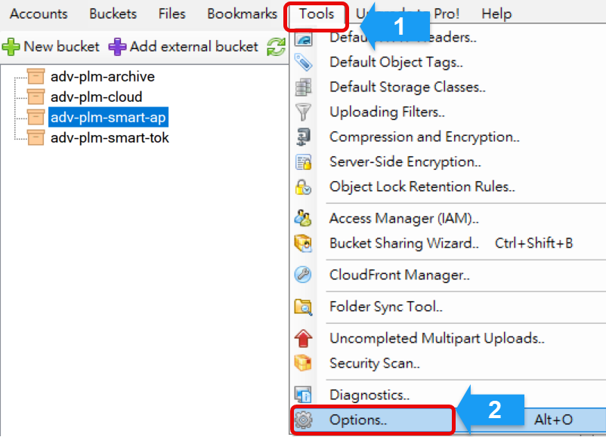  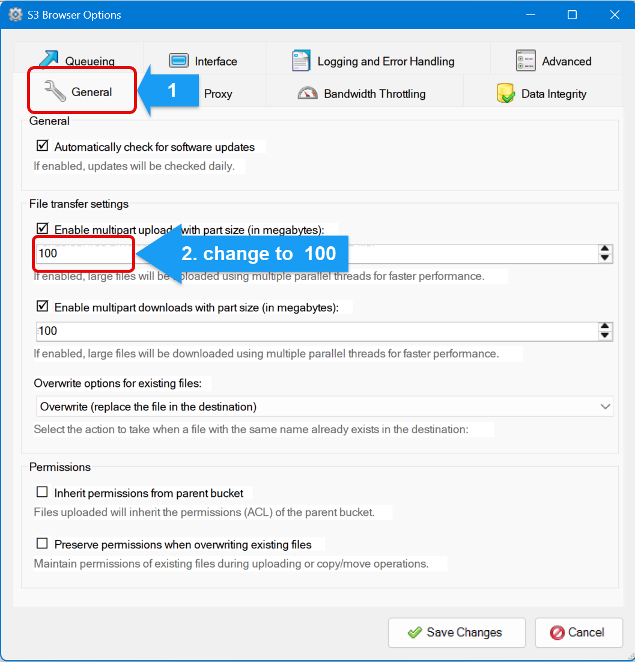  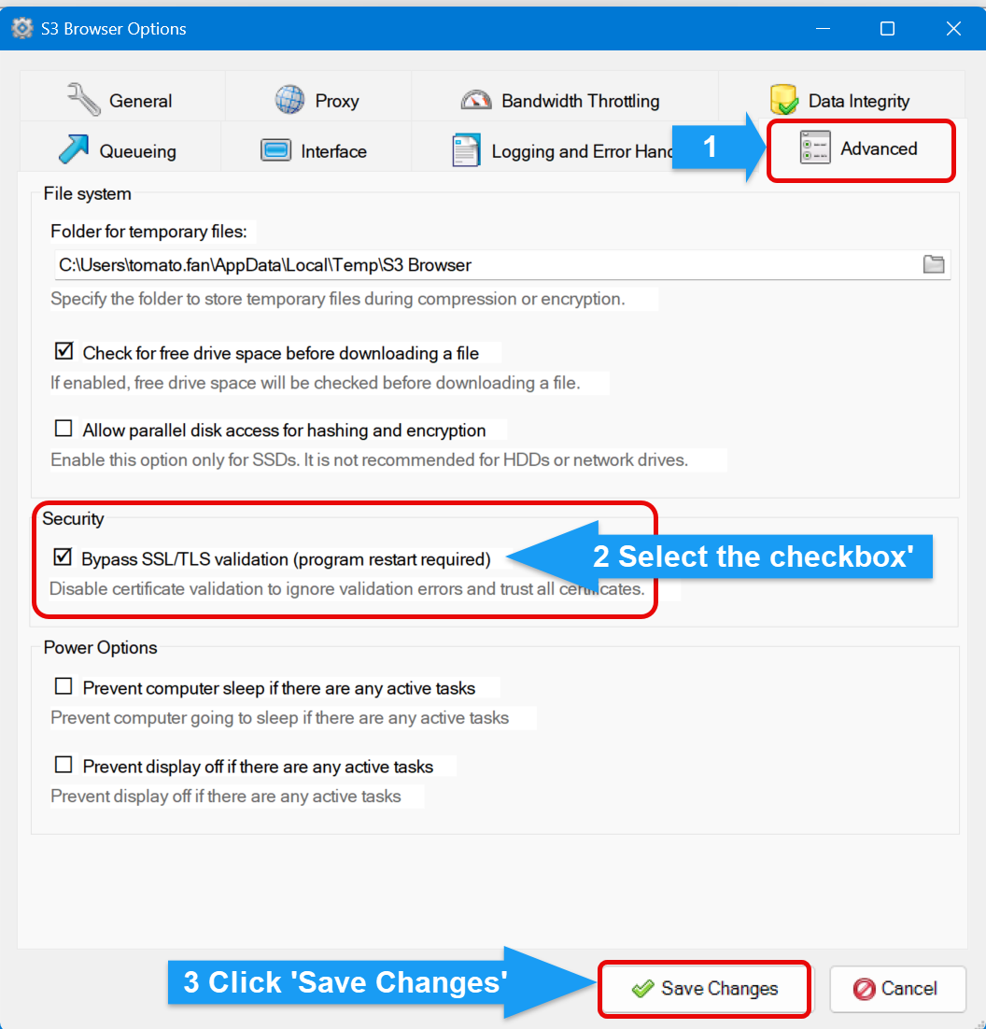

Standard Operating Procedure: File Upload Process
Purpose:
To ensure files are uploaded correctly and securely to the designated system or platform.
Scope:
This procedure applies to all employees who need to upload files to the company’s cloud storage.
Compliance:
Ensure all uploaded files comply with company data security and confidentiality policies.
Step  - Verify the Part Number  - Confirm the correct part number from the PLM.  - Create the Folder  - Right-click in the directory and select New Folder.  - Name the folder using the exact part number  - Avoid adding extra spaces, special characters, or suffixes unless specified by company policy.  - Add Metadata  - Include a README file inside the folder with details such as:  - Part number  - Description  - Date created  - Responsible person  - Log in to the company’s cloud storage.  Navigate to the directory /PLM/Upload and start Upload process.  Start Download | 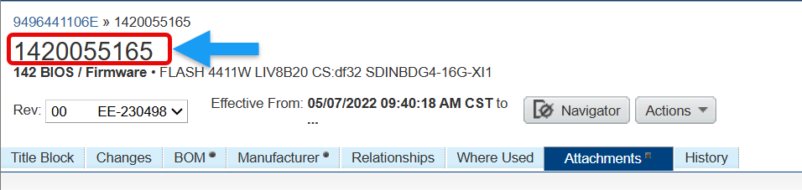  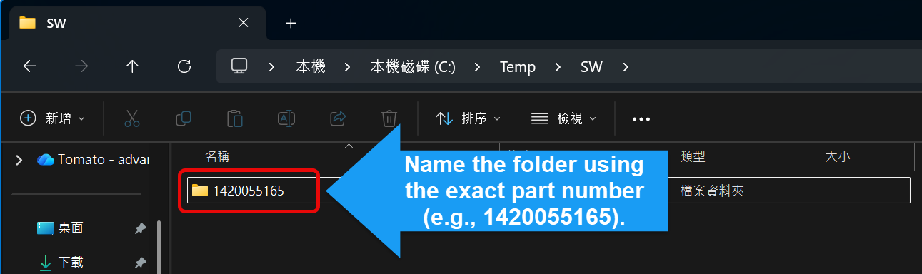  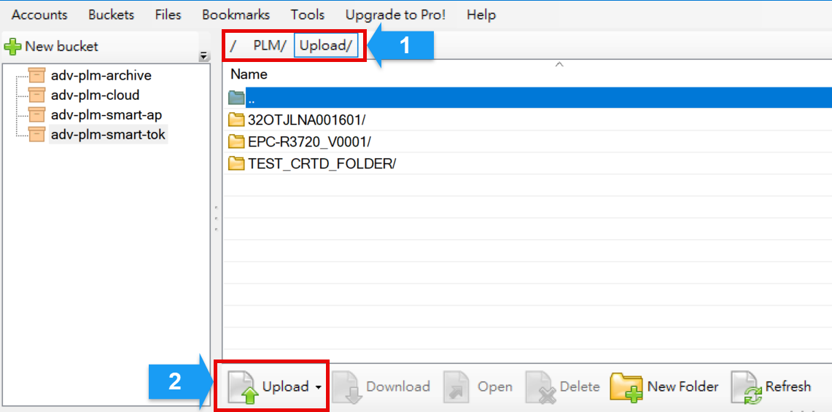  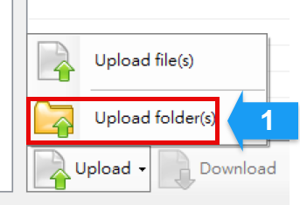  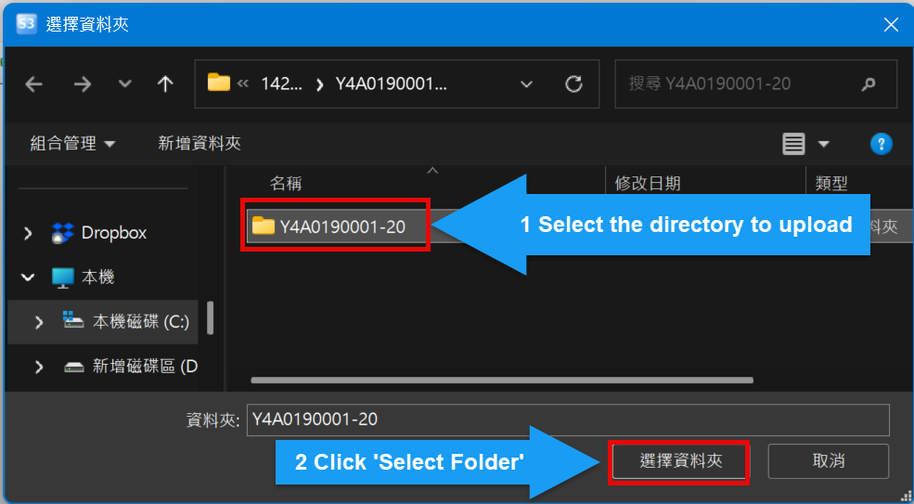

Standard Operating Procedure: Downloading Files from Part Number Folders
Purpose:
To ensure employees correctly download files from folders named according to part numbers for efficient and accurate data retrieval.
Scope:
This procedure applies to all employees who need to access and download files from the company’s cloud storage or internal system.
Compliance:
Ensure all downloaded files comply with company data security and confidentiality policies.
Step  - Log in to the System  - Use your authorized credentials to access the company’s ERP or inventory management system.  - Search for the Part Number  - Navigate to the Search function.  - Enter the exact part number in the search field.  - Double-check for typos or incorrect formatting before submitting.  - Confirm Existence  - Review the search results, If the part number exists, proceed to the next step.  - Access the Part Information Page  - Click on the part number TAB ‘Attachments’.  - Ensure the page displays:  - File description  - File name  - Get Folder Information  - Log in to the company’s cloud storage.  Navigate to the directory specified by the system prompt.  - Navigate to the directory where part number folders are stored and start download process.  This section provides details about the fields displayed when downloading files | 