**AIW(EWM) FAQ**

|  |  |  |  |
| --- | --- | --- | --- |
| **Category** | AIW | **Date** | 2023/11/23 |
| **Keyword** | AIW-170, driver, ARK-1220, Ubuntu 20.04.5, kernel 5.15 | | |

* **Question:**

How to setup and install Wi-Fi driver for AIW-170 on Linux Ubuntu 20.04.5 with kernel 5.15?

* **Instructions :**

Driver package version r00017.9: For the driver package, please check further with us directly.

Using root authority. (sudo su)1. apt-get install libdbus-1-dev

2. Follow BuildWlanDriver_SOP “3. Build WLAN” as following screenshot but there’re something required to be modified before using command “make” to build driver.

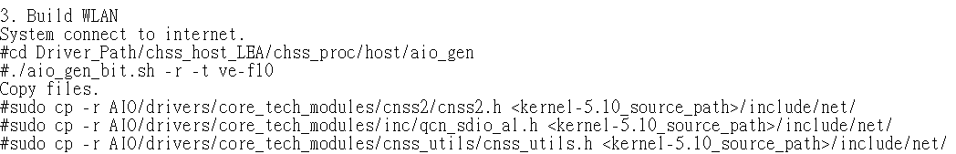

*It’s mentioned Driver_Path in step 3, Driver_Path should be “qca2066-lea-1-0_qca_standard_oem-r00017.9-384c6e17c2a3d3e9acaf295b79f7660913626894” after decompress “qca2066-lea-1-0_qca_standard_oem-r00017.9.zip”.

3. Before building driver, please move the whole folder /host under /root/ path.

# cp -r host/ /root/

Original path is too long, to avoid error appearing, make whole folder /host change path.

Original path:

/root/qca2066-lea-1-0_qca_standard_oem-r00017.9-384c6e17c2a3d3e9acaf295b79f7660913626894/chss_host_LEA/chss_proc/host/AIO/build/

Modified path:  
/root/host/AIO/build/

4. Modify Kbuild file under AIO/drivers/qcacld-3.0/.  
# vim /AIO/drivers/qcacld-3.0/Kbuild  
line: 2664

cppflags-y +=

-DANI_OS_TYPE_ANDROID=6 \

-Wall\

-Werror\

-D__linux__\

-Wno-error=frame-larger-than=

5. Then, build driver with following commands.

# cd /AIO/build/

# make CONFIG_ONE_MSI_BUILD=y

6. Follow BuildWlanDriver_SOP “4. Set up and load WLAN”.



* bdwlang.elf can be found in original driver package.

7. Modify qcom_cfg.ini file and add following lines as following screenshot.

**g11dSupportEnabled=1**

**gindoor_channel_support=1**

**scan_mode_6ghz=2**

# nano qcom_cfg.ini file

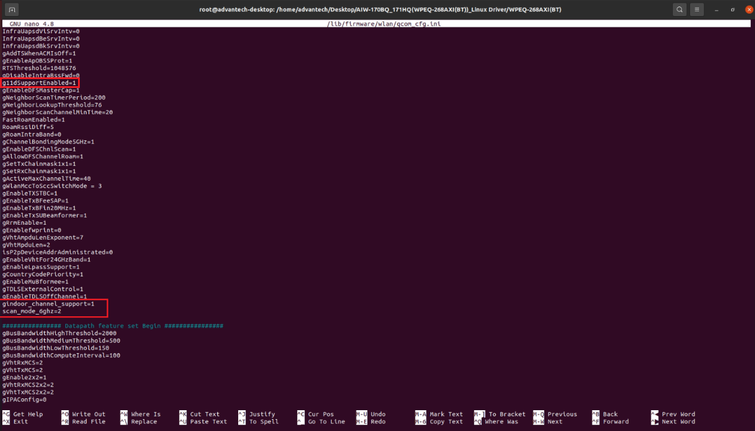

8. Follow BuildWlanDriver_SOP “5. Load WLAN drivers”.

After both .ko files are inserted, then wlan interface should appear.

Using “ifconfig” to check.

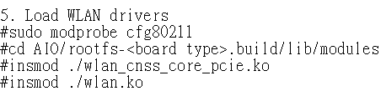

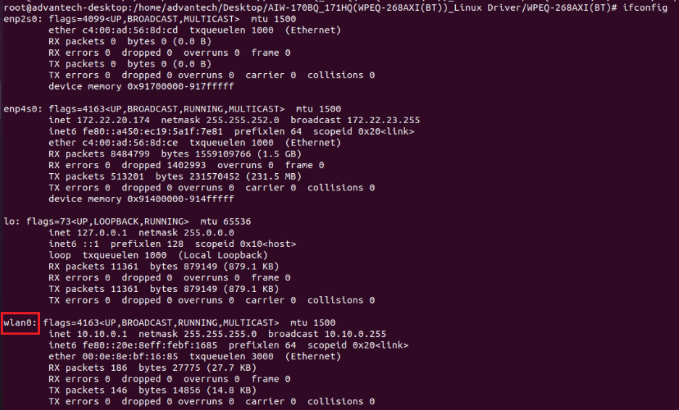

* If encountered system crash issue, please enter BIOS and enable Vt-d option.

**Intel Visual BIOS -> Advanced -> Security -> Under Security Features ensure "Intel VT for Directed I/O (VT-d)" checkbox is checked.**