EWM-W170 wifi porting guide for imx6 Yocto2.5

Porting (Yocto2.5)
- Get source code

Module_Name | Platform | Porting Guide | Interface | OS Support | Support Kernel version | Module Driver Version
WPEQ-160ACN | x86/x64 | Linux | PCIE-USB | Linux | 4.1 | 4.5.21.410
WPEQ-160ACN | ARM32 | Linux | PCIE-USB | Linux | 4.14 | 4.5.25.33
WPEQ-160ACN | ARM64 | Linux | PCIE-USB | Linux | 4.14 | 4.5.25.33

1. Get the qcacld-2.0-SparkLAN-4.5.25.33.tar.xz
2. Modify Makefile KERNEL_SRC path ＆ Add CROSS_COMPILE toolchain path
ARCH := arm
CROSS_COMPILE := arm-poky-linux-gnueabi-
KERNEL_SRC := /home/clayder/project/imx6/y25/linux-imx6
3 Get the Firmware and wlan.ko
4 Download yocto 2.5
5 Add Kernel config
Add config: CONFIG_ATH10K=m , CONFIG_ATH10K_PCI=m CONFIG_ATH_DEBUG=y
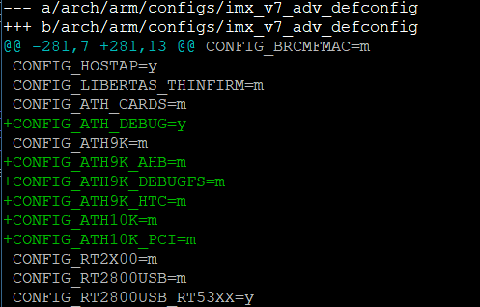
- Make Kernel and Kernel module in Yocto2.5
$ make -j4 modules
$ make modules_install INSTALL_MOD_PATH=~/temp/rootfs
Change the ZImage form official build Image.
Copy the “rootfs/lib/modules/4.14.98-00002-gfc8cc77-dirty” to devices (/lib/modules) (imx6).

7 Copy wlan.ko and firmware from ”qcacld-2.0-SparkLAN-4.5.25.33.”
Copy the firmware “qcacld-2.0-SparkLAN-4.5.25.33/firmware_bin” to device (imx6).
Copy wlan.ko file to device (/lib/modules/ewm-w170/) (imx6).

Test
Load module
# modprobe cfg80211
# insmod /lib/modules/ewm-w170/wlan.ko
# ifconfig wlan0 up
Link
# wpa_passphrase "ASUS_RISC_SOM_ESBC_2.4" 1qaz2wsx > /tmp/wpa.conf
#wpa_supplicant -BDwext -iwlan0 -c/tmp/wpa.conf
# cat /tmp/wpa.conf
# udhcpc -b -i wlan0

