**1810 ST-LINK Utility Firmware Refresh FAQ**

|  |  |  |  |
| --- | --- | --- | --- |
| **Category** | WISE-1810 | **Date** | 2018/07/25 |
| **Keyword** | List all related keywords | | |

* **Firmware Refresh Step:**

**Note: Before the version 1.0.20 of WISE-3610 and the version 1.0.20 of WISE-1810, fresh the firmware have to use ST-link tool.**

1. Use ST-Link/V2 Tool connected ED20 as below pic 1.

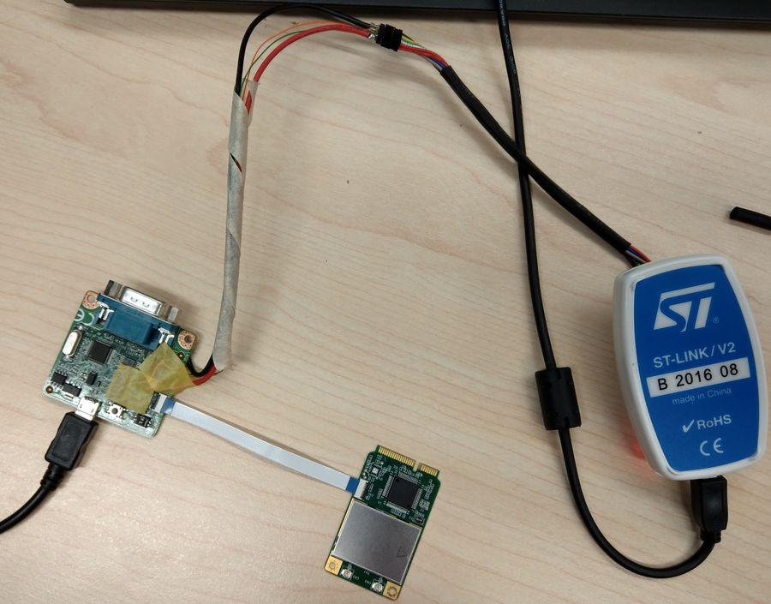

Pic 1

ED 20 please check pin1 and pin2 to “ON” as default.

Switch pin1 to “ON”: flash programming, “OFF”: boot from flash.

Switch pin2 to “OFF”.

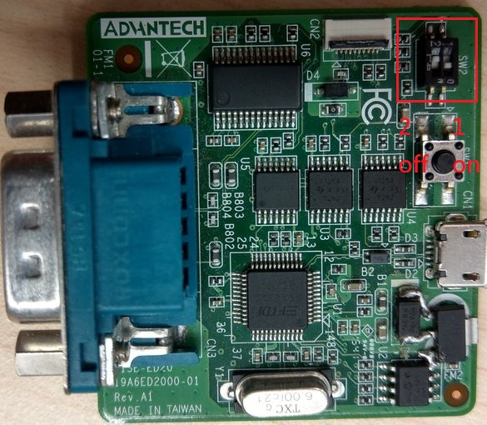

Pic 2

1. Install STM32 ST-LINK Utility v4.2.0 setup and execute STM32 ST-LINK Utility.

Click Target->Settings

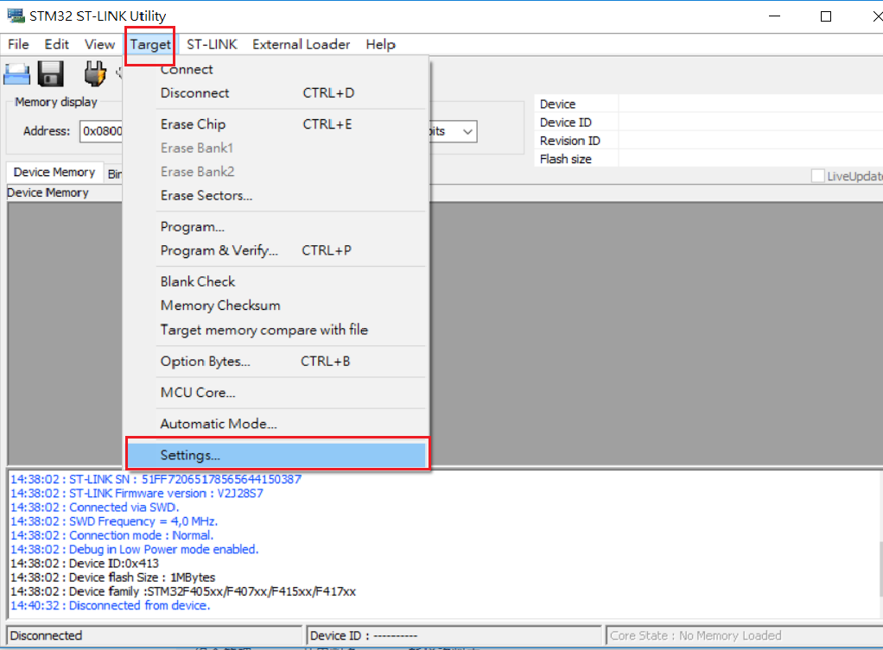

Pic 3

As below Pic 3, if connected successfully, you can see STM32 Target Information has right STM32 MCU type and press OK. If not, it presents “Detection Fail”.

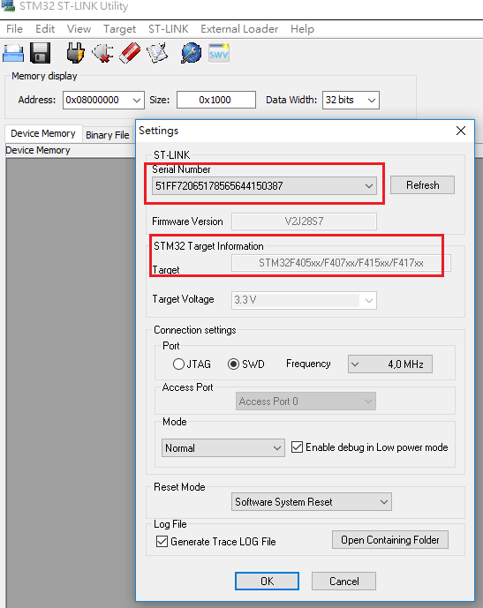

Pic 4

Next step Click Target->Erase chip and press OK

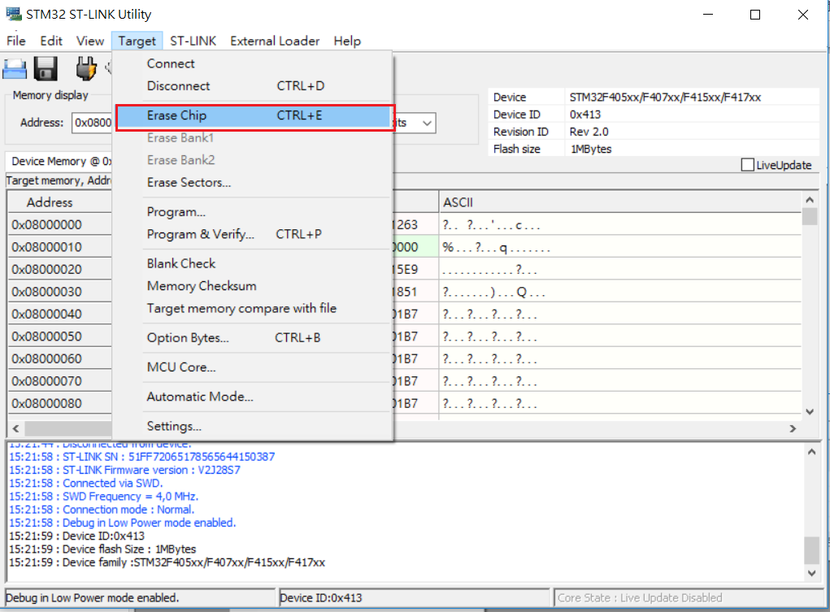

Pic 5

Next step Click Target->program , click start after choosing the 1810 newest bin file as below pic 6、7. The bin file can be download from WISE-EC FTP server.

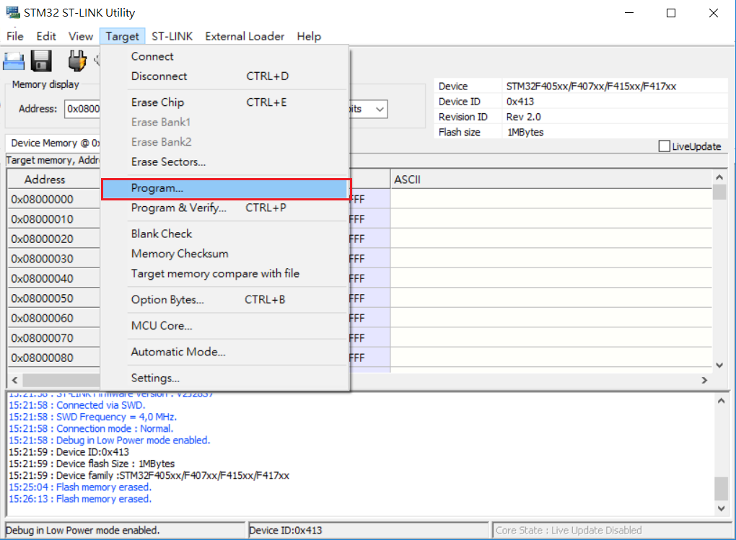

Pic 6

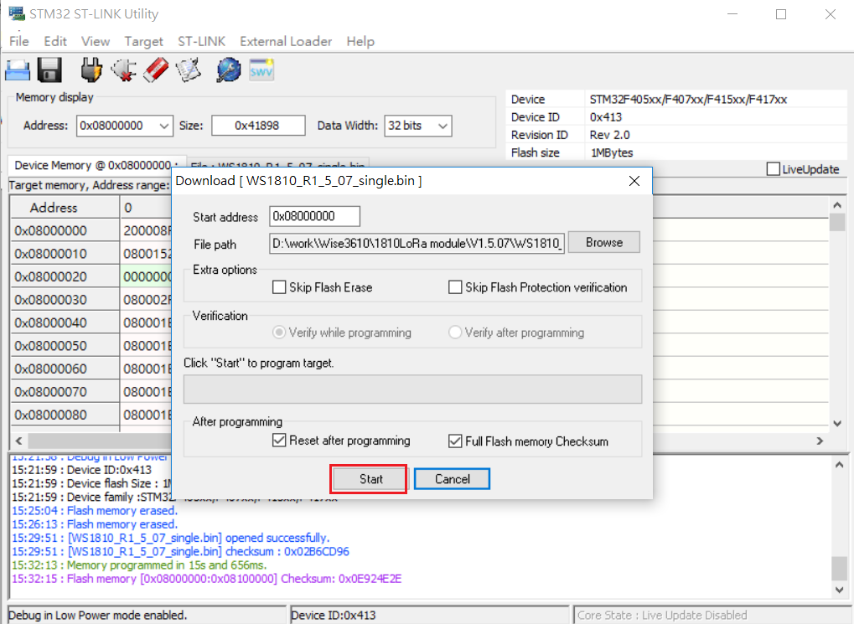

Pic 7

Refresh image successfully as below

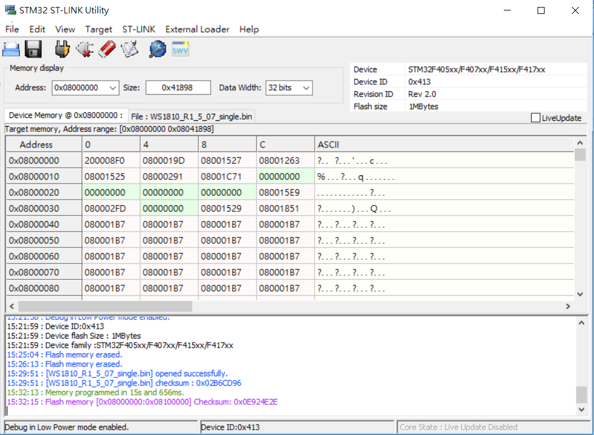

Pic 8