EPD FAQ
Category |  | Date | 2021/8/19
Keyword | ePaper Manager, EPD-053, EPD-132

- Question:
How to transmit graphic to the EPD device?

- Description:
In the ePaper Manager, there are two way to transmit graphic to the device. Following, I will introduce how to do it.

First is putting the graphic in the template.
Step 1: Select “Template” and “Create a new one”
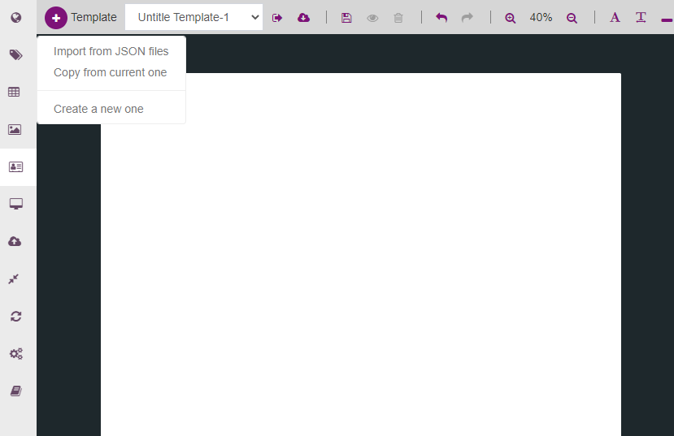

Step 2: Drag the graphic to the canvas, and click select file
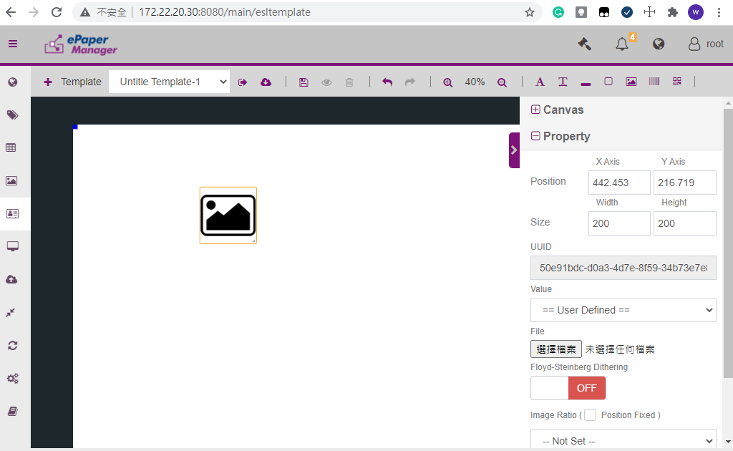
2
1
Step 3: Go back to the EPD controller and select the “select Item”
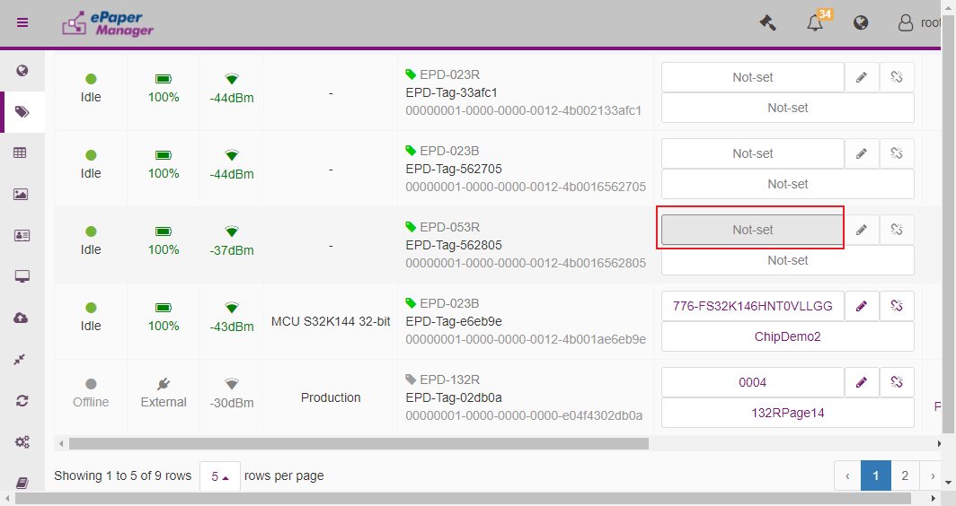
Step 4: A new window will show as below, you can see the graphic in the window. In this example, we don’t use the Item data in the template so we can select any one item.
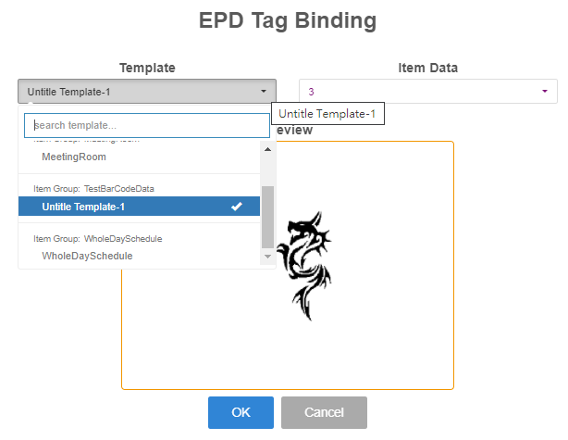
Finally, you transmit the image and your graphic will show in the ePaper Manager

Second, Select the graphic from Item data.
Step 1: Open notepad and edit the content as below.
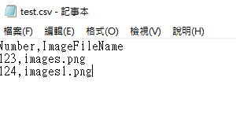

Step 2: Create a new ItemData and upload test.txt to the ItemData
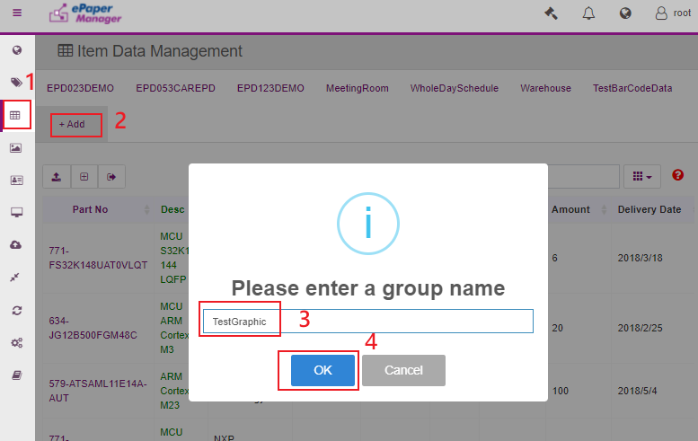

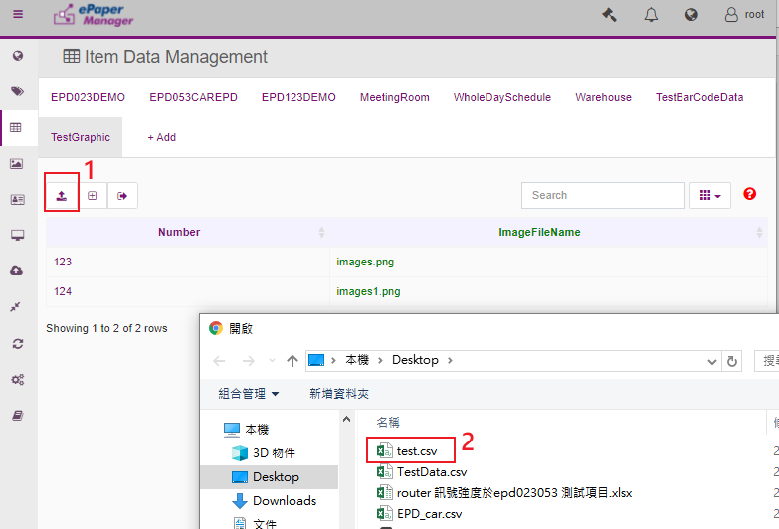

Step 3: Click “Gallery” and upload the imag
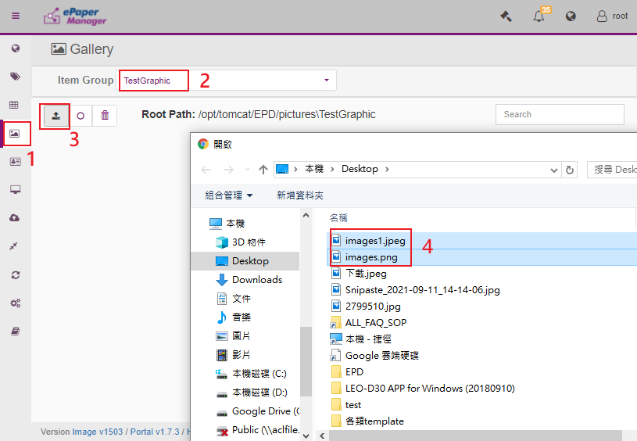

Step 4: Check the image in the ePaper Manager.
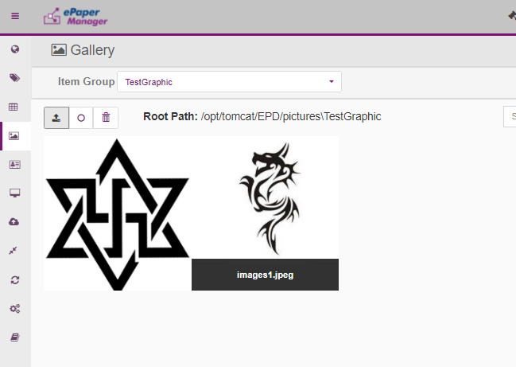
Step 5:Create a new template and binding the template with TestGraphic ItemData.
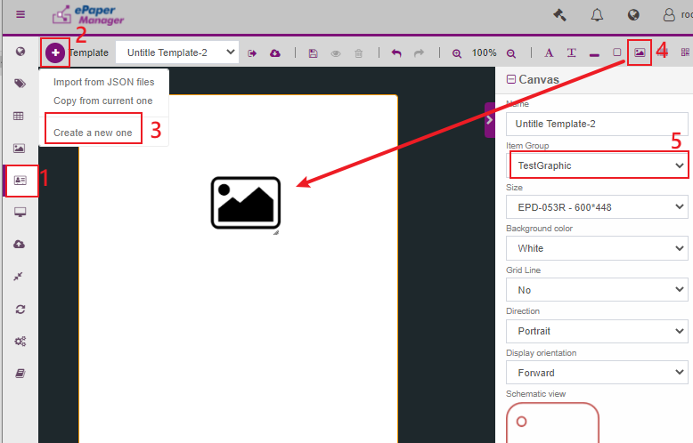

Step 6: Click the graphic and select the binding data. Finally, click save.
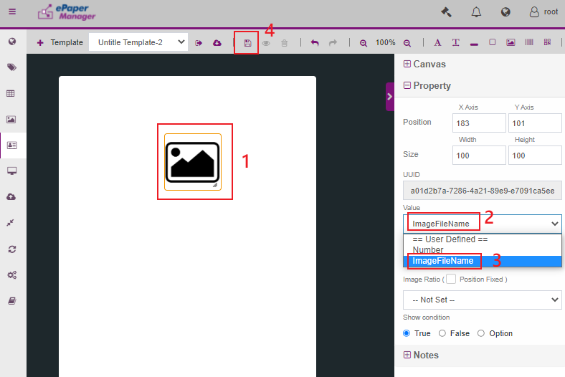

Step 7: Go to the EPD controller web page and click “Select Item”
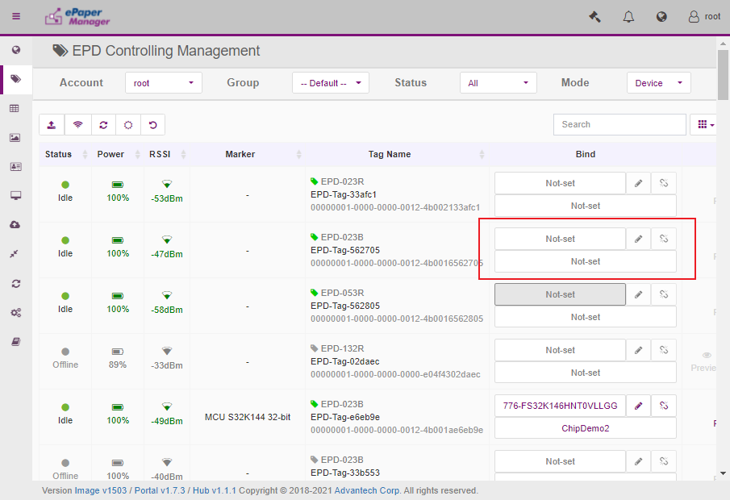

Step 8: Select the “Template” and the “Item Data”. You will see the graphic in the preview window.
Then you can transmit the image to your device.
