EWM FAQ
Category | EWM | Date | 2020/01/20
Keyword | Bluetooth,Ubuntu 16.04/18.04, RTL8822BE-CG, EWM-W308S01E, EWM-W188M201E,EWM-W168H01E, support linux kernel 5.x

- Question:
How to integrate realtek’s bluetooth driver on Linux OS with EWM-W308S01E/ EWM-W188M201E/EWM-W168H01E module?

- Instructions :
Step 1
Download the realtek Bluetooth linux driver by attached file
Step 2
Enter “sudo make install –s” command to install realtek’s Bluetooth driver and make sure the prompt message of “install rtk_btusb success” shows after processing done
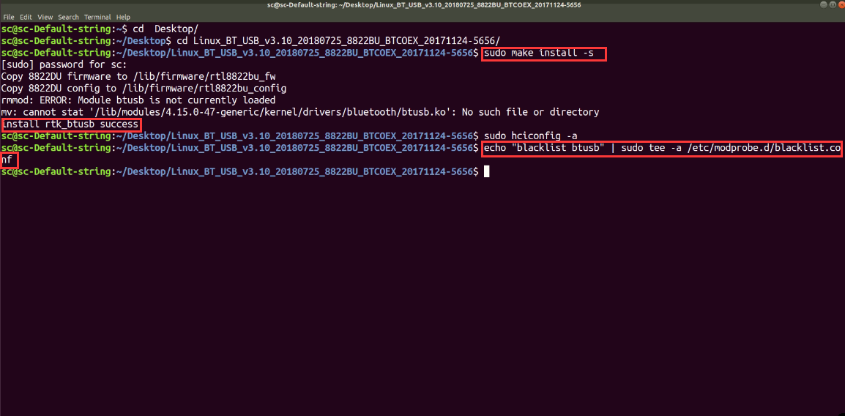
Step 3
Reboot the system and confirm if realtek’s driver has activate when system boots up
- Type “ sudo dmesg” command in terminal for sure
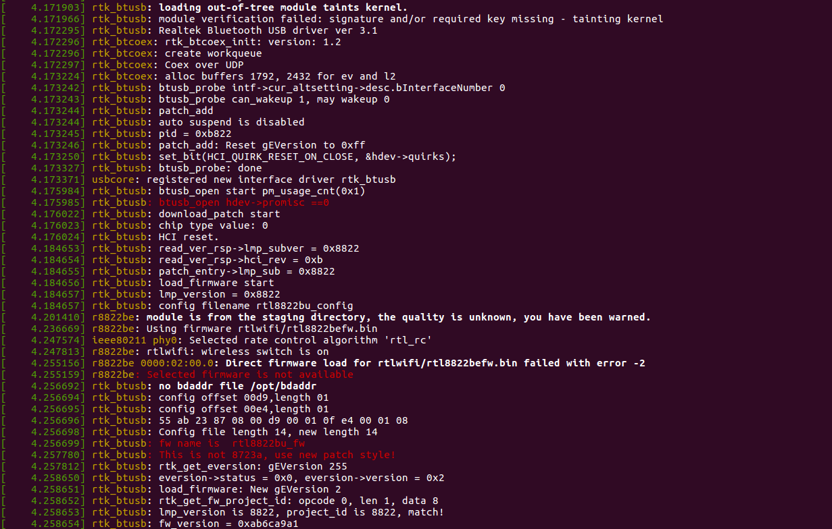
Step 4
If the Bluetooth driver is still original “btusb” driver, please insert following command in terminal, then reboot system again
echo "blacklist btusb" | sudo tee -a /etc/modprobe.d/blacklist.conf
Step 5
Afterward, the Bluetooth function can work proper after replacing driver successfully
