EIS-D620 opcua SOP

- Download \\172.22.31.128\share\Image\Software_Request_10926\device-opcua_20191002.tar.gz
- Copy to EIS-D620
- # tar zxvf device-opcua_20191002.tar.gz
- [PC] open OPC-UA server.
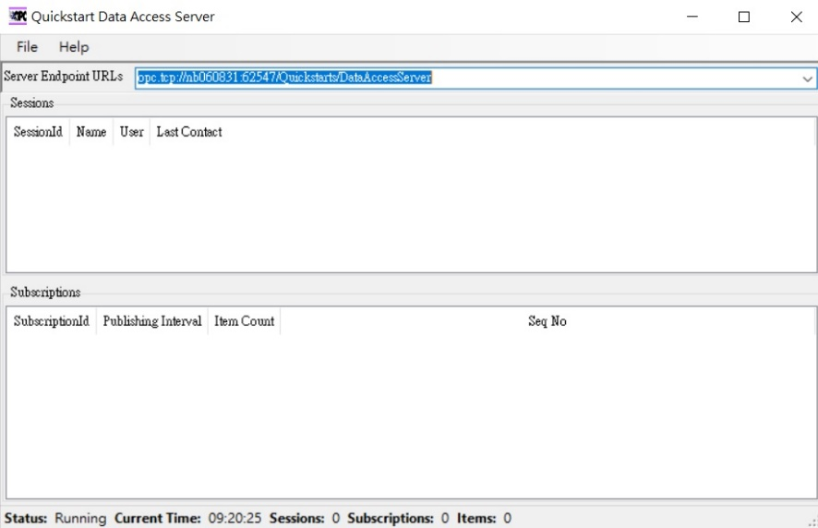
(5) [EIS-620] node index.js
(6)