Software Specification Proposal

Alarm Event

Revision History

Revision | Date | Notes | Owner
1.0 | 2018/11/20 | Software proposal for customization alarm event | Luke.Su, Dylan.Chang

Project (*) | Application for 東正 customize event message | Apply Date (*) |  | 2018/11/08
Customer (*) | 東正 | Business (*) |  | WISE point
PM (*) | Kurt.Ou | AE (*) |  | Sammy.Hsu
Platform (*) | EIS-D210W | OS (*) |  | Windows
Peripheral | Name | Purpose
User /  Functional Requirements | Description |  | Evaluate Solution
 | Request for an application to fulfill customized event message from PLC |  | Provide an application to send customized event message
 | Dashboard panel to show these alert messages |  | Customization event message table
Others
- Please do not affect existing Modbus plugin
- PLC user manual “MANY1202A.EN_AIRMASTER™ Q1 SOFTWARE MANUAL_ZH(T)_E08.pdf”

- Customer’s requirement analysis
(*): Must

- Software Specification
Project Scope、System Structure、System Scope、System Function、Advantech’s suggestion for Customer’s requirement.

EdgeSense

- “Alarm Event” Function:
  - Get ModbusHandler data from MQTT broker.
  - To check the “Error_Code” value as condition of sending event message.
  - If the “Error_Code” value is equal to error list ( modbus address (Hao updated)--CMC.xlsx ) and send an alarm event message ( EventNotify Format ) to local MQTT Broker.
  - "Alarm event" only sends event messages once if received the same "Error_Code".
  - RMM-Agent will retransfer event to WISE-PaaS/RMM.

- Software Architecture:
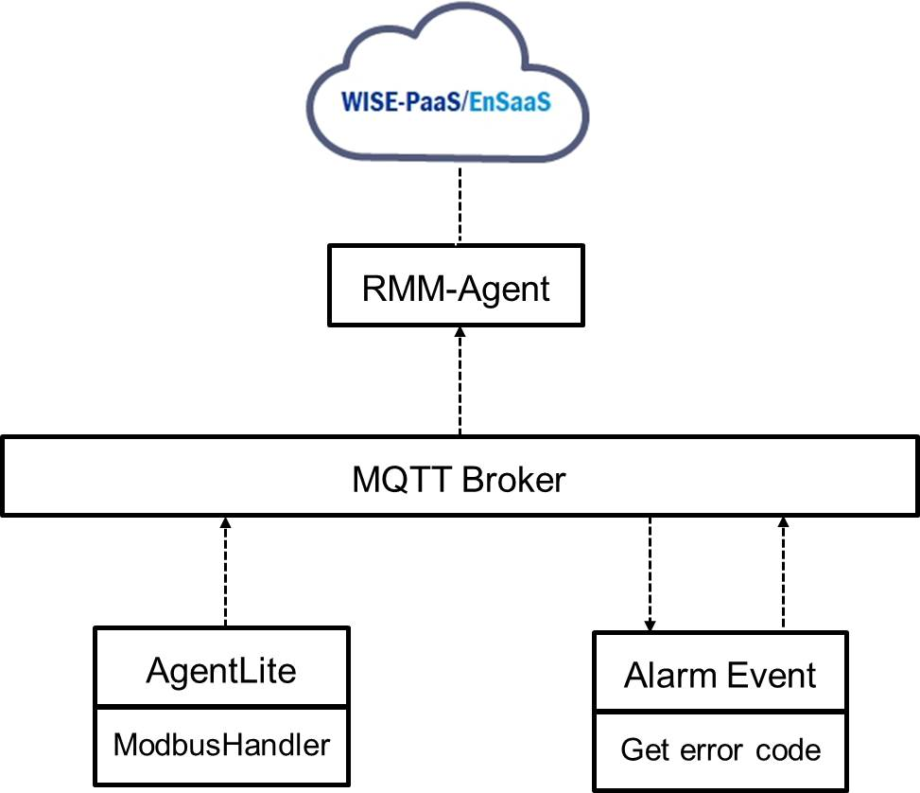
Figure 1.

- Format of Event Notify:
- Follow the WISE-PaaS/RMM event format in JSON
- Example of Message Code: A:0030

{
"susiCommData":
{
"commCmd":2059,
"requestID":2001,
"agentID":"Modbus_Handler",
"handlerName":"general",
"sendTS":1541992952337,
"eventnotify":
{
"subtype":"TC_AC",
"msg":"Door Open",
"severity":4,
"handler":"Modbus_Handler",
"extMsg":
{
"n": "Warning: Enclosure door open",
"ErrorCode":"A:0030",
"eventID":242
}
}
}
}

Code Type map to Advantech event Severity Level:
Code Type | Advantech Event Severity Level
A: Warning | Severity_Warning ( 4 )
E:Immediate stop, S: Start inhibit, R: Run inhibit | Severity_Emergency ( 0 )

- Message code & text table:
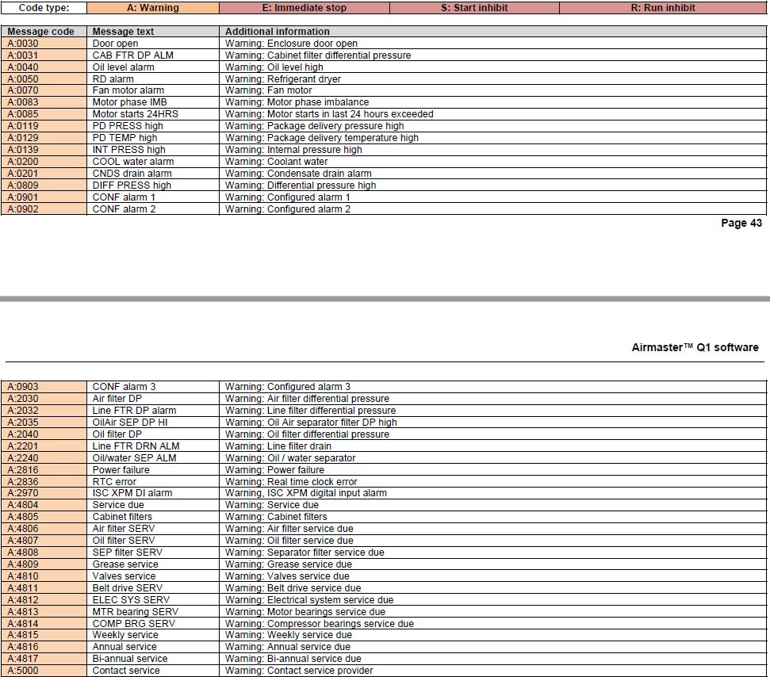
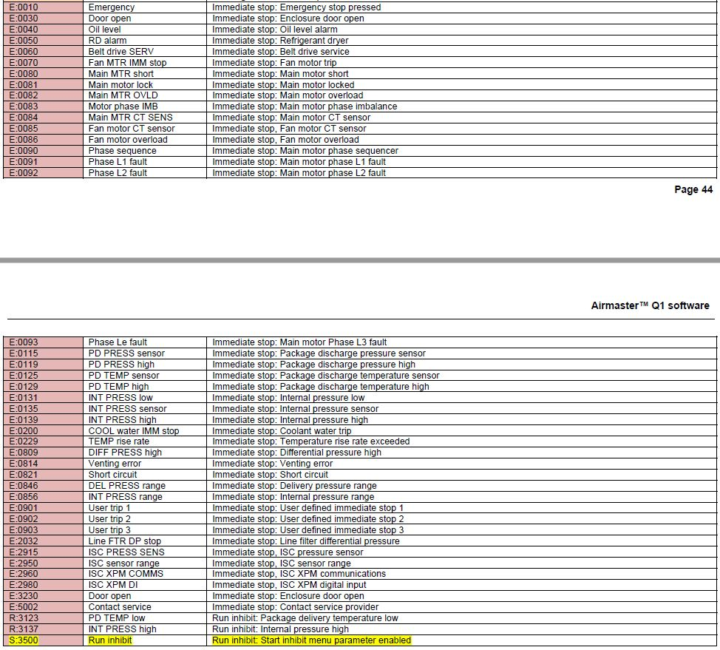
- Modbus’s Error Code & Message Code
Refer to attachment “modbus address (Hao updated)--CMC.xlsx”

WISE-PaaS/EdgeSense
- Event table panel for Error code:
  - Panel : Base on Grafana table panel
  - Name : Error Code Table
  - Column : Time, Error Code, Reason.
  - Data Source : RMM-Event-SimpleJson.
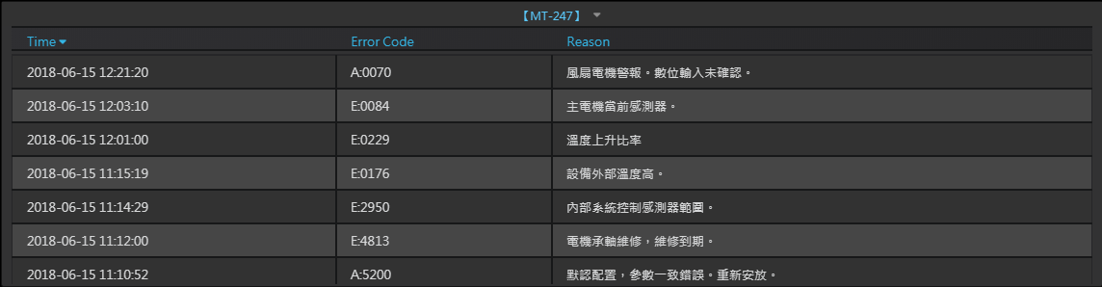
Figure 2.

- Efforts of Software Development/Customization

Tasks | Comment | Man-days
Design Architecture | Software architecture design | 2
Implement – ( EdgeSense ) | Develop a service to send customization event. | 4
Implement – ( WISE-PaaS ) | Develop a Grafana table panel for error code. | 8
Document | Create user guide in Wiki. | 1
Functional verification | QA test | 5
Total |  | 20

- Project Management

Schedule plan (Optional) | 20 working days after 2018/11/05
Proposal Valid | This proposal will be valid before 2018/12/15
Expense | WISE Point: 600
Warranty | 6 months
Attachment | - modbus address (Hao updated)--CMC.xlsx,  - MANY1202A.EN_AIRMASTER™ Q1 SOFTWARE MANUAL_ZH(T)_E08.pdf

- Signature

Customer: ________________________________  By (Signature): ________________________________  Name (Print): __________________________________  Title: _________________________________________  Address: _____________________________________  Tel: __________________________________________ | Advantech Co., Ltd.  By (Signature): ________________________________  Name(Print): __________________________________  Title: _________________________________________  Address:2F., No.27, Wende Rd., Guishan Dist., Taoyuan City 333, Taiwan, R.O.C  Tel: 886-2-2792-7818
Copyright Notice:
Advantech and the Customer will be bound by this Proposal after both parties execute it by their duly authorized representatives. The software (applications, drivers, API…etc) derivative in this executed Proposal is licensed by Advantech. You are expressly prohibited from copying, modifying, selling, leasing, redistributing, assigning, or transferring in any matter, this Software and its derivative thereof. This Software and its derivative are protected by international intellectual property laws and treaties. This Software is licensed, not sold. Copyright © 1983-2018 Advantech Co., Ltd. All Rights Reserved. This executed Proposal shall be governed by and construed in accordance with the laws of Republic of China.
If either party fails to perform or violates any material obligation of this executed Proposal, then sixty (60) days after providing a written notice to the delinquent party specifying the default (the “Default Notice”), the non-delinquent party may terminate this executed Proposal, without liability.

