**EWM FAQ**

|  |  |  |  |
| --- | --- | --- | --- |
| **Category** | EWM | **Date** | 2018/09/26 |
| **Keyword** | EWM-C109F601E, EWM-C117FL0XE,3G/4G Connection,PPP mode,Ubuntu 16.04 LTS and above version | | |

* **Question:**

How to establish 3G/4G connection with EWM-C109F601E/ EWM-C117FL0XE automatically when system startup on Ubuntu Linux OS?

* **Instructions :**

Step 1

Install “Wvdial” application by Typing “apt-get install wvdial” command in terminal

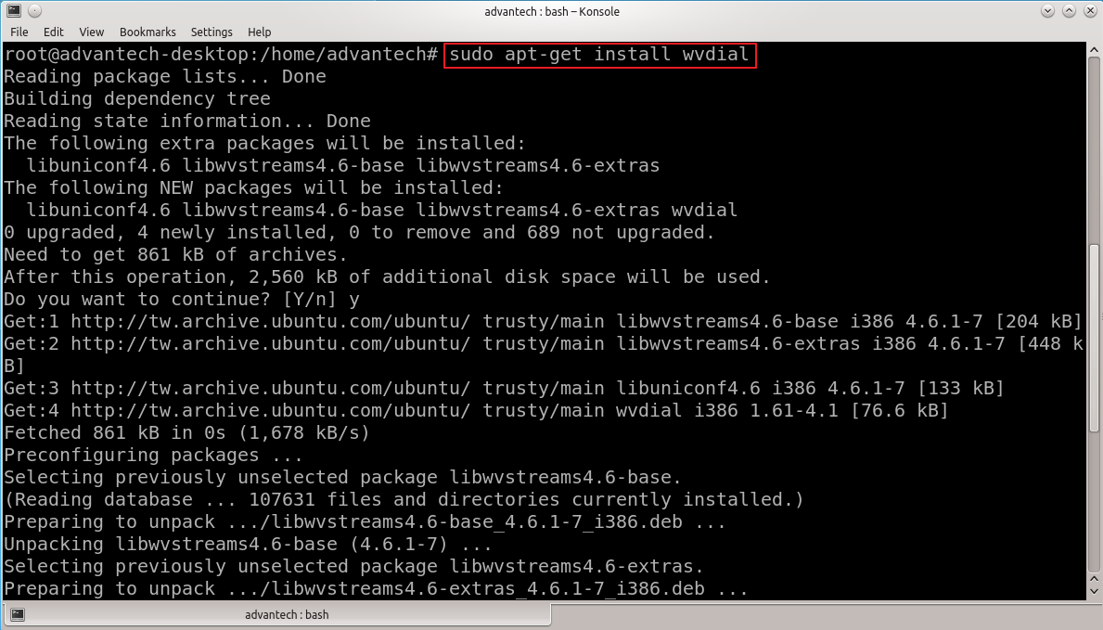

Step 2

Create your “wvdial.conf” profile in specific path (/etc/wvdial.conf) which must refer to your sim card information

**<Example_3G>**

[Dialer Defaults]

Baud = 115200

Modem = /dev/ttyACM0 //select correct ACM port

Init1 =AT+CGDCONT=1,"ip","internet"

Phone=*99#

Username=’’ //please enter Apostrophe keys twice when the username is empty

Password=’’ //please enter Apostrophe keys twice when the password is empty

Dial Command =ATDT

NEW PPPD=yes

NOTE: Please remember to modify your APN(internet) and the serial port number of Modem before saving profile

**<Example_4G>**

[Dialer Defaults]

Baud = 115200

Modem = /dev/ttyACM0 //select correct ACM port

Init1 =AT+UCGDFLT=1,"ip","internet"

Phone=*99***4#

Username=’’ //please enter Apostrophe keys twice when the username is empty

Password=’’ //please enter Apostrophe keys twice when the password is empty

Dial Command =ATDT

NEW PPPD=yes

NOTE: Please remember to modify your APN(internet) and the serial port number of Modem before saving profile

Step 3

Input SIM card’s PIN code in “minicom” application before 3G connecting

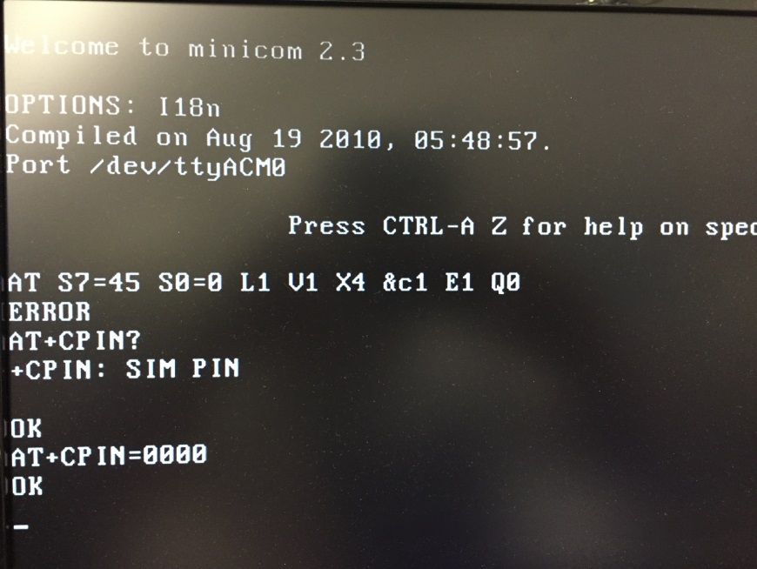

Step 4

Exit “minicom” application (CTRL+A+Z) and input “wvdial &” command to establish 3G connection

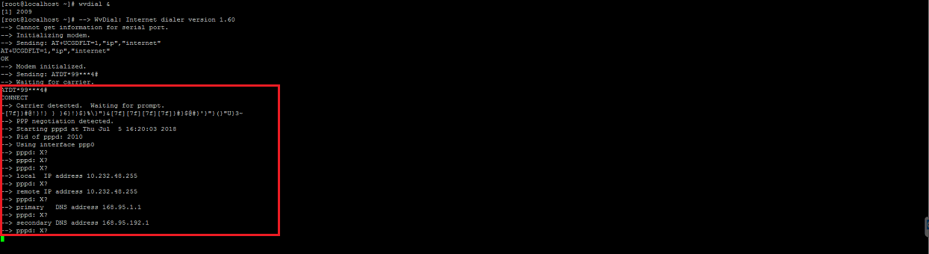

Step 5

After connecting 3G/4G by wvdial application, please cross check if the ppp interface has generated in network interface

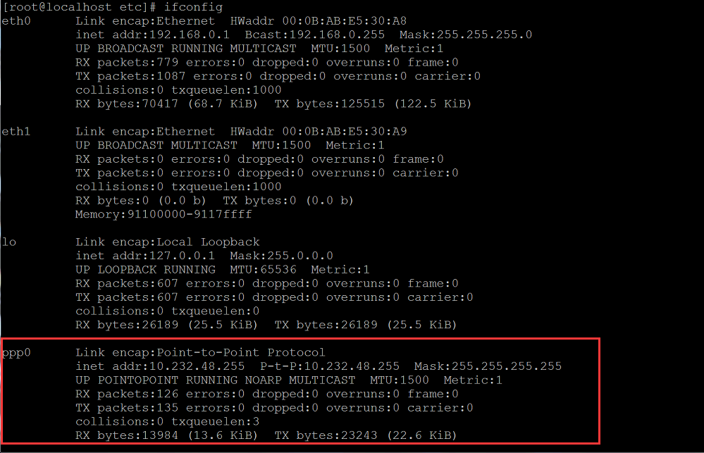

Step 6

Create a shell script to execute “wvdial” application under specific folder(/home/Desktop/Startup) <refer to attached script file below>

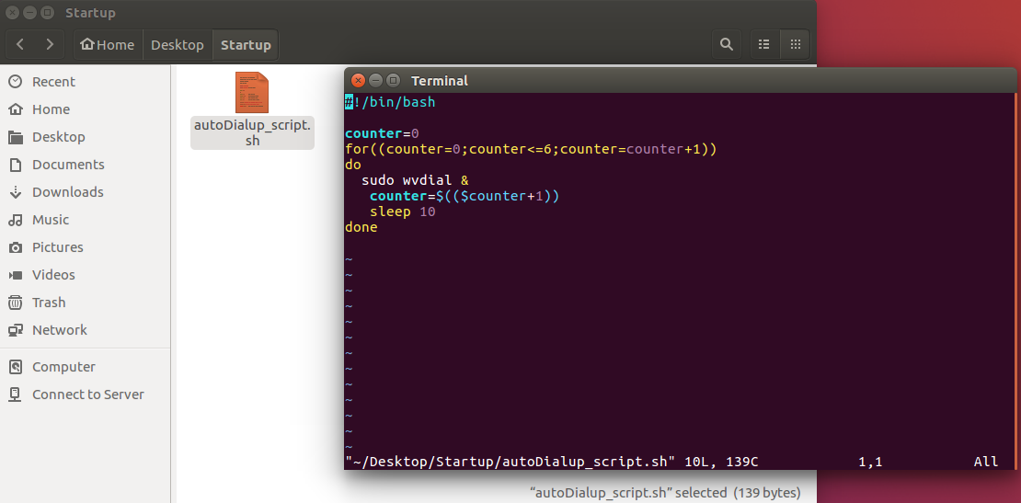



Step 7

Create a startup service under specific folder(/etc/systemd/system/)which can execute “autoDialup_script.sh” script when boots up system automatically <please refer to attached service file below>

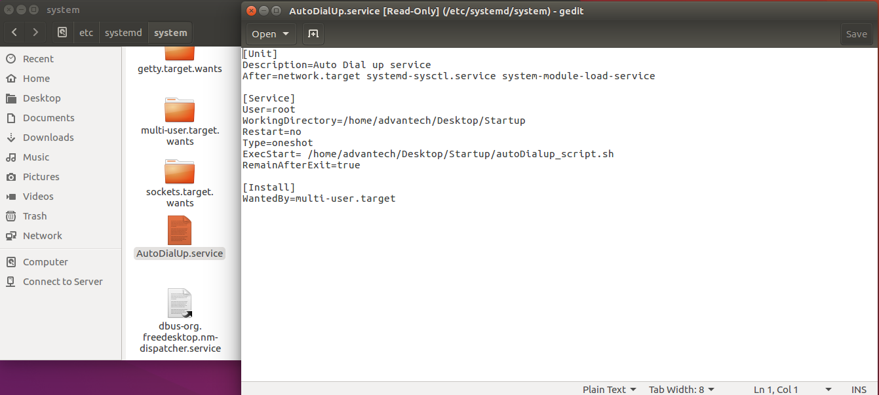



<Directory modification>

/etc/systemd/system/AutoDialUp.service

|  |
| --- |
| [Unit]  Description=Auto Dial up service  After=network.target systemd-sysctl.service systemd-modules-load.service  [Service]  User=root  WorkingDirectory=/home/advantech/Desktop/Startup  Restart=no  Type=oneshot  ExecStart=//home/advantech/Desktop/Startup/autoDialup_script.sh  RemainAfterExit=true  [Install]  WantedBy=multi-user.target |

Step 8

Double check if the service has created under specific folder

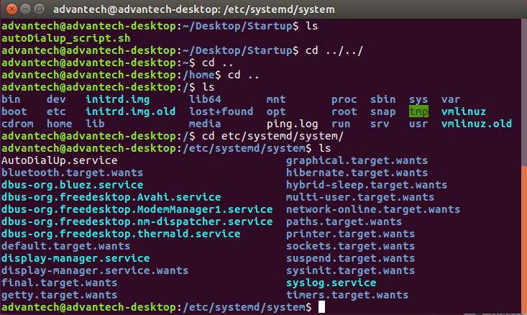

Step 9

Shut down system and confirm if the 3G/4G connection can be established after booting up

